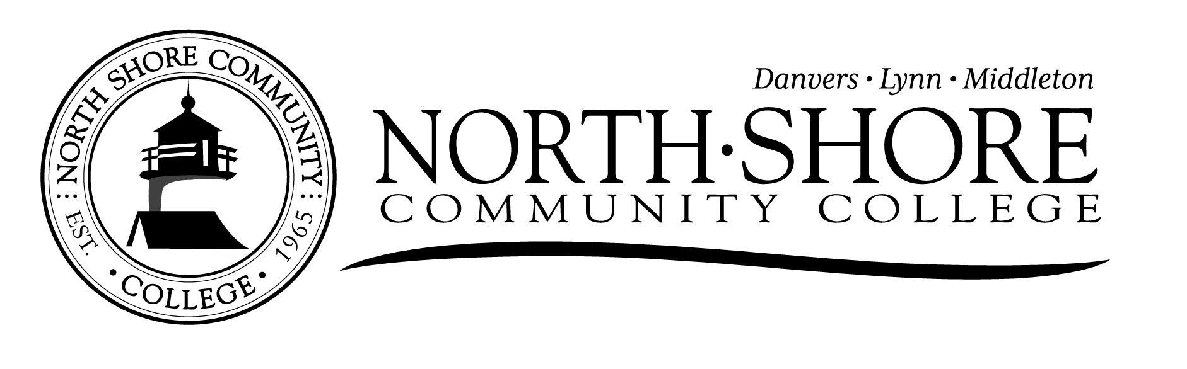
AN EQUAL OPPORTUNITY EMPLOYER
Visit us on the Web! www.northshore.edu
DATE: April 19, 202 POSITION POSTING FY’23-PT

POSITION OPENING:
PT Distance Learning Instructor - Hybrid
15 hours per week/50 week per year
Non-benefited, grant funded, MCCC unit position

GENERAL STATEMENT OF DUTIES:
The Adult Learning Center (ALC) of North Shore Community College, based on the Danvers campus, is funded by the MA Department of Elementary and Secondary Education to provide general instruction and College/Career Readiness services to individuals who have not earned a high school diploma. The goal of the program is to provide adults with opportunities to develop the literacy, numeracy and college and career readiness skills necessary to qualify for further education, job training and/or better employment.

The Distance Learning Instructor of the ALC is responsible for instructing and motivating students with a state-approved on-demand online Distance Learning curriculum (Aztec) and providing face to face support for ALC instructors and students on Aztec implementation and curriculum integration. The Distance Learning Instructor provides one-on-one or small group individualized and differentiated instruction to online students to prepare them for success on the HiSET and/or GED exams in five distinct subjects: Reading, Writing, Math, Social Studies and Science.

DUTIES AND RESPONSIBILITIES:
- Provide remote instructional support and guidance to adult learners who are working asynchronously to achieve their high school credential
- Conduct remote individual and group tutoring sessions during the day and evening, depending on student availability, via video conferencing such as Zoom
- Provide orientation on the Aztec learning system to enrolled remote and face to face ALC students
- Set up student accounts on Aztec for remote and face to face students
- Provide support and instruction to classroom teachers to facilitate integration of Aztec use in the ALC curriculum and as a supplemental learning resource for face to face students
- Work in collaboration with the Distance Learning Coach to establish learning goals with online students, and provide timely and effective feedback on their progress
- Work in collaboration with the Distance Learning Coach to implement and reinforce time management, intrinsic motivation, goal-setting skills with online students
- Collaborate with instructors to provide onsite training workshops for integration into lesson planning
- Maintain and submit weekly attendance records for online students
- Attend DESE trainings as appropriate; complete one annual SMART professional development goal
- Work collaboratively in a team environment, including attendance at semimonthly staff meeting
- Commit to the relational learning culture at the ALC, including personal and center-wide continuous improvement
- Commit to the principles of Diversity, Equity and Inclusion, including the creation of a respectful and culturally responsive learning environment
- Other duties as assigned.

SUPERVISION RECEIVED: Reports to the Senior Special Program Coordinator of the Adult Learning Center

REQUIREMENTS:

- Master's degree preferred or equivalent combination of experience and education
- Minimum of two years' experience teaching adult learners
- Ability to understand and explain high school level curriculum content
- Proficiency with Google Workspace or Microsoft products, including Zoom
- Successful experience interacting with culturally diverse populations
- Ability to work flexible hours in response to program and student needs
- Candidates will be required to pass a CORI/SORI and/or a National background check as a condition of employment.

COVID VACCINATION REQUIREMENT:
Candidates for employment should be aware that all North Shore Community College students, faculty and staff are required to be fully vaccinated by January, 2022. Accordingly, initial employment is dependent upon receipt and verification of full vaccination status records; details of how to fulfill vaccine record verification requirements will be provided during the hire and onboarding process.

SALARY: $30.03/hour (CESE ABE grant rate), non-benefited position

STARTING DATE: June 12, 2023

APPLICATION INSTRUCTIONS:
Please forward resume and cover letter indicating how your experience matches the qualifications for the position.

GENERAL INFORMATION: North Shore Community College is an affirmative action/equal opportunity employer and does not discriminate on the basis of race, color, national origin, sex, disability, religion, age, veteran or military status, genetic information, gender identity, or sexual orientation in it programs and activities as required by Title IX or the Educational Amendments of 1972, the Americans with Disabilities Act of 1990, Section 504 of the Rehabilitation Act of 1973, Title VII of the Civil Rights Action of 1964, and other applicable statutes and college policies. The College prohibits sexual harassment, including sexual violence. Inquires or complaints concerning discrimination, harassment, retaliation, or sexual violence shall be referred to the College's Affirmative Action and/or Title IX Coordinator, Nikki Pelonia, the Massachusetts Commission Against Discrimination or the Equal Employment Opportunities Commission or the United States Department of Education's Office for Civil Rights. North Shore Community College will provide reasonable accommodations to qualified individuals with disabilities and encourages both prospective and current employees to discuss potential accommodations with the employer.

Prospective employees are encouraged to review the College's Annual Security Report (ASR), in compliance with the Jeanne Clery Disclosure of Campus Security Policy and Campus Crime Statistic Act, which can be found on the disclosure page of the College's website by clicking here.

