For each scenario described below, choose at least one of the four bar models to represent it and fill in all the information you can.
- 80 people were surveyed. 25% of them said that spring was their favorite season.

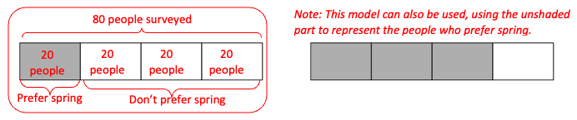
Use the model you chose to fill in the information in the table below:
 | Number of people | Fraction of people | Percent of people
People who prefer spring | 20 | 20/80 or ¼ | 25%
People who do not prefer spring | 60 | 60/80 or ¾ | 75%
Total | 80 | 80/80 or 1 | 100%

- Out of 60 people surveyed, 45 of them said they watch more than three hours of tv each day.

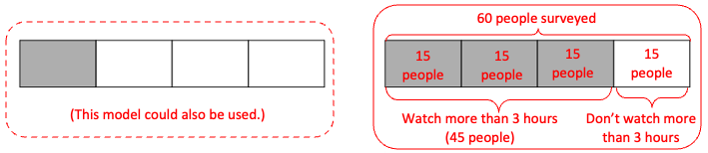
Use the model you chose to fill in the information in the table below:
 | Number of people | Fraction of people | Percent of people
People who watch more than 3 hours of tv | 45 | 45/60 or ¾ | 75%
People who do not watch more than 3 hours of tv | 15 | 15/60 or ¼ | 25%
Total | 60 | 60/60 or 1 | 100%

- Half of the people surveyed said they are happy in their jobs. 35 people said they are happy.

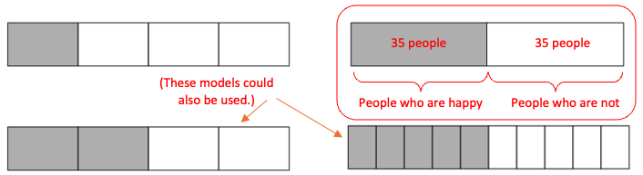
Use the model you chose to fill in the information in the table below:
 | Number of people | Fraction of people | Percent of people
People who said they are happy in their jobs | 35 | 35/70 or ½ | 50%
People who did not say they are happy in their jobs. | 35 | 35/70 or ½ | 50%
Total | 70 | 70/70 or 1 | 100%

- A job training program accepted 80% of the people who applied. 40 people were accepted.

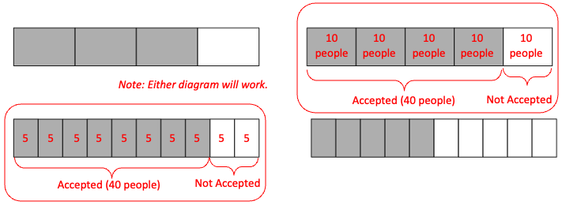

Use the model you chose to fill in the information in the table below:
 | Number of people | Fraction of people | Percent of people
People who were accepted into the program | 40 | 40/50 or 8/10 or 4/5 | 80%
People who were not accepted into the program | 10 | 10/50 or 2/10 or 1/5 | 20%
Total | 50 | 50/50 or 1 | 100%

- Your goal is to take 10,000 steps in a day. Yesterday you reached only 60% of that.

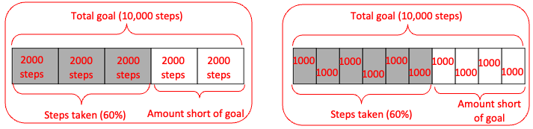
Use the model you chose to fill in the information in the table below:
 | Number of steps | Fraction of steps | Percent of steps
Steps you took yesterday | 6000 | 6000/10000 or 6/10 or 3/5 | 60%
Steps by which you fell short of your goal | 4000 | 4000/10000 or 4/10 or 2/5 | 40%
Total | 10000 | 10000/1000 or 1 | 100%

- You also try to take 250 steps every hour. So far this hour, you have taken 100 steps.

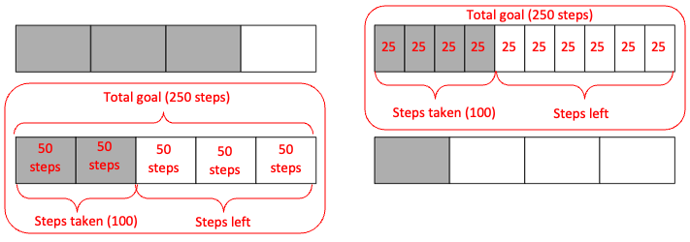
Use the model you chose to fill in the information in the table below:
 | Number of steps | Fraction of steps | Percent of steps
Steps you have taken so far this hour | 100 | 100/250 or 4/10 or 2/5 | 40%
Steps you still need to take to make your goal | 150 | 150/250 or 6/10 or 3/5 | 60%
Total | 250 | 250/250 or 1 | 100%

- In a survey, 75% of people said they prefer streaming video to cable. 180 people said they preferred streaming video.

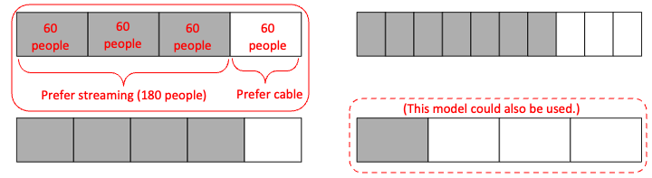
Use the model you chose to fill in the information in the table below:
 | Number of people | Fraction of people | Percent of people
People who prefer streaming video | 180 | 180/240 or ¾ | 75%
People who do not prefer streaming video | 60 | 60/240 or ¼ | 25%
Total | 240 | 240/240 or 1 | 100%

- 144 out of 160 people surveyed said they check their phones at least five times every hour.

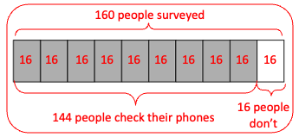
Use the model you chose to fill in the information in the table below:
 | Number of people | Fraction of people | Percent of people
People who check their phones at least five times every hour | 144 | 144/160 or 9/10 | 90%
People who do not check their phones at least five times every hour | 16 | 16/160 or 1/10 | 10%
Total | 160 | 160/160 or 1 | 100%

Challenge scenarios:
Create a model and a table for each of these scenarios.
- 80% of the people who signed up for a yoga class showed up. 3 people didn’t show.

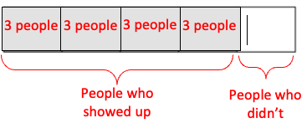

 | Number of people | Fraction of people | Percent of people
People who showed up | 12 | 12/15 or 4/5 | 80%
People who didn’t show up | 3 | 3/15 or 1/5 | 20%
Total | 15 | 15/15 or 1 | 100%

- A teacher reported that her class had 75% attendance on Monday. 3 students were absent that day.

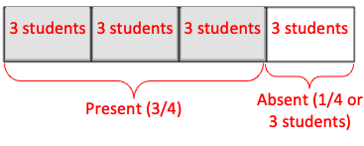

 | Number of students | Fraction of students | Percent of students
Present | 9 | 9/12 or ¾ | 75%
Absent | 3 | 3/12 or ¼ | 25%
Total | 12 | 12/12 or 1 | 100%

- 15 of the 60 children on a field trip forgot to pack a lunch.
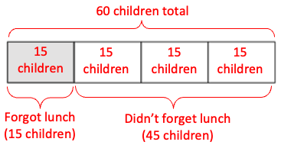

 | Number of children | Fraction of children | Percent of children
Forgot lunch | 15 | 15/60 or ¼ | 25%
Remembered lunch | 45 | 45/60 or ¾ | 75%
Total | 60 | 60/60 or 1 | 100%

- 65% of 160 people surveyed said they eat breakfast every day.

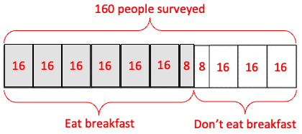

 | Number of people | Fraction of people | Percent of people
People who eat breakfast every day | 104 | 104/160 | 65%
People who don’t eat breakfast every day | 56 | 56/160 | 35%
Total | 160 | 160/160 or 1 | 100%

