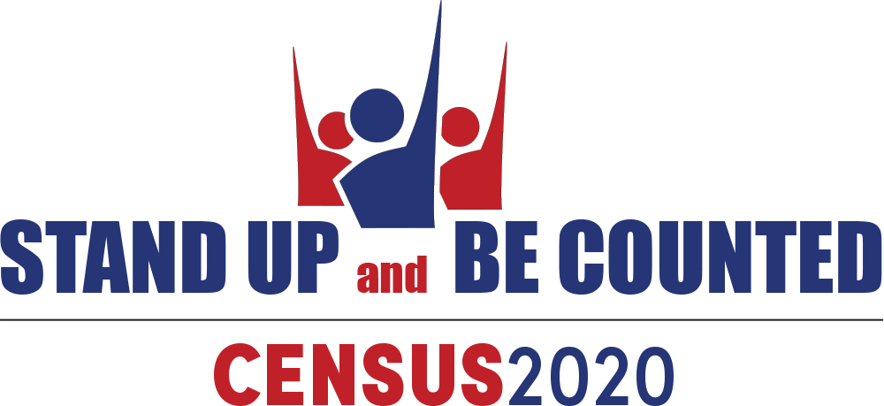
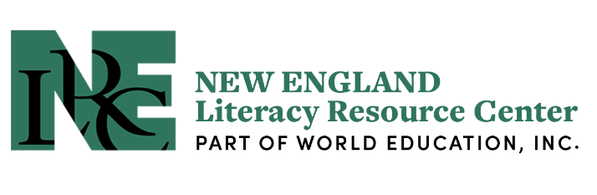

Webinar: Census 2020 Activities for Adult Education Classrooms & Programs

Date: January 28, 2020
Time: 2 p.m. to 3:15 p.m. EST
Panelists:
- Jennifer Gagliardi (Milpitas Unified School District)
- Stephanie Kriebel (San Mateo Adult and Career Education)
- Andy Nash (World Education, Inc.)
- Heather Ritchie (Carlos Rosario Int’l Public Charter School)

Register here.

In this webinar, we’ll hear about resources and activities aimed at mobilizing adult education students and their communities to get out the census count! The teaching resources we will share address census basics (what it is, why it matters, and how to participate) as well as census issues (such as past misuse of census data and what’s different now) as they build language, literacy, and numeracy skills. We will also share examples of program-wide campaigns that energize students and give them an opportunity to practice their leadership and civic skills.

This webinar is part of a series, sponsored by the National Coalition for Literacy and its member partners, to educate and mobilize the field to support a full census count. The decennial U.S. census data collection determines the resources and representation your community will receive for the next decade. To see other webinars in the series and find educational resources, please go to NELRC’s Stand Up and Be Counted/Census page.

