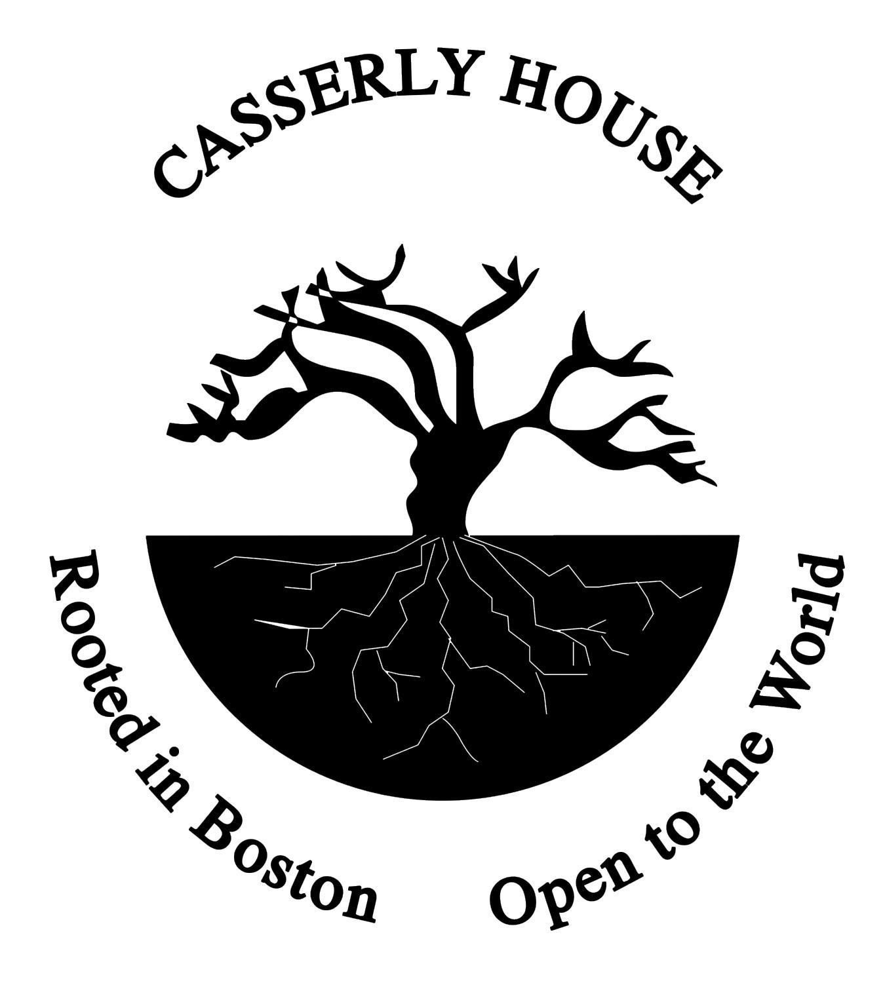

JOB DESCRIPTION:
ESOL Coordinator, part-time

Mission of Casserly House: A place of welcome and connection for immigrants while advocating for the neighborhood in collaboration with others. Casserly House, located in the immigrant section of Roslindale, is a ministry of the Sisters of St. Joseph of Boston, in the charism of being a good neighbor inspired by God’s unifying love.

Position Objective: The ESOL Coordinator (English for Speakers of Other Languages) will coordinate and improve our in-person English Language Classes for adult immigrants from Roslindale and surrounding areas. The Coordinator of English Classes is a new position in our 15-year plus program. Preference will be given for candidates who bring experience, demonstrated ability, and perspective to strengthen our capacity to meet our mission.
Essential Duties and Responsibilities:

- Primarily responsible for coordinating in-person classes for adult English language learners, often new arrivals to the US and mostly beginners, though some intermediate level. The new position aims to improve program quality, depth, and reach. Prioritize relationship building.
- Enroll potential adult learners in classes and assess appropriate fit and level. Refer adult learners to other formal programs, as necessary.
- Support volunteer instructors by leading curriculum planning, scheduling, and recruitment. The Coordinator needs to be flexible to provide coverage for volunteer instructors.
- Over the next two years, outreach to Roslindale immigrants to increase the number of adult learners from our current 20-24 up to 36.
- Offer welcome and connection to new arrivals and other immigrants to the United States. May advise, connect, and help navigate adult learners and neighbors to resources; Create opportunities to integrate life issues (for example, worker rights and affordable housing) into English Language Learning.
- Be an advocate for neighborhood issues that impact the everyday lives of immigrants, especially those with limited economic resources. Embolden immigrant voices in promoting their rights. Participate and represent CH at external meeting(s).
- Work in collaboration with lead volunteers and Director. Participate as part of the CH team, attend monthly meetings, and “roll up your sleeves” in other Casserly House activities.
- Support and foster the mission of Casserly House.

The ideal candidate will have at least 3-5 years of experience working with English language learners, who have a variety of literacy skills. Strong record of cultural competence and cross-cultural communication skills. Highly organized and flexible.

Additionally, candidates would have the following qualifications:

- Bachelor’s degree in education or related field; Master’s Degree in Adult Education preferred. Popular education approach appreciated. Please note if you have any certifications.
- Adept at adaptive and contextualized curriculum development across language levels, with creativity engaging the beginners and pre-beginners.
- Competence in informal assessment to place adult learners in class groups and track progress.
- Ability to work independently and as part of a team. Effective collaboration with diverse groups of people and organizations. Enjoys working with volunteer instructors.
- High attention-to-detail along with flexibility. The day-to-day can be variable due to the adult learner and volunteer instructor schedules. The Coordinator provides structure, though patience, adaptability, and resourcefulness are essential.
- Demonstrated commitment to racial equity and minimizing power differential in service provision and volunteer engagement. Lived understanding of immigrant experience is a bonus. Preference for Bilingual (Spanish, Haitian Creole, French) and bicultural. Please note your languages and level of proficiency.
- Computer proficient with Microsoft applications, zoom meetings, and Google platform.

The in-person classes are currently offered Monday through Thursday, 10am-12noon. The weekday schedule is anticipated to be 9am-1pm in person. Some remote hours possible; additional hours may be considered.

Interested candidates should submit a thoughtful letter of interest (addressed to Donna Stiglmeier, Director), resume, and contact information for three professional references to hr@csjboston.org. Please put “Casserly House” in the subject line. No phone calls. In your letter, please briefly outline how your experience matches this position and our mission. Scheduling of interviews will likely begin week of August 15th and thereafter, though, position is open until filled!
Casserly House is located at 42 Stellman Road,#1, Roslindale, MA. Along bus lines between Roslindale Square and Forest Hills Subway MBTA and walkable from Needham commuter line. Nearby onstreet parking. Please note: Current Casserly House COVID protocols require updated vaccination status with boosters and indoor mask wearing.

Posted on Indeed.

