7 february, 2-3 pm ET  WEBINAR: Accessing Free Mobile Learning Apps for ESOL and Literacy  Adult learning programs and other organizations who provide direct services to adults with limited literacy are increasingly looking to mobile learning to extend learning opportunities. Team WorldEd will provide support and access to synergy that comes from working with others as part of the XPRIZE Communities Competition. We will discuss the purpose, requirements, and strategies of this Competition for those who have joined or are thinking of joining Team WorldEd. We’ll hear about learner recruitment strategies being planned and implemented and check in about what assistance and recruitment materials Team members would find helpful.  Register HERE for the webinar. | Join this webinar to learn more about this unique, time-limited opportunity.  ────  The Adult Literacy XPRIZE Communities Competition aims to “put free learning tools in the hands of those who need them the most, so learning can happen anytime, anywhere.” They will provide apps designed for native English-speakers and English language learner adults.  ────  Team World Ed is a growing, virtual community of adult education providers, community partners, PD providers, and funders in CT, MA, NH, RI,  TX, and VA.  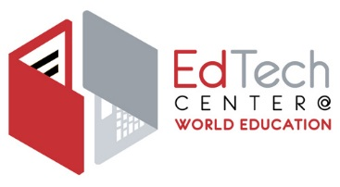  Join us!

