REVERE COMMUNITY SCHOOL

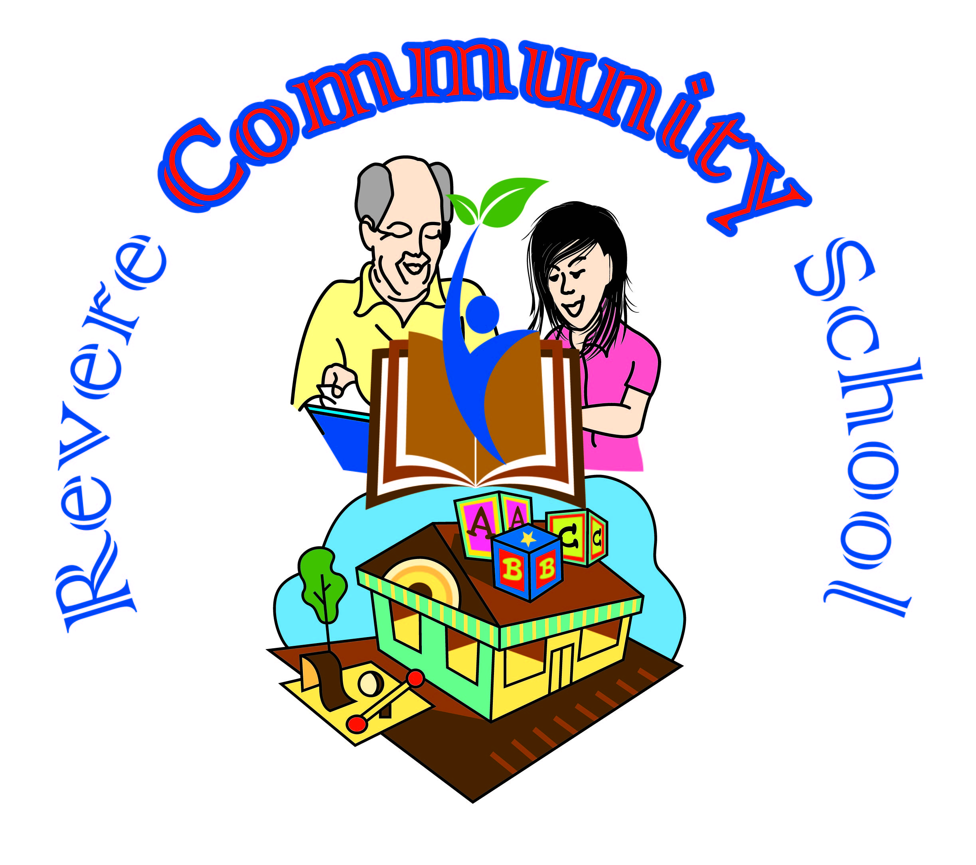
ADULT EDUCATION PROGRAM
Job Title: Instructor for ESOL, Low Beginner, Level 1, 2 & 3 and subtitle teachers for all levels
Program: Adult Education
Report to: Revere Community School Manager
Location: Revere High Schools, Revere, MA
Duration: September 2022, to July, 2023
Pay Rate: $21-$24/hour based on experience and include paid Prep Time

Part-Time- In-Person (3-4 positions)
Schedule: Each class meet twice a week: Monday & Wednesday- AND Tuesday and Thursday from 5:30 – 8:00 p.m.
The Revere Community School has been serving residents of Revere and neighboring communities since 2013. Its primary focus centers on providing ESOL, Citizenship, HiSET, Computer, workforce development, financial literacy and social services to empower immigrant communities speakers of other languages and economically disadvantaged people.

Scope of work:
The English for Speakers of Other Languages Instructor provide English instruction to adult learners with good and advance English skills in the evening ESOL program. She/he is responsible for developing lesson plans and providing instruction for 15-20 learners of different needs and culture. The instructor must be able to successfully tailor curriculum and materials to the specific needs of our learners. This is a part time position with a regular 2 or 4 day/week schedule on Monday & Wednesday or Tuesday & Thursday 5:30 – 8:00 p.m. for a total of 5 hours teaching. Instructors are compensated for 1.5 hours of prep time for each 2.5-hour class.

QUALIFICATIONS:
Minimum of a Bachelor's degree in education or related field required and or TESOL certificate or teaching English as a second language; a minimum of (2) years ESOL teaching experience in a community- based setting preferably with immigrant population. Proficiency in use of technology in classroom and knowledge of Google Office Suite and Drive applications, Prior experience working with low-income immigrants and refugees or have an understanding of, sensitivity to, and respect for the diverse socio-economic, ethnic, religious, and cultural backgrounds .Must have proficiency in Microsoft and google application and ability to integrate technology into instruction. Have excellent oral and written communication skills. Experience in curriculum development highly preferred. Successful candidate should be flexible, creative, self-driven, detail oriented, comfortable working in a multicultural environment. Bilingual is a plus

General Duties and Responsibilities
- Plan and prepare ESOL lessons and instructional practices appropriate to assigned class level to meet the needs of students
- Teach using a variety of activities to enable students growths’ growth in reading, writing, speaking and listening skills, grammar, Vocabulary and critical thinking
- Provide daily English language instruction to groups of 15-20 students of diverse ethnic, literacy, and educational background
- Maintain accurate students attendance records, monitor and report student progress at the end of each session
- Incorporate appropriate technology into curriculum and instructional methods
- Assist with program recruitment and overall retention of students
- Develop new teaching materials and or update instructional materials and lessons
- Assist Manager in student evaluation, intake assessment and placement students in appropriate levels.
- Work closely with and refer student and classroom issues/needs to the lead Teacher
- Maintain case notes on student needs, interests, and refer them to Revere Community School (RCS) Coordinator
- Collect and submit student feeback, and adjust teaching method and materials to meet student needs
- Work with RCS Manager to compile data and produce narrative reports as requested by funders
- Participate in coordination and staff meetings, curriculum design and revision, planning and evaluation and improvement of programmatic policies for students.
- Work with volunteer tutors and prepare lesson materials for substitute teachers when absent.
- Actively participate in promotion events and social and cultural activities for the program
- Utilize appropriate class materials and create a safe and welcoming learning environment for adult learners/ students
- Access community resources and incorporate them into instruction so as to provide students with knowledge of their community, higher education, and career options
- Engage in professional development to ensure that knowledge and skills stay current at least 10 hours per year.
- Strong ability to work independently and as part of a team
- Perform other duties as assigned by RCS Manager.

How to Apply:

Qualified candidates, please email your resume and cover letter to: Fatou Drammeh, fdrammeh@reverek12.org Dateline August 5, 2022
Revere Community School is an adult education program under the Park and Recreation Department and located at Revere High School. Our Mission is to ensure quality, robust community-based learning opportunities for residents of Revere, where they can improve their English language skills, attend college preparedness classes, gain employment and citizenship preparation.

DISCLAIMER
The above statements are intended to describe the general nature and level of work being performed by people assigned to this classification. They are not to be construed as an exhaustive list of all responsibilities, duties, and skills required of the person so classified. All personnel may be required to perform duties outside of their normal responsibilities from time to time as needed.
The City of Revere is an equal opportunity employer. All qualified applicants will receive consideration for employment without regard to race, color, religion, sex, national origin, disability or protected veteran status, or any other legally protected basis, in accordance with applicable law.

