
Number Sense
Beginning Curriculum for Adults Learning Math

STUDENT PACKET



Acknowledgements

The titles in the BeCALM series were developed and piloted in the classroom by Melissa Braaten for the SABES Mathematics and Adult Numeracy Curriculum & Instruction PD Team, with contributions from Yvonne Readdy, Emily Rudd, and Sherry Soares.

The BeCALM series includes four sequential packets:

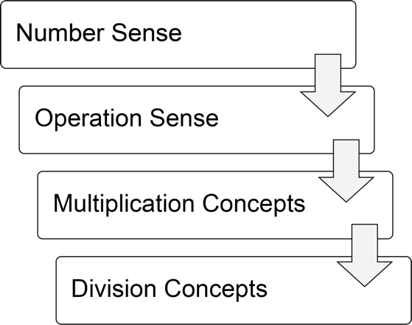

and three non-sequential packets:

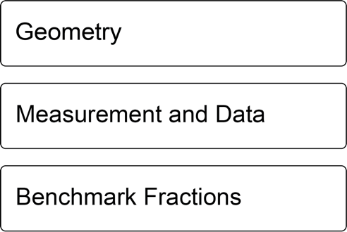

Activities from the EMPower™ and EMPower Plus™ series title Everyday Number Sense: Mental Math and Visual Models Student Book are used and/or adapted with permission from the author, TERC, Inc.

Estimation
Estimation is the ability to judge the size or amount of something. Estimation does not give us an exact answer but helps us to have an idea of “about how much” we have.
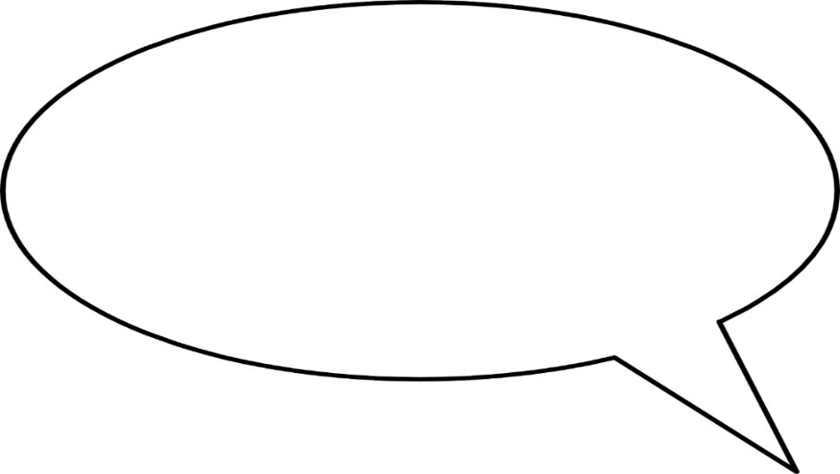
I get paid $11.25 per hour.
When I see my schedule, I multiply the number of hours I work by 10 to estimate what my paycheck should be.

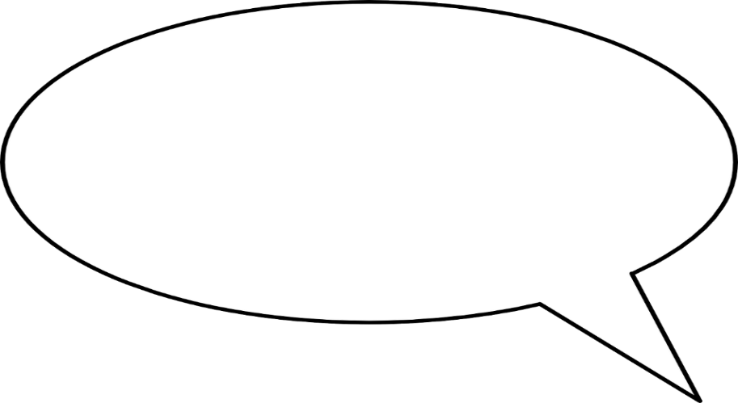
I never use measuring cups
when I cook, but I know how full the pot should look and how much water to add, and the rice always comes out right.

Share an example of when you estimate in your daily life.

Number Sense

Number sense is the ability to break apart and put together numbers in useful ways that make them easier to work with.

OK, that’s $86 in tips.
I have to split them with Ayanna. If we share the $80, we each get $40, and if we share the $6, we each get $3. So, we should each get $43.

I worked 8 hours, and I get
paid $16 per hour. Let’s see...
I know that $10 times 8 hours is $80, and $6 times 8 hours
is $48, so I should get
paid $128.

Share an example of how you use number sense in your everyday life.

“Street Math” and “School Math”
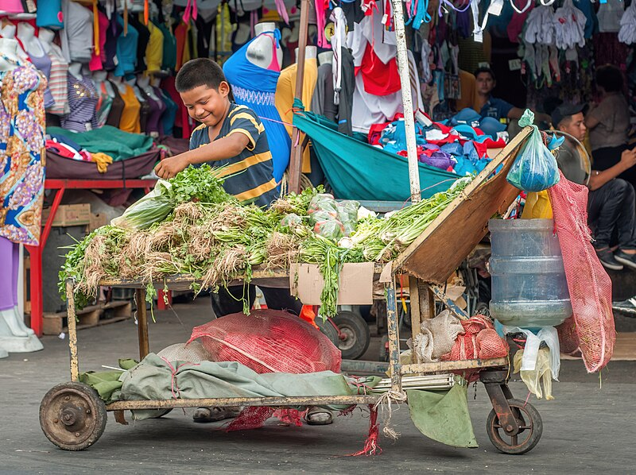
Creative Commons CC0 1.0 Universal Public Domain

Some children work as street vendors in Brazil. Researchers studied how they did math. When they were selling, they did math differently than when they were in school. When they were selling, they used strategies to break down numbers in their heads. They could calculate without paper. In school, the same children did math on paper, using the steps they were taught. When these children did math in their heads while selling, they were much more accurate than when they did math in school.

street vendors
people who sell something, like food or clothing, out of a stall or a cart instead of a store
accurate
correct, exact
Source: Adapted from Mathematics Learning - Numeracy And Culture - School, Cultural, Teachers, and Children - StateUniversity.com https://education.stateuniversity.com/pages/2205/Mathematics-Learning-NUMERACY-CULTURE.html#ixzz6WhZj0qb9

Questions for Discussion
- Do you have strategies for using math in your daily life that are different from the steps you learned in school?

- Where do you see examples of people using “street math” in the culture or community you grew up in?

- The children they studied were more accurate when they were using their own strategies than when they were following the steps they were taught in school. What is the value of math education for these children? What do you think their math education should look like?

UNIT 1: Estimation and Adding

Saving Money on Coffee
By Rahaf Almasri
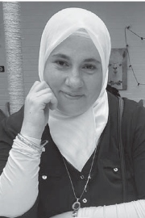
My typical day can’t start without a cup of hot coffee. Buying my coffee from a coffee shop would cost me $2.50 daily, which would add up to $75 a month. However, one cup of homemade coffee costs about $1, which would add up to $30 per month. So, to save some money, I will make my coffee at home.

Rahaf Almasri was a student in the TASC program at the Central Library in Brooklyn, NY. She is a Syrian mother who chose to take a chance on education in hopes of becoming a mathematics teacher to help immigrant students. The paragraph above appears in her article, “Math in Our Daily Lives”, published
in The Change Agent, Issue 47 “Math”, September 2018.

Do you think Rahaf is using estimation to help her figure out the cost of coffee? Why?

Have you ever tried to estimate the monthly cost of something you use daily? How could that be helpful?

Vocabulary List for This Unit
Word | Definition | Example
estimate  (verb, action)  estimate  (noun, thing) | to find an answer that is ________ but not exact  an answer that is ________ but not exact | My dog weighs about 30 pounds.  $12.92 is close to $13.
tick mark | the vertical marks on a ____________. These are often labeled, but not always. | 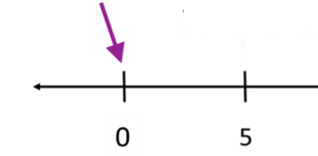
interval | the space between two ____________ on a number line. | 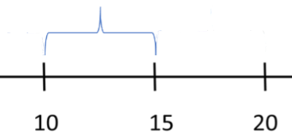
Word | Definition | Example

About How Much?

$1.95 + $3.95 a) $4 b) $5 c) $6

$12.75 + $3.19 a) $15 b) $16 c) $17

$1.05 + $6.00 + $19.99 a) $25 b) $27 c) $29

Source: EMPower™ book Everyday Number Sense: Mental Math and Visual Models

Agree or Disagree?
These are the amounts that Lianne spent on groceries over the past four weeks.

$109 $25 $76 $18

She wants to know her total for the month.

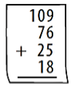
- Lianne says start with the biggest number, then the next largest, and so on. Agree or disagree? Will this way always work?

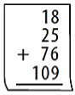
- Peter says to put the numbers in order from smallest to largest, then start at the top and work your way down. Agree or disagree?
Will this way always work?

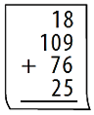
- Ana says the order doesn’t matter, just pay attention to what you’re doing. Agree or disagree? Will this always work?

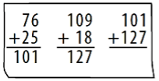
- Chen says take two numbers at a time and total them. Keep going until you have added everything. Agree or disagree? Will this way always work?

- In your own words, what is the best advice about the order in which numbers can be added?

Source: EMPower™ book Everyday Number Sense: Mental Math and Visual Models

Which One Doesn’t Belong? 1

Choose one item in this picture that you don’t think belongs with the rest. Explain why.

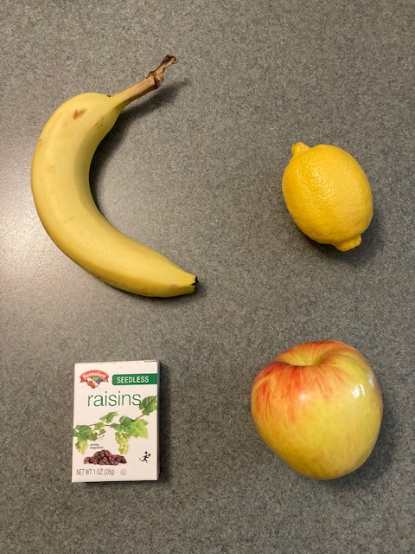

Now pick another item and explain why it doesn’t belong.

Adding Two-Digit Numbers

Directions: Using the digits 1 to 9 at most one time each, fill in the boxes to make the smallest (or largest) sum.

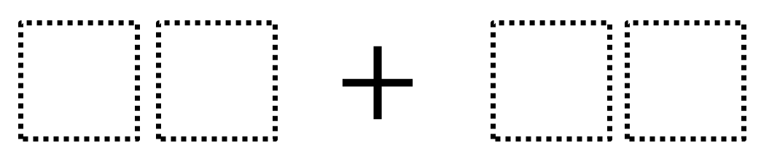


Source: https://www.openmiddle.com/ - Robert Kaplinsky
Open Middle© problems are licensed under a Creative Commons Attribution-NonCommerical-ShareAlike 4.0 International License

Introduction to Number Lines

This is a tick mark.
It can be labeled with a number.
The space between two tick marks is an interval.
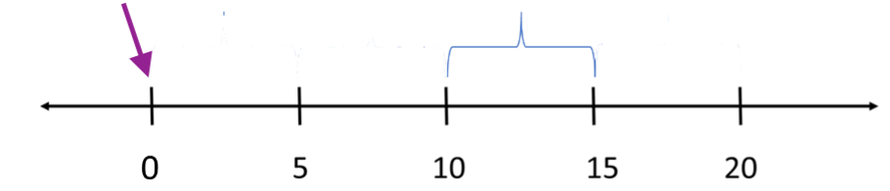

Usually the spaces or intervals are the same size.

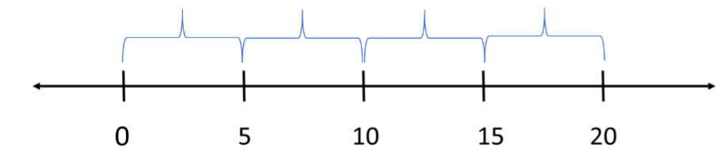

Intervals of the same size have the same value.

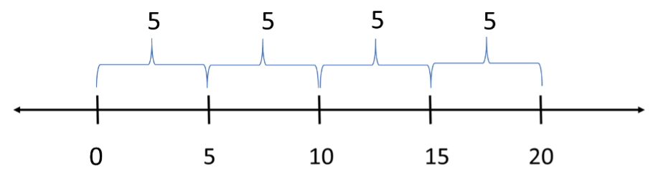
The numbers keep growing by the same amount.

Number Line Puzzles 1a
Fill in the missing numbers.

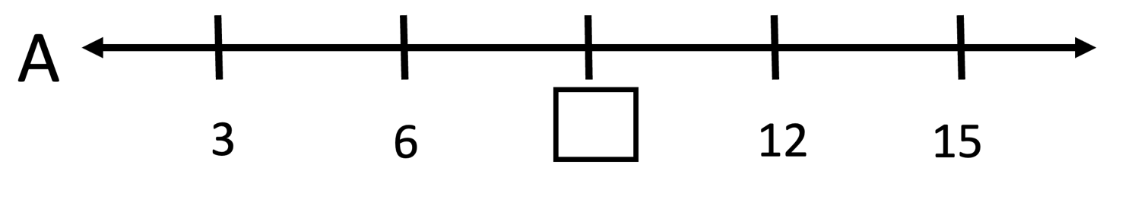

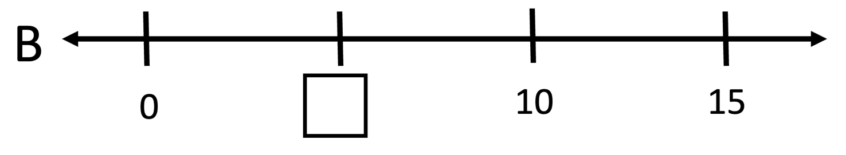

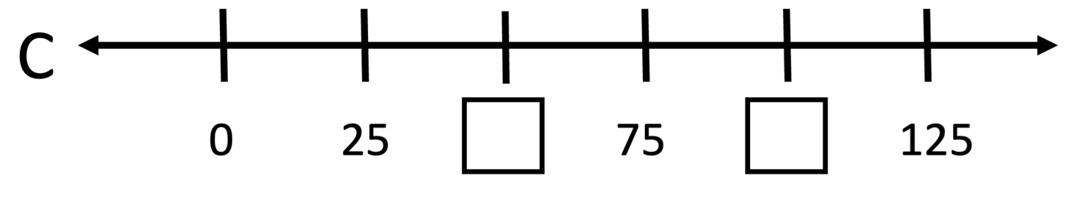

Create your own number line puzzle below.

Number Line Puzzles 1b

Fill in the missing numbers.

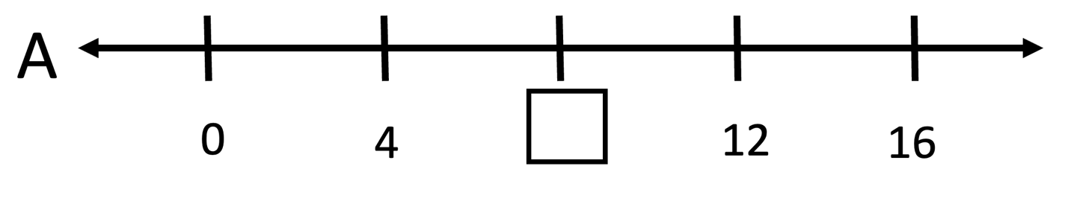

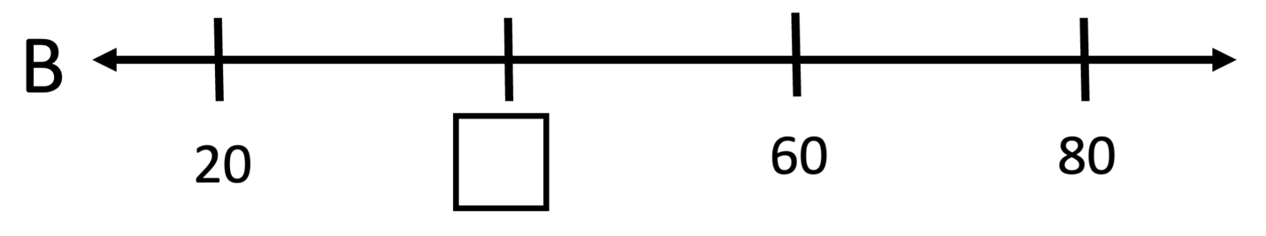

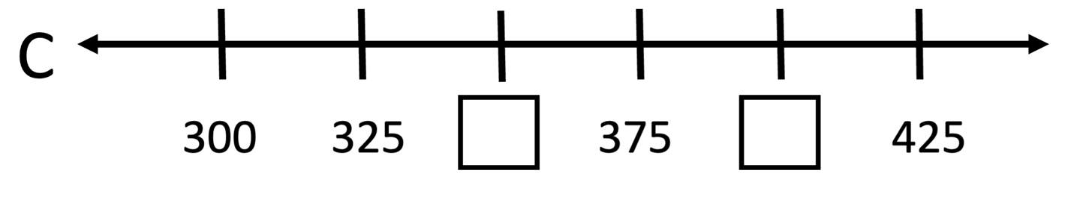

Create your own number line puzzle below.

UNIT 2: Rounding

Rounding at the Grocery Store

I use rounding when I am food shopping. I always round, for example, if something is $2.79, I round it to $3. When I am in the grocery store, I always over-round, I never under-round. It helps me with money management, to make sure that I always have enough and don’t go over. For example, if I have $150 to spend, I make sure that I don’t go over $140, because of tax. Rounding makes it quicker to keep track in my mind, and I don’t have to use a calculator.
Kimberly, adult education student, Boston, MA

Questions for Discussion
- Do you ever use rounding to help you make numbers easier to work with? Where and when do you do this?

- The author said, “I always over-round.” What might be the advantage of always rounding up in this situation?

Vocabulary List for This Unit
Word | Definition | Example
benchmarks | Number used to __________ and __________ less-familiar numbers. We choose benchmarks that are __________ to understand and work with  (“__________numbers”) | Whole numbers of dollars ($1, $5, $14, etc.)  Multiples of 10 (10, 20, 30, etc.)
round | to estimate a number by choosing a __________ that is close.  Place values (ones, tens, hundreds) are often used as benchmarks for rounding.
round to the nearest … | “nearest” means __________. This phrase explains which __________ were used for rounding. | $4.13 to the nearest dollar is $4.  89 to the nearest 10 is 90.
Word | Definition | Example
round up | to make the amount __________ when rounding by choosing the larger benchmark | 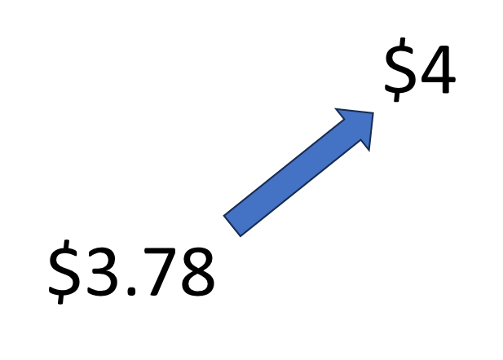
round down | to make the amount __________ when rounding by choosing the smaller benchmark | 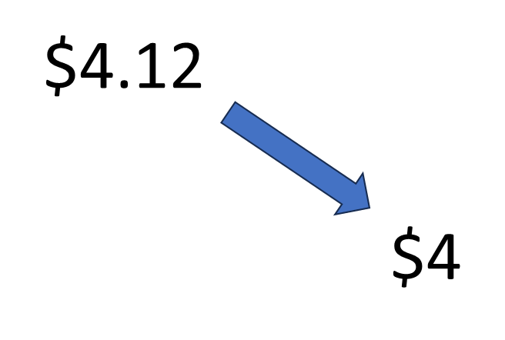
midpoint | the exact __________ between two benchmarks | 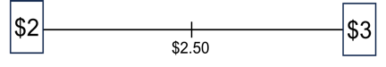

Between Which Dollars?

When we have dollars and cents, the amount will fall between two whole dollar amounts.
$6.23
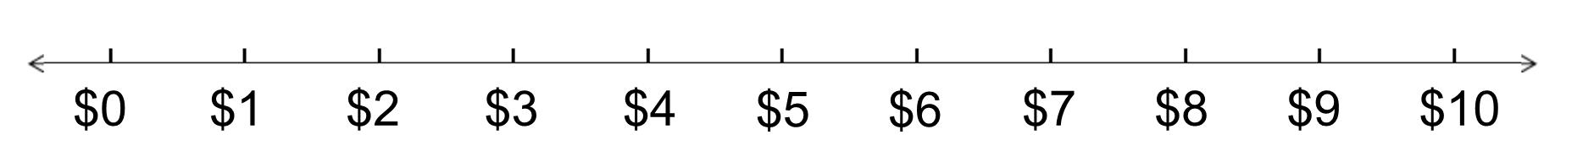
This is more than $6, but less than $7.
We can say that it is between $6 and $7.

Use the number line below to help you decide between which dollars each amount will be.

- $3.45 is between _____ and _____.
- $1.23 is between _____ and _____.
- $6.70 is between _____ and _____.
- $0.50 is between _____ and _____.
- $9.91 is between _____ and _____.

Between Which Dollars Extension:

Larger Amounts
- $13.45 is between ______ and _______.
- $21.23 is between ______ and _______.
- $56.70 is between ______ and _______.
- $100.50 is between ______ and ______.
- $239.91 is between ______ and ______.

In your own words:
How do you decide which whole dollars the amount is between?

These whole dollars will be our dollar benchmarks for rounding to the nearest dollar.

Rounding to the Nearest Dollar

- Put the dollar benchmarks in the boxes.
- Put an x on the number line where the exact amount of money would go.
- Circle the dollar benchmark nearest to the exact amount.

Example: $5.78
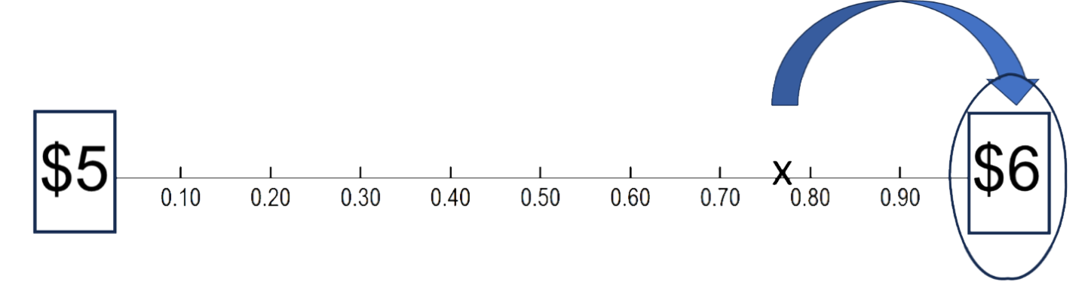
Exact amount: $2.13
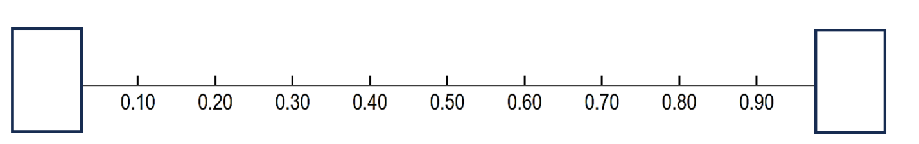
Exact amount: $4.28
Exact amount: $7.61

Rounding to the Nearest Dollar 2

- Put the dollar benchmarks in the boxes. Label the midpoint.
- Which side of the midpoint is the exact amount?
- Circle the dollar benchmark nearest to the exact amount.

Example: $2.39
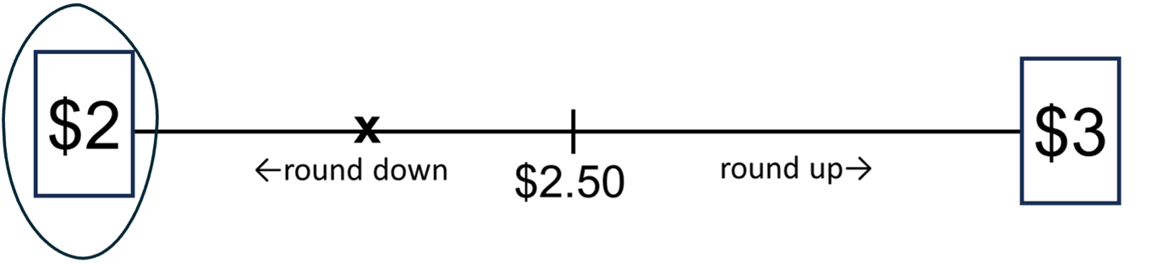
Exact amount: $8.03
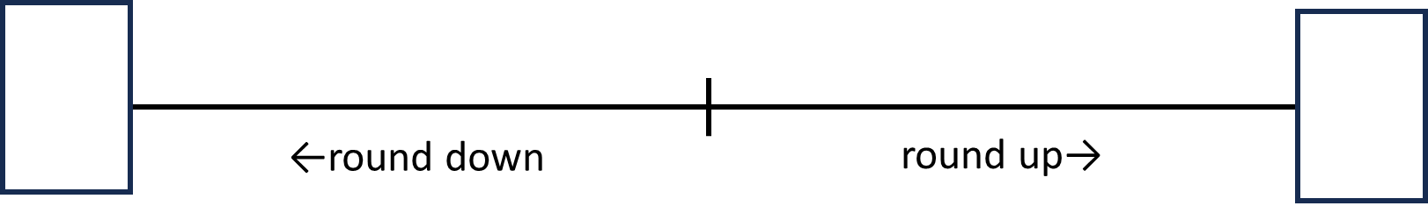

Exact amount: $12.34

Exact amount: $19.02

Rounding to the Nearest Dollar
(more scaffolding)
Circle the nearest dollar.
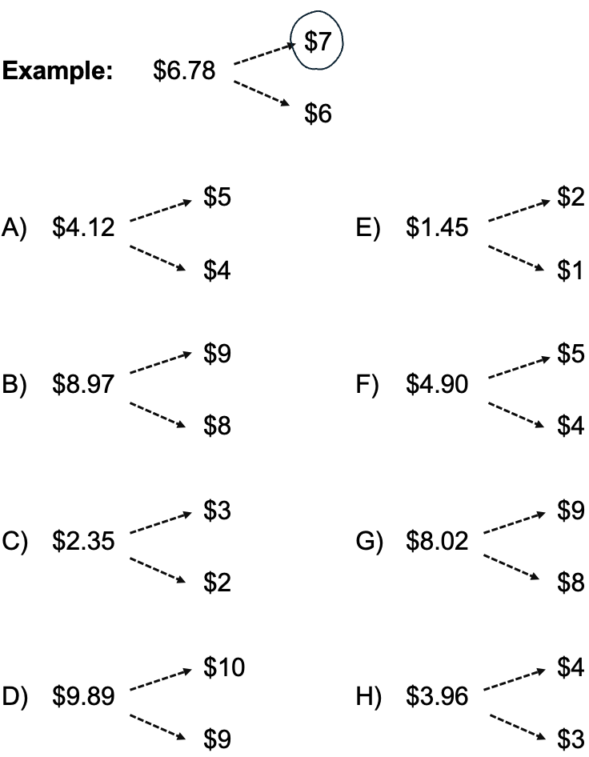

Rounding to the Nearest Dollar

(less scaffolding)

Example: $19.78 $20

- $10.58 ______________
- $ 6.23 ______________
- $ 7.32 ______________
- $ 3.02 ______________
- $5.95 ______________
- $12.99 ______________
- $14.45 ______________
- $15.12 ______________
- $34.98 ______________

Rounding to the Nearest Dollar: Extension

Example: $19.68 $20

- $23.51 ______________
- $ 0.87 ______________
- $ 67.49 ______________
- 39¢ ______________
- $43.52 ______________
- $29.99 ______________
- $99.45 ______________
- $609.77 ______________
- $999.51 ______________

Roll and Round

- Roll three dice.
- Use what you roll to fill in the blanks.
- Round the number to the nearest dollar.

We rolled $___.___ ___ This rounds to _________.
We rolled $___.___ ___ This rounds to _________.
We rolled $___.___ ___ This rounds to _________.
We rolled $___.___ ___ This rounds to _________.
We rolled $___.___ ___ This rounds to _________.
We rolled $___.___ ___ This rounds to _________.
We rolled $___.___ ___ This rounds to _________.

Shopping Trip


Kana went grocery shopping. This is what she bought.

Milk $3.85

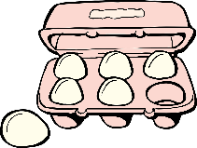
Eggs $2.25


Rice $10.30


Bananas $1.95

- Round all of the prices down and find the total.
Milk $3.85
Eggs $2.25
Rice $10.30
Bananas $1.95

Is this estimate larger or smaller than the exact amount? How do you know?

- Round all of the prices up and find the total.
Milk $3.85
Eggs $2.25
Rice $10.30
Bananas $1.95

Is this estimate larger or smaller than the exact amount? How do you know?

- Round all of the prices to the nearest dollar and find the total.
Milk $3.85
Eggs $2.25
Rice $10.30
Bananas $1.95

Is this estimate larger or smaller than the exact amount? How do you know?

- Find the exact total. You can use a calculator.

- Which method (#1-3) do you think gave the best estimate? Explain why.

Which One Doesn’t Belong? 2

Choose one shape in this picture that you don’t think belongs with the rest. Explain why.

Now pick another shape and explain why it doesn’t belong.

Missing Digits

Fill in the blanks with digits to make the answer as large as possible.
Fill in the blanks with digits to make the answer as small as possible.

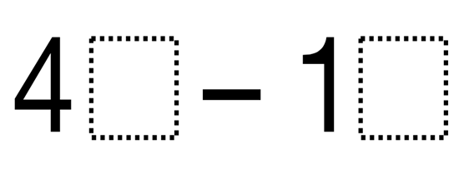

Source: https://www.openmiddle.com/ - Marilyn Burns and Graham Fletcher
Open Middle© problems are licensed under a Creative Commons Attribution-NonCommerical-ShareAlike 4.0 International License

Number Line Puzzles 2
Fill in the missing numbers.

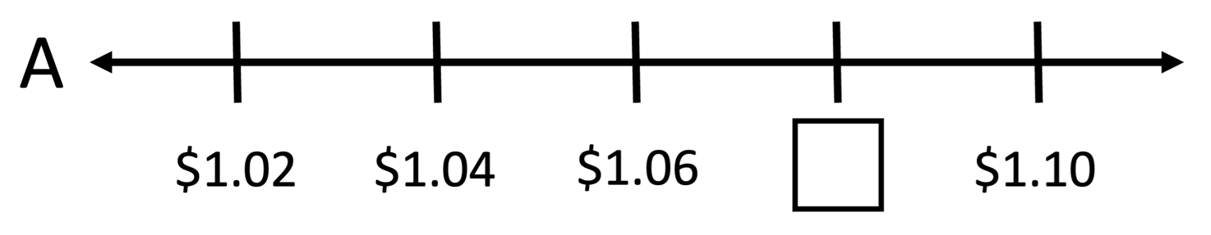

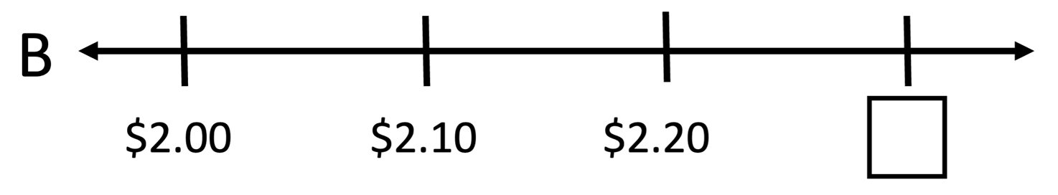

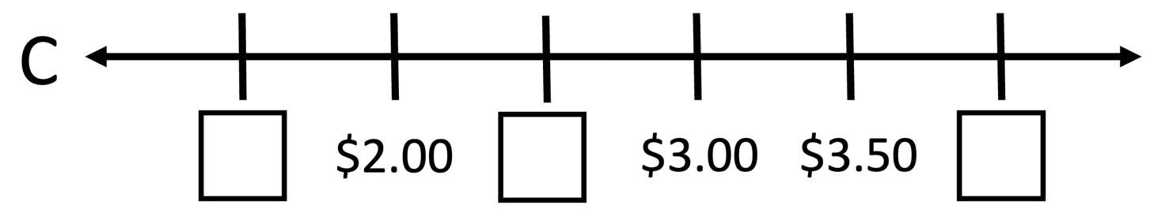

Create your own number line puzzle below.

UNIT 3: Combining

Help Me, Mom!
By Abir Yousef
When I was a small girl, I said, “Mom, please help me with my math homework.” I didn’t have anyone to help me. She cried because she didn’t go to school when she was a girl. This was so hard for me. I practiced by myself for a long time. I feel I am strong in life. Math is important. I did well in math. I remember my teacher in school told me, “In the future, you must study to be an engineer.”
My children like math and they do well too. Sometimes they tell me, “Mom, please help us.” But I feel sad because it is hard to help them. I need more English. When my children were small, I could teach them math. As they’ve gotten older, some of the problems are too hard. Sometimes, it takes me one hour to find the right answer. Now I learn English to help me in math also. I use math all the time in my life. I want to find a job very fast and math will help.
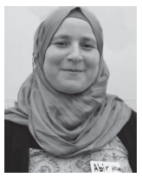
Abir Yousef is a student at the IRIS Mother & Child ESOL Program in New Haven, CT. She is from Syria, where she studied psychology at Damascus University. When she went to Jordan, she worked for the International Rescue Committee helping refugees. Now she wants to study to be an ultrasound technician in the USA and work part-time because she has seven children. The piece above was published in The Change Agent, Issue 47 “Math”, September 2018.

Reflect: What was your experience as a child getting help with math? What is your experience as an adult helping children with math?

Vocabulary List for This Unit
Word | Definition | Example
friendly numbers | numbers that are ___________ to understand and work with. Often used as benchmarks.
sum | the ___________ of adding | 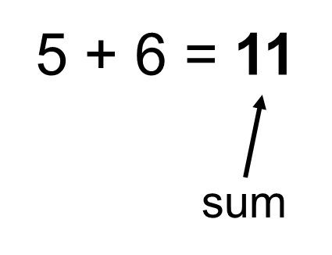
Word | Definition | Example

Closest Answer

- $26 + $18.99 + $4
- $30 b. $50 c. $70

- 10 + 59 –19
- 70 b. 60 c. 50

- 79 – 25 + 19
a. 65 b. 75 c. 85

- 86 + 13 + 2
- 90 b. 100 c. 110

- $24.99 + $9.99 + $11.99
- $65 b. $55 c. $45

Source: EMPower™ book Everyday Number Sense: Mental Math and Visual Models

How Much Money Is in the Jar?
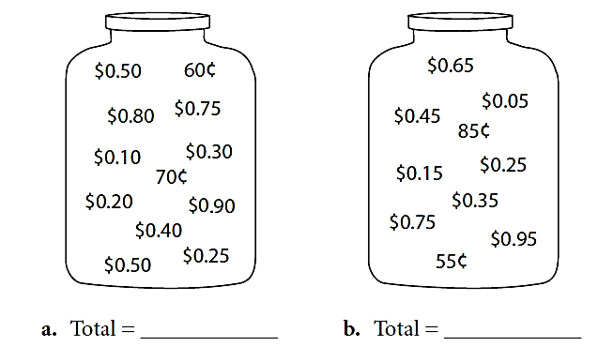
Write down five combinations that equal one dollar.

Use mental math to add the following amounts.
$0.10 + $0.20 + $0.30 + $0.40 + $0.60 + $0.70 + $0.80 + $0.90 =

$0.05 + $0.15 + $0.25 + $0.75 + $0.85 + $0.95 =

Source: EMPower™ book Everyday Number Sense: Mental Math and Visual Models

How Much Money Is in the Jar?—Larger Amounts
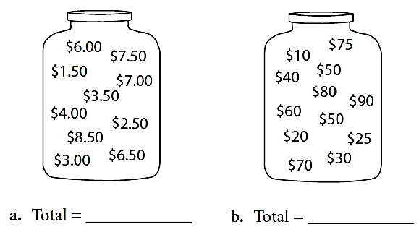

Write down five combinations that equal $10.

Use mental math to find the total.

$1 + $2 + $3 + $4 + $5 + $6 + $7 + $8 + $9 =

$10 + $20 + $30 + $40 + $50 + $60 + $70 + $80 + $90 =

Source: EMPower™ book Everyday Number Sense: Mental Math and Visual Models

Which One Doesn’t Belong? 3

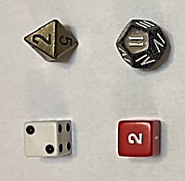
Choose one die in this picture that you don’t think belongs with the rest. Explain why.

Now pick another die and explain why it doesn’t belong.

Pyramid Puzzle 3
Each number in the Pyramid is the sum of the two numbers below it. Fill in the missing numbers in the Pyramid. Numbers may repeat.

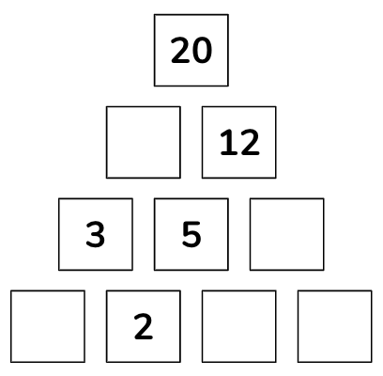

Created by Math for Love. More available at mathforlove.com

Number Line Puzzles 3
Fill in the missing numbers.

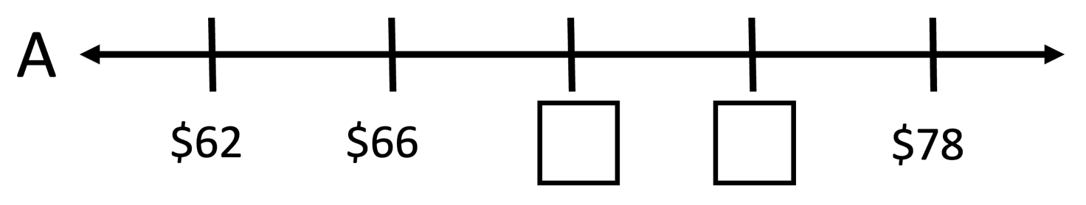

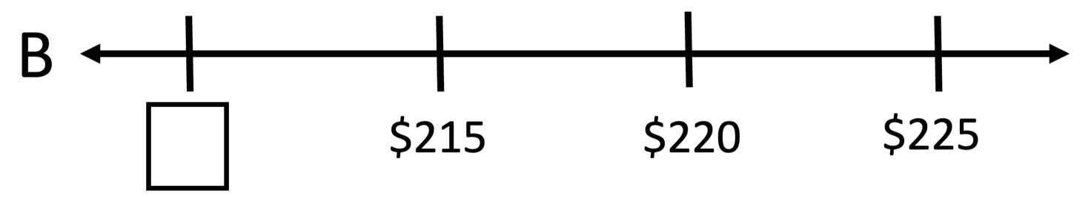

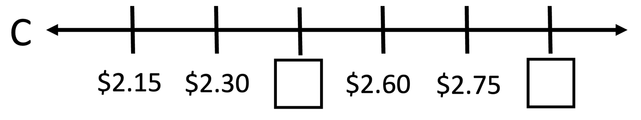

Create your own number line puzzle below.

UNIT 4: Gauges

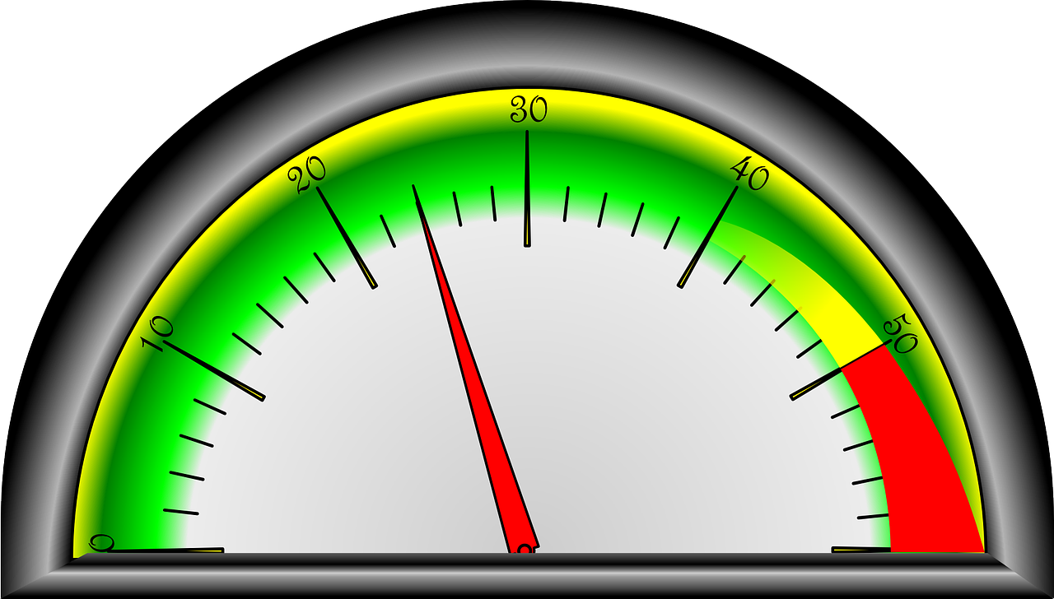

This is a gauge. A gauge is any tool that uses a number line to measure something.
Look closely at the gauge above. What do you notice? What do you wonder?

What do you think this gauge might be measuring?

Vocabulary List for This Unit
Word | Definition | Example
gauge | a measuring tool that uses a _____________ | 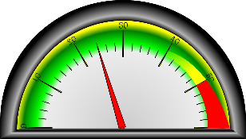
analog | using a _____________ to show a number or measurement | 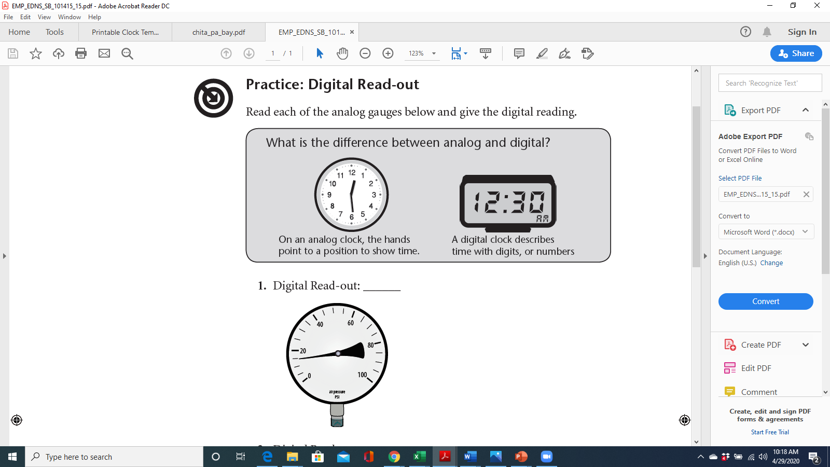
digital | displaying _________ to show a number or measurement
maximum | the ____________ value | 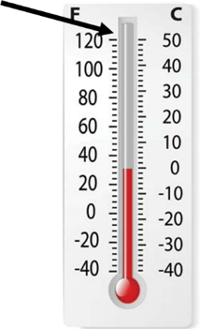
Word | Definition | Example
minimum | the _____________ value | 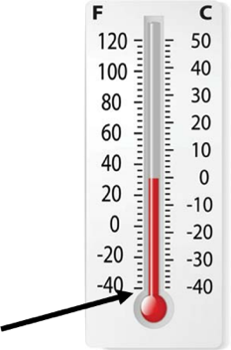
range | the _____________ between the maximum and minimum value | 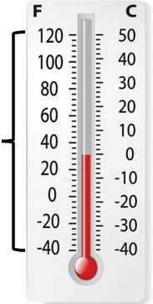
units | what is _____________ by the gauge | psi, degrees, mph, etc.

Examples of Gauges
For each gauge, consider:
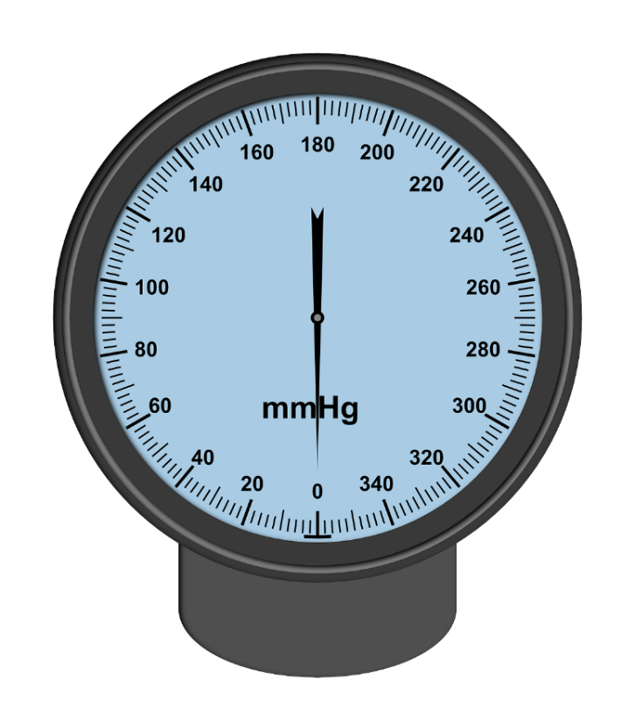
- What is the smallest interval worth?
- Which numbers are labelled?
- What is are the smallest and largest amounts that this gauge can measure?
- What do you think this gauge would be used for?

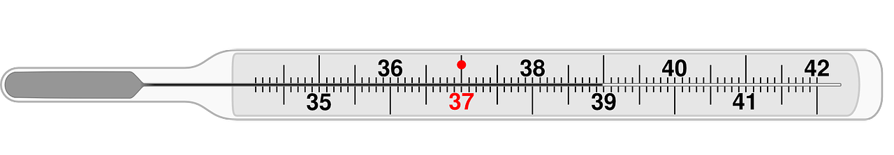
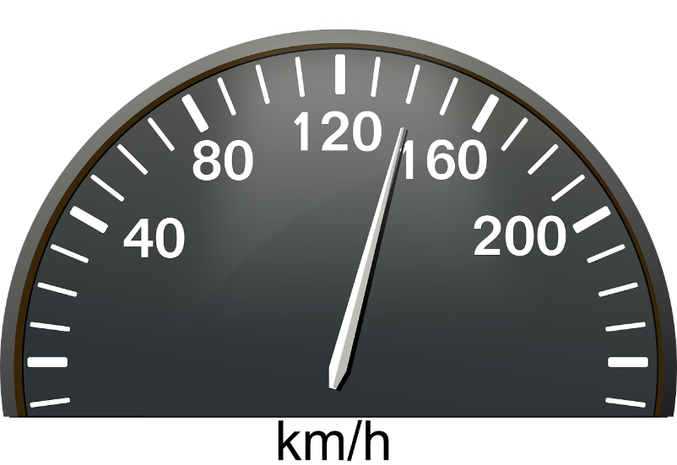

Practice: Reading Gauges
In each case, which lettered point marks the target number?
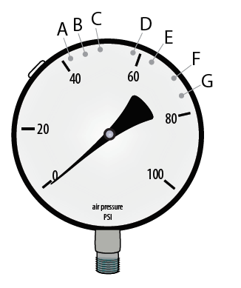
- Air pressure is measured in pounds per square inch (psi). A mountain bike calls for 46 psi. Circle the letter for that point on the tire pressure gauge.

Explain your reasoning.

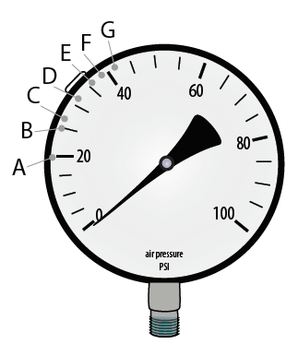

- When Ray checked his tires, the gauge showed a pressure of 27 psi. Circle the letter for that point on the tire pressure gauge.

Explain your reasoning.

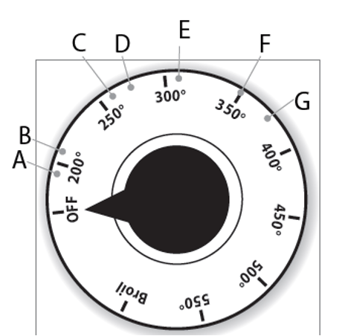
- The cooking directions stated that the oven needs to be pre-heated to 275 degrees. Circle the letter for that point on the oven thermometer.

Explain your reasoning.

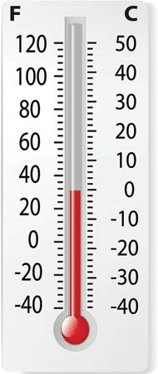
- What is the temperature shown on this gauge in Fahrenheit degrees? What is the temperature in Celsius degrees?

Explain your reasoning.

Source: EMPower™ Plus book Everyday Number Sense: Mental Math and Visual Models

Digital Read-out
What is the difference between analog and digital?
- On an analog clock, the hands point to a position to show time.
- A digital clock describes the time with digits, or numbers.

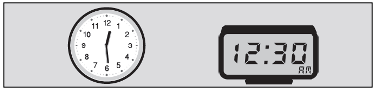

- Digital Read-out: __________
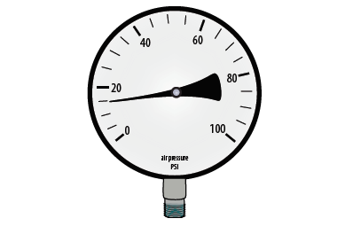
- Digital Read-out: __________

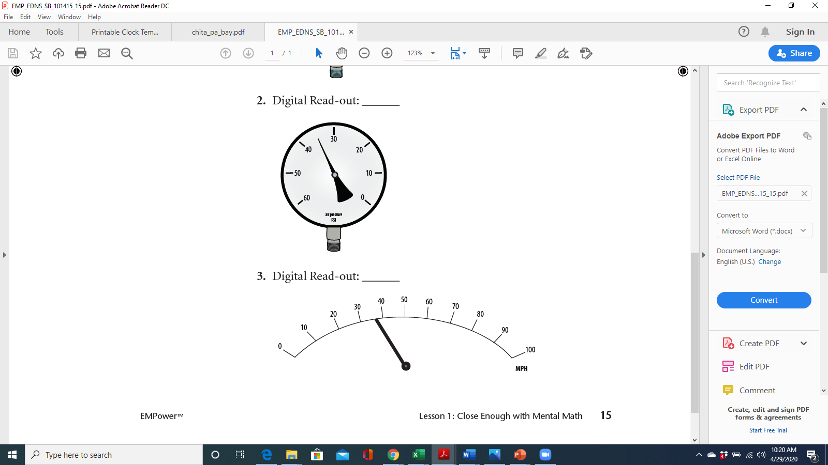

- Digital Read-out: __________

Source: EMPower™ Plus book Everyday Number Sense: Mental Math and Visual Models

Which One Doesn’t Belong? 4

Choose one number in this picture that you don’t think belongs with the rest. Explain why.

1 | 5
45 | 150

Now pick another number and explain why it doesn’t belong.

Pyramid Puzzle 4
Each number in the Pyramid is the sum of the two numbers below it. Fill in the missing numbers in the Pyramid. Numbers may repeat.
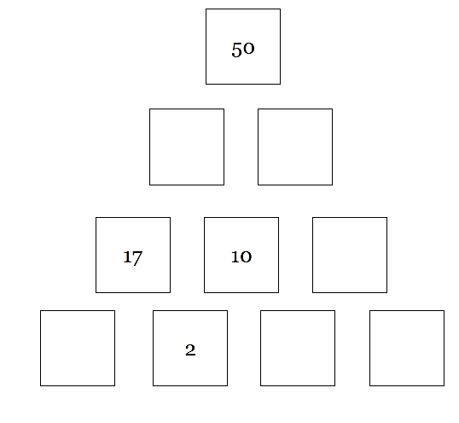

Created by Math for Love. More available at mathforlove.com

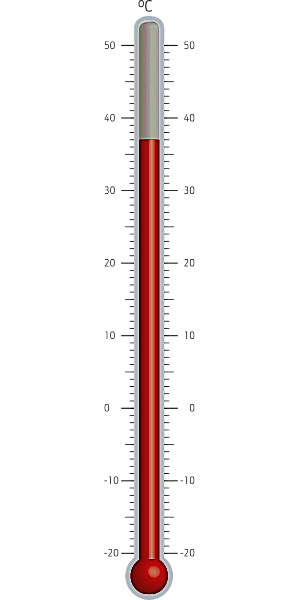
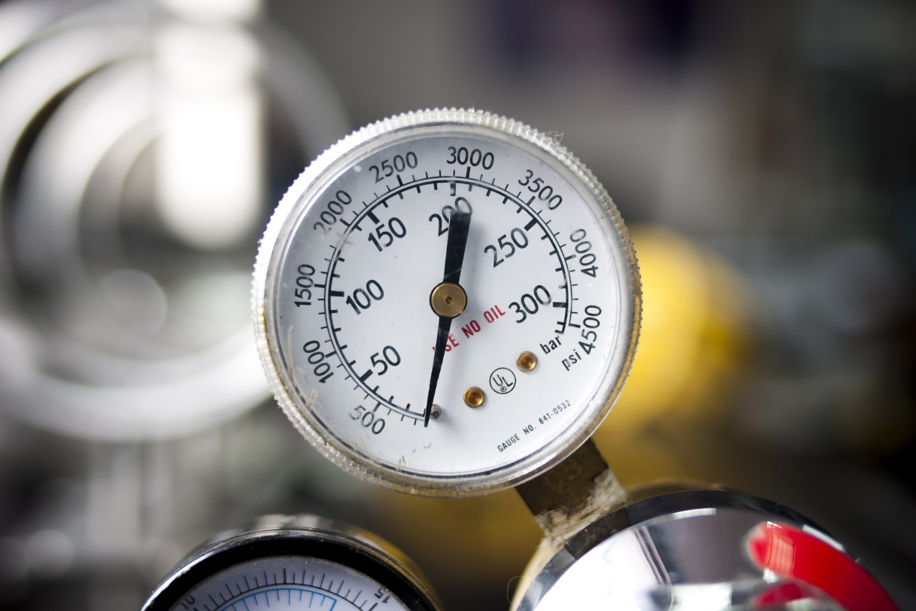
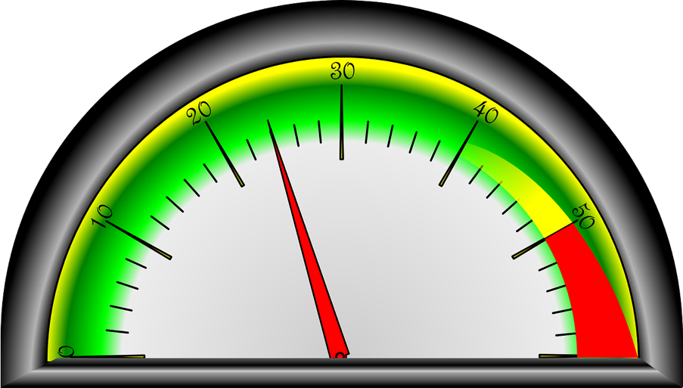
Gauge Puzzles

UNIT 5: Equations

These are equations.

12 + 3 = 15 1 = 20 – 19

10 + 5 = 6 + 9 0 + 3 + 1 = 2 + 2 – 0

What do they have in common?

What is different? Do any of them surprise you?

Vocabulary List for This Unit
Word | Definition | Example
expression | a mathematical ____________. It can contain numbers, variables, and operations (addition, subtraction, multiplication, division), but there is no _____________. | 2 + 5  4 Î 20  6  1 + 3 + 20 + 4 – 5
equation | a mathematical ____________. It contains an “=” symbol between two expressions that have the same ___________. | 2 + 5 = 7  9 = 1 + 8  2 + 8 = 5 + 5
operation | something you can do to a number or numbers | Add +  Subtract –  Multiply Î  Divide ÷
Word | Definition | Example

What Is an Equation?
An equation is a math sentence. It says that both sides of the equal sign have the same value.

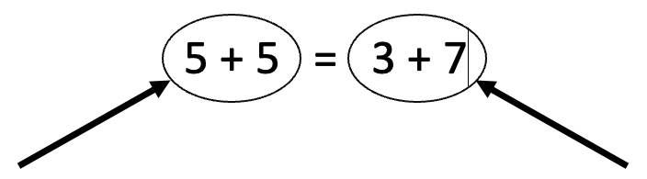
This has a value of 10. This has a value of 10.

Equations can look like this, with a single number on one side:

10 + 5 = 15 15 = 8 + 7

or like this, with operations on both sides:

5 + 10 = 8 + 7 2 + 5 = 9 – 2

All of these are true equations, since both sides of the equals sign have the same value.

Make It True
Add addition signs and an equal sign to make an equation that is true for each set of numbers below.

Example: 5 + 4 = 2 + 1 + 6

- 12 3 6 1 10 10
- 28 19 3 24 20
- 2 19 8 3 24 2
- 35 3 19 12 0 7
- 32 16 8 4 2 1 1

Source: EMPower™ book Everyday Number Sense: Mental Math and Visual Models

Check Both Sides of the Equal Sign

9 + 7 = 10 + 6
12 + 7 = 10 + 9
6 + 18 = 4 + 20
35 + 97 = 32 + 100
297 + 438 = 300 + 435

What’s going on in these equations?

Write another equation that follows this pattern.

Source: EMPower™ book Everyday Number Sense: Mental Math and Visual Models

Fast Actions with 10 or 100

When you add ten, pay attention to the tens place.
489 + 10 = 499

When you add 100, pay attention to the hundreds place.
489 + 100 = 589

- If you add $100 to $568, you get __________.
- If you add $10 to $283, you get ___________.
- If you add $100 to $283, you get __________.
- If you add $10 to $650, you get ___________.
- If you add $100 to $650, you get __________.
- If you add $10 to $396, you get ___________.
- If you add $100 to $396, you get __________.
- If you add $10 to $969, you get ___________.

Source: EMPower™ book Everyday Number Sense: Mental Math and Visual Models

Fast Actions with 9 or 90
Fill in the missing numbers. Look for a pattern.

1. a. 65 + 10 = _______ b. 65 + 9 = _______
2. a. 137 + 10 = _______ b. 137 + 9 = _______
3. a. 89 + 10 = _______ b. 89 + 9 = _______
4. a. 406 + 10 = _______ b. 406 + 9 = _______
5. a. 665 + 10 = _______ b. 665 + 9 = _______
6. a. 198 + 10 = _______ b. 198 + 9 = _______
What is a fast way to add 9 to any amount with mental math?

7. a. 650 + 100 = _______ b. 65 + 90 = _______
8. a. 437 + 100 = _______ b. 437 + 90 = _______
9. a. 809 + 100 = _______ b. 809 + 90 = _______
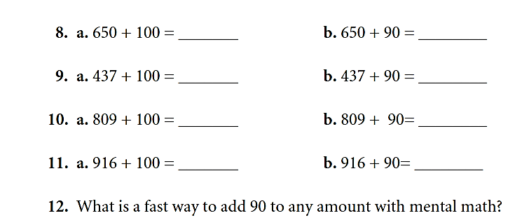
10. a. 916 + 100 = _______ b. 916 + 90 = _______
What is a fast way to add 90 to any amount with mental math?

Source: EMPower™ book Everyday Number Sense: Mental Math and Visual Models

Which One Doesn’t Belong? 5
Choose one equation in this picture that you don’t think belongs with the rest. Explain why.

5 + 10 = 15 | 15 = 10 + 5
7 + 8 = 10 + 5 | 15 = 15

Now pick another equation and explain why it doesn’t belong.

Make It Equal

Directions: Using the digits 1 to 9 at most one time each, place a digit in each box to create a true statement.
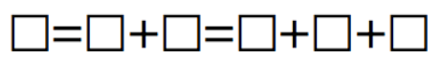

Source: https://www.openmiddle.com/ - Molly Rawding
Open Middle© problems are licensed under a Creative Commons Attribution-NonCommerical-ShareAlike 4.0 International License

Adding Two-Digit Numbers Given One

Directions: Using the digits 0 to 9 at most one time each, fill in the boxes to make a true equation.
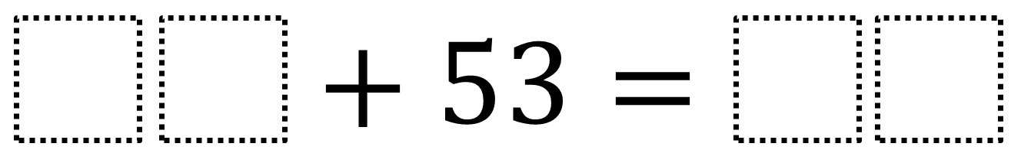

Source: https://www.openmiddle.com/ - Robert Kaplinsky
Open Middle© problems are licensed under a Creative Commons Attribution-NonCommerical-ShareAlike 4.0 International License

Number Line Puzzles 5
Fill in the missing numbers.

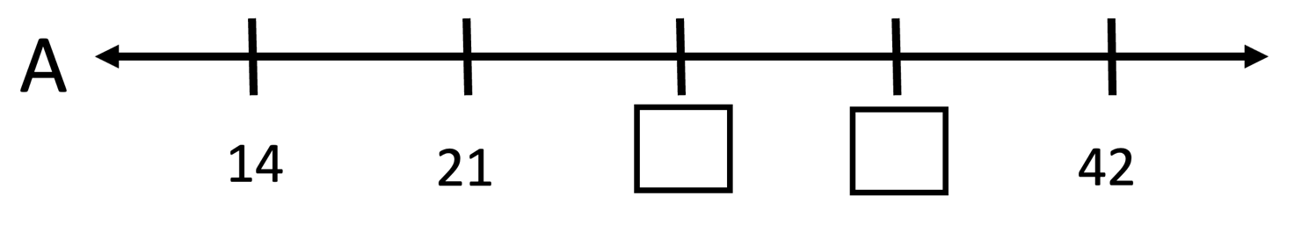

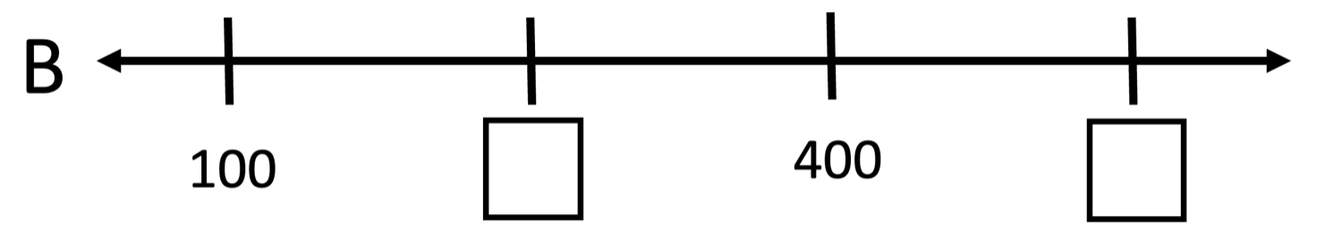

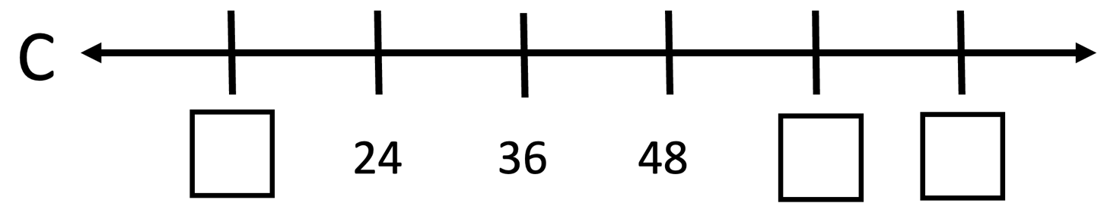

Create your own number line puzzle below.

Test Practice
- At his clothing stall in the flea market, Bhuvan sold a suit for $4.95, a sweater for $3.95, and a winter coat for $14.95. Which of the following is closest to the total amount of his sales?
- $20
- $25
- $30
- $35
- $40

- Mariana sells used furniture at a flea market. She sold a desk for $19, two chairs for $7 each, and a table for $18. Which of the following is closest to the total amount of her sales?
- $30
- $35
- $40
- $45
- $50

- Alma borrowed money for lunch from her brother every day last week. He loaned her $7.55 on Monday, $5.40 on Tuesday, $6.75 on Wednesday, $4.25 on Thursday, and $6.50 on Friday. About how much money did Alma borrow from her brother?
- $28
- $31
- $33
- $34
- $36

- Wade bought a used bike for $26. When he got it home, he realized it was too small for him. He found someone to buy it from him for $15. Wade did which of the following from buying and selling the bike?
- Lost about $10
- Gained about $10
- Lost about $15
- Gained about $15
- None of the above.

Source: EMPower™ book Everyday Number Sense: Mental Math and Visual Models

Blank Number Lines
