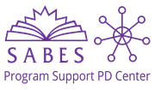

Continuous Improvement Planning

Session 2: Leading with Data for Continuous Improvement
Handouts

Table of Contents
Handout 1 | Session Overview 1
Handout 2 | Warm-Up Activity 2
Handout 3 | Reflecting on Data 4
Handout 4 | Defining Performance and Accountability 5
Handout 5 | ACLS Accountability Resources 6
Handout 6 | LACES Reports 7
Handout 7 | The ATLAS Looking at Data Protocol 11
Handout 8 | Sources of Data by IPQ 26
Handout 9 | References 33

Handout 1 | Session Overview

Session Goal
Program teams evaluate the strengths and limitations of multiple qualitative and quantitative data sources in order to select appropriate resources that are relevant to individual program improvement needs and goals.

Learning Objectives
- Identify at least three types of relevant, appropriate data to inform continuous improvement planning.
- Evaluate the quality and context of data, including data bias.
- Name at least two core accountability partners and two ways that programs are accountable to each.
- Reflect on performance data, make hypotheses, draw conclusions, and identify problems of practice that could be addressed in a continuous improvement plan.

Pre-Work
- Complete Steps 1-4 of the Preparing to Plan Questionnaire or make a plan to do so
- Begin to assemble your planning team
- Find 3 data elements to bring to the next session, including one from LACES/Desk Review and one not from LACES/Desk Review
- Check in with an accountability partner to ask about progress on the homework
Homework
- Continue to assemble your planning team (Steps 5 and 6 of the Pre-Planning Questionnaire).
- Begin to discuss 1-3 IPQs that you might want to focus on.
- Collect data to your IPQ(s) and make a plan to use the ATLAS protocol with your planning team to narrow your focus and choose specific goals.
- Check in with your accountability partner.

Handout 2 | Warm-Up Activity: Do Countries that Spend More on Education Have Better Outcomes?

Review the charts with your group and identify:
- One thing you see in the data
- One possible interpretation of what you see
- One factor that is not named but might be influencing the data

Chart 1 | Correlation between education outcomes and education expenditure
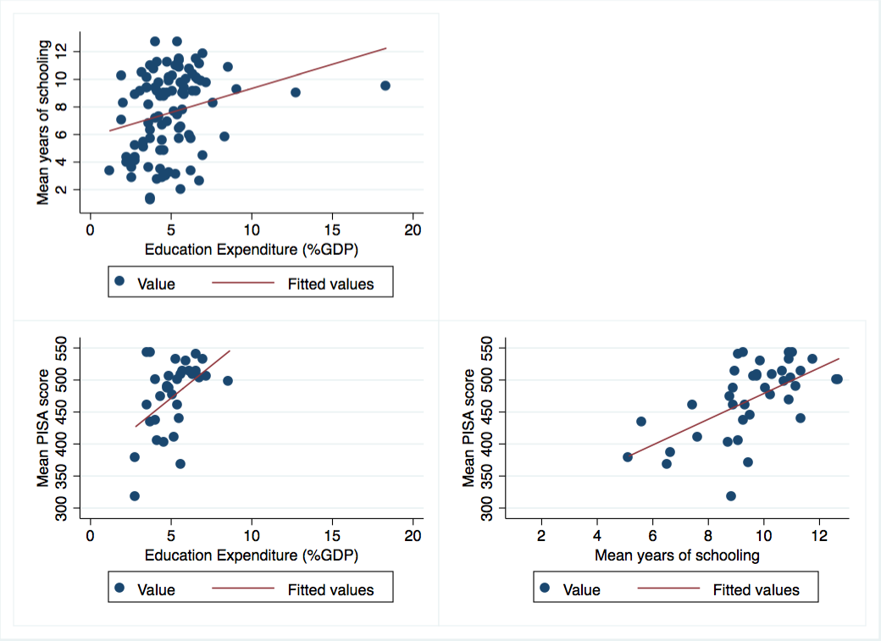

Chart 2 | Average reading performance in PISA and average spending
per student (ages 6-15)

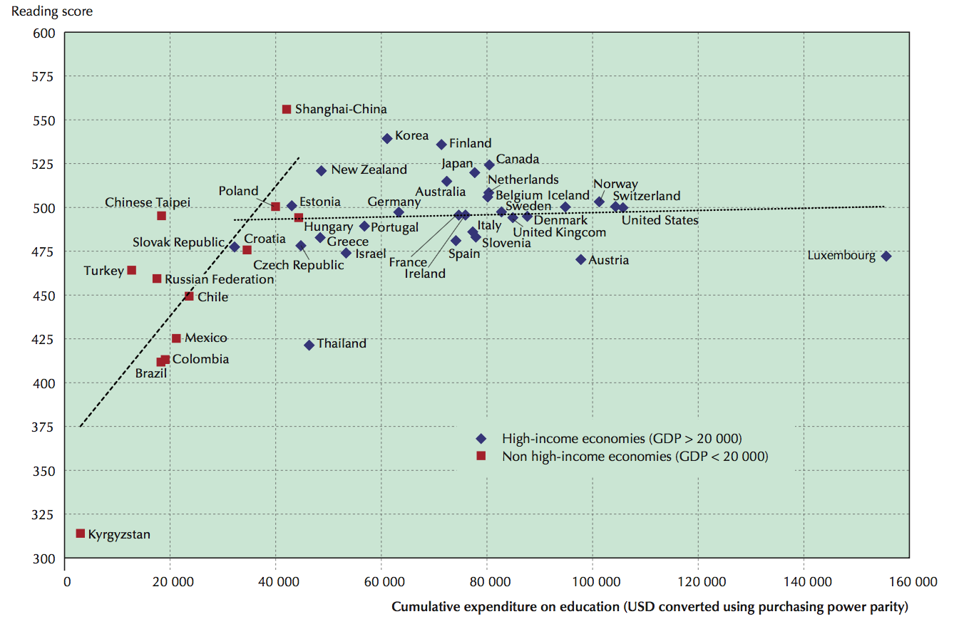

Data Source: Max Roser and Esteban Ortiz-Ospina (2016). “Education Spending.” OurWorldInData.org https://ourworldindata.org/financing-education

Handout 3 | Reflecting on Data

Reflect on the data you brought with you today.
What predictions and assumptions do you have about the data you’ve brought?
How might those predictions or assumptions be informed by bias?
What biases might be reflected in the data?

Handout 4 | Defining Performance and Accountability

With your group, create shared definitions:
performance
accountability

Handout 5 | ACLS Accountability Resources
Use these resources to learn about accountability and ACLS.

Overview of ACLS Accountability Tools

Student Outcomes | Program Quality | Compliance
Desk Reviews
Measurable Skill Gains (MSG) Reports |  | Grant Approval Process
 | Program Quality Reviews (PQRs) | Data Quality Checklist
 | Site Visits | Risk Analysis

ACLS Core Components of Accountability
- Enrollment: The average monthly enrollment relative to the program’s targets.
- Student Outcomes: Also known as measurable skills gain or MSG---specific to ABE and ESOL learners and important for AE programs because they can be reported without Social Security numbers.
- Program Quality: The ACLS Indicators of Program Quality represent ACLS’ best thinking at this time of what high quality programming entails so programs are held to these standards of quality. Evaluated through Program Quality Reviews (PQRs), once per funding cycle for each program. Annual PQR Summative Reports provide a state snapshot of strengths, challenges, and promising practices.
- Compliance: A third component of the accountability system is compliance, which measures the extent to which local programs operate in accordance with federal and state programmatic, financial, and reporting requirements and deadlines. These requirements are outlined in the FY24 – FY28 Massachusetts Policies for Effective Adult Education in Community Adult Learning Centers and Correctional Institutions.

Additional Accountability Resources
- Finding Your FY24 MSG Target
- LACES Resources & Trainings from the SABES Program Support PD Center
- Desk Review Resources
- ACLS Annual PQR Summative Reviews
- GEM$ Resources
- FY24-FY28 Massachusetts Policies for Effective Adult Education

Handout 6 | LACES Reports
Link to dashboard reports

Desk Review Reports
- In the student tab, select Searches > Desk Review > and then one of the five dropdown reports

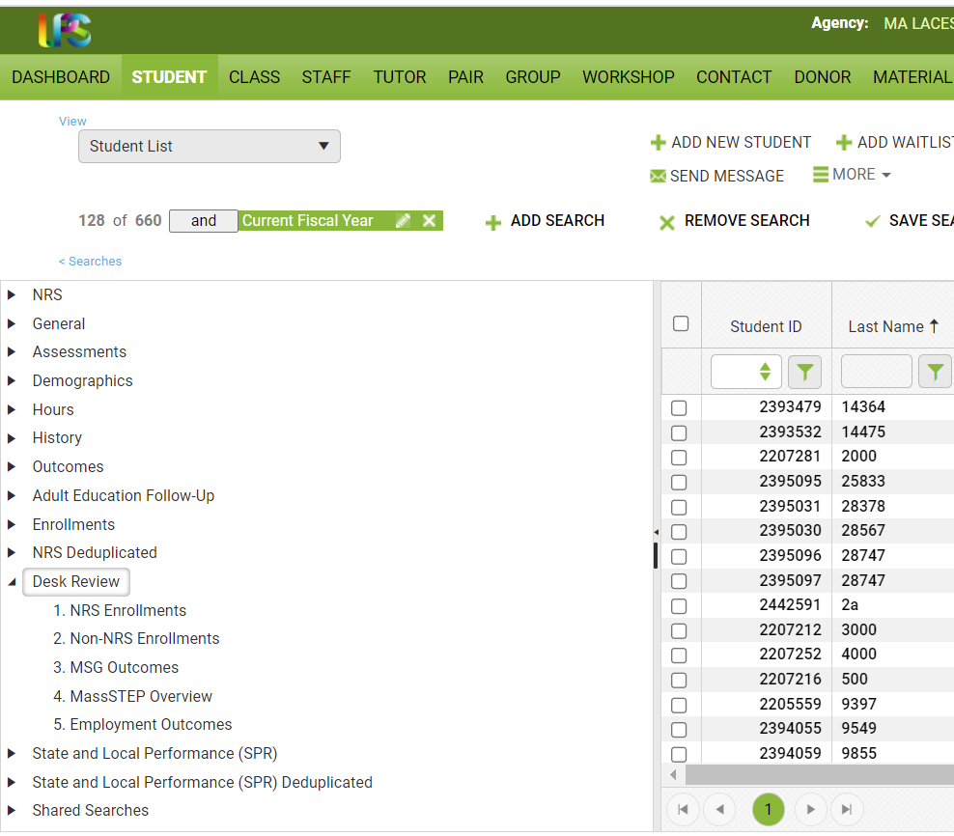

NRS Reports
- Go to student screen
- Click on “Searches” (beneath Student List)
- Click on NRS
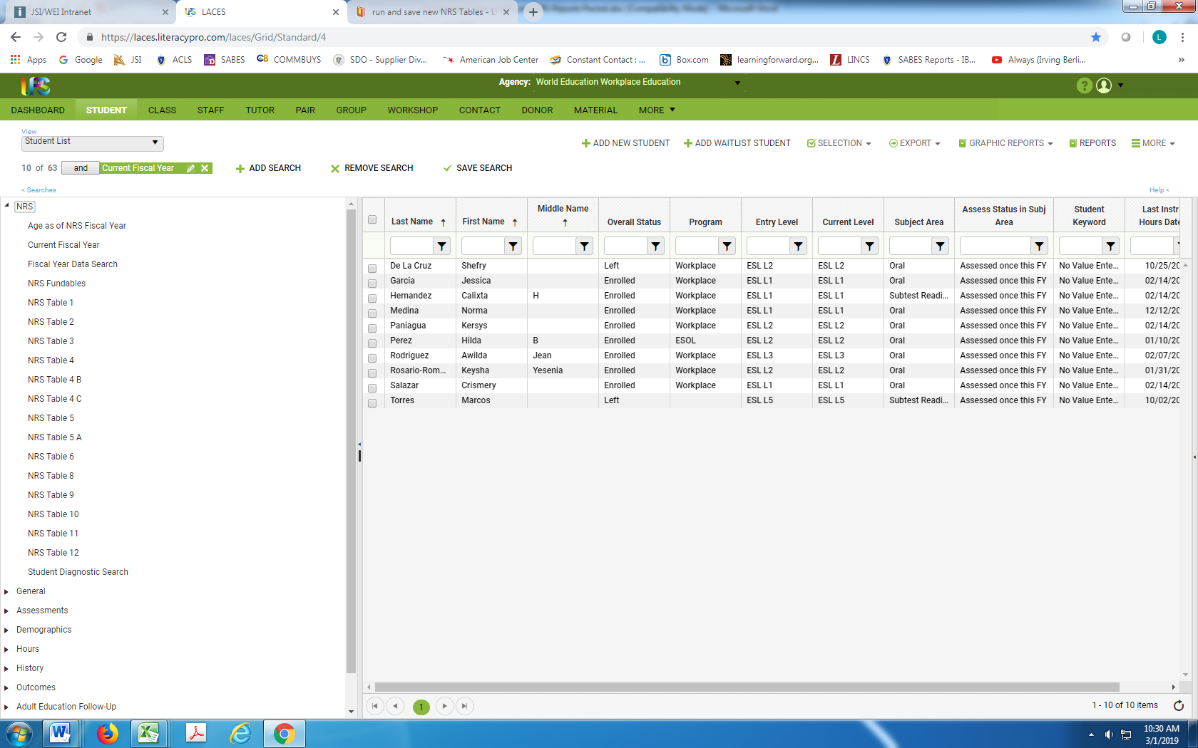

Additional Resources
- For more information, see NRS Reporting Tables
- Massachusetts state summary
- Massachusetts NRS Statewide Tables

Student Alerts

Dashboard > Widget Library > Student Alerts
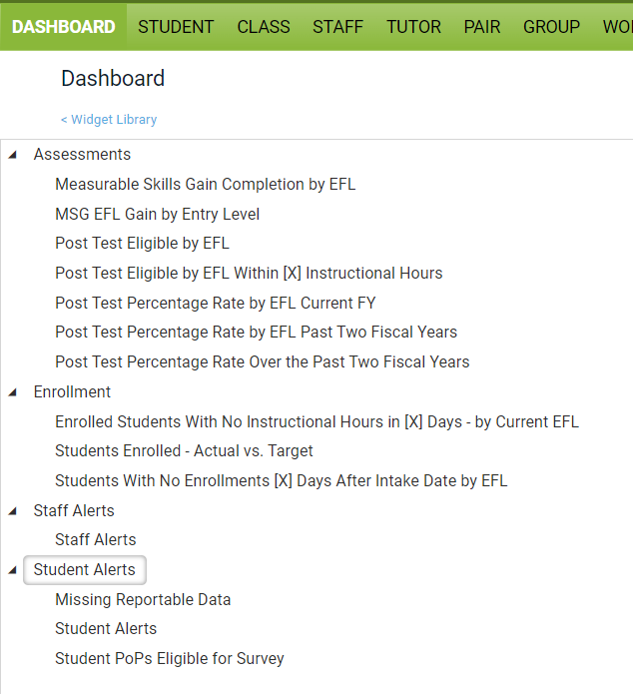

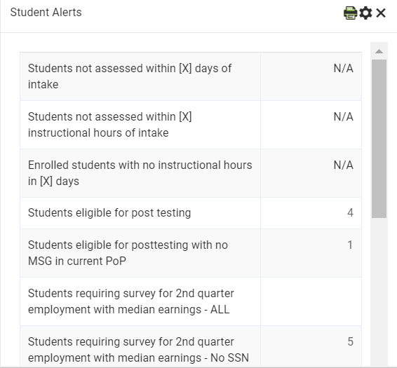

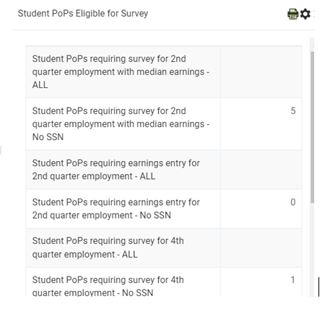

Automatically Generated Reports
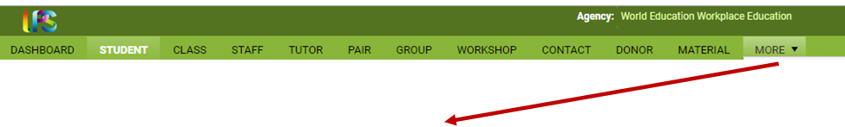
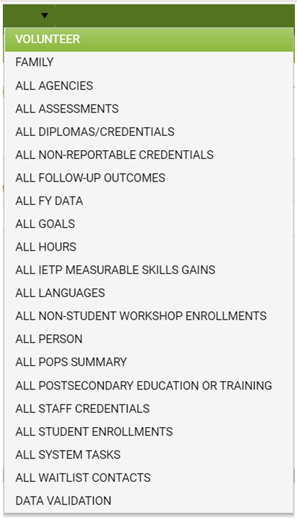

Handout 7 | The ATLAS Looking at Data Protocol
Adapted from the Center for Leadership & Educational Equity (formerly the School Reform Initiative)

Purpose: This protocol is for use in guiding a group through analysis of data to identify strengths and problems of practice.
Total time for protocol: 45-60 minutes
Materials: copies of data for team members, highlighters, chart paper, markers

Getting Started | Roles & Overview
3 minutes
- Choose a facilitator, note taker, time keeper, and reporter to the larger group
- Give a very brief description of the data and answer any clarifying questions.

Facilitator:
Note Taker:
Time Keeper:
Reporter:

Step 1 | Reflect
5 minutes: 3 minutes silently writing and 3 minutes discussing as a group
What question are you trying to answer by looking at the data? What predictions or assumptions do you have about the data? How might those predictions or assumptions be informed by implicit bias?
Purpose: Identify assumptions and biases that might inform our understanding and analysis of data.
Notes:

Step 2 | Just the Facts
8 minutes: 2 minutes silently writing individual observations, 6 minutes discussing as a group
What parts of the data catch your attention? Describe observations without making inferences. If inferences come up, record them elsewhere and save them for Step 2.
Purpose: Gather evidence to analyze later in the conversation.
Notes:

Step 3 | Drawing Conclusions
10 minutes: 3 minutes silently writing, 7 minutes discussing as a group
What does the data tell us? What does the data not tell us? What assumptions do we make about students and their learning? What context do we need to consider?
Purpose: Make sense of what the data says and why. Find as many interpretations as possible and evaluate them against the kind and quality of evidence. Facilitator: encourage team members to support their statements with evidence from the data.
Notes:

Step 4 | Good News
5 minutes discussing as a group
What positive data can you see? What is there to celebrate?
Purpose: Identify and celebrate strengths.
Notes:

Step 5 | Identifying Problems of Practice
10 minutes: 3 minutes silently writing, 7 minutes discussing as a group
What problems of practice might be suggested by the data?
Purpose: Interpret the data and make connections to practice.
Notes:

Step 6 | Summarizing & Moving to Action
5 minutes
What are our key conclusions? What recommendations could we make for addressing the problem of practice? What context do we need to communicate about our data?
Purpose: Ideally, this step moves us towards action as we make recommendations and an action plan. For the purpose of this activity, the purpose of Step 5 is to begin to shift towards action. Consider what additional information may be needed and who else should be involved in understanding the data and making recommendations.
Notes:

Additional Data Protocols
Relay Data Protocol, from the Relay Graduate School of Education

Data for Protocol
from MA Measurable Skill Gains

 | ABE Services |  |  |  |  |  |  |  |  | ESOL Services
Program | Stud-ents | ABE NRS Excl-uded | EFL Completers | HSE | PSET | Post- test Rate | MSG Target | MSG % | % of Target Met | Stu-dents | ESOL NRS Excl-uded | EFL Complet-ers | HSE | PSET | Post- test Rate | MSG Target | MSG % | % of Target Met
Action For Boston Community Development |  |  |  |  |  |  |  |  |  | 182 | 0 | 69 | 0 | 1 | 58% | 59% | 41% | 69%
Ascentria Community Services |  |  |  |  |  |  |  |  |  | 265 | 0 | 67 | 0 | 1 | 39% | 59% | 27% | 46%
Asian American Civic Association |  |  |  |  |  |  |  |  |  | 212 | 0 | 59 | 1 | 8 | 66% | 51% | 31% | 61%
Asian American Civic Association-Workplace Education |  |  |  |  |  |  |  |  |  | 8 | 0 | 4 | 0 | 0 | 75% | 61% | 61% | 100%
Berkshire Community College - South County |  |  |  |  |  |  |  |  |  | 142 | 0 | 82 | 0 | 1 | 86% | 57% | 62% | 108%
Berkshire County Sheriff's Office | 64 | 0 | 3 | 2 | 1 | 17% | 40% | 9% | 24%
Blue Hills Regional Technical School | 63 | 0 | 7 | 4 | 1 | 48% | 40% | 19% | 48% | 105 | 1 | 49 | 0 | 0 | 76% | 54% | 49% | 90%
Boston Chinatown Neighborhood Center - Quincy |  |  |  |  |  |  |  |  |  | 191 | 0 | 82 | 1 | 2 | 80% | 54% | 45% | 84%
Boston Public Schools | 266 | 0 | 49 | 83 | 3 | 56% | 39% | 47% | 120% | 249 | 0 | 104 | 0 | 1 | 67% | 58% | 45% | 77%
Bristol Community College | 359 | 0 | 74 | 51 | 17 | 51% | 39% | 34% | 86% | 312 | 0 | 92 | 0 | 0 | 52% | 54% | 31% | 58%
Bristol County Sheriff's Office | 238 | 0 | 33 | 5 | 1 | 33% | 38% | 16% | 42%
Brockton Public Schools | 133 | 0 | 35 | 11 | 1 | 64% | 38% | 35% | 91% | 871 | 0 | 421 | 0 | 14 | 74% | 59% | 53% | 90%
Bunker Hill Community College - Boston |  |  |  |  |  |  |  |  |  | 201 | 0 | 77 | 0 | 1 | 86% | 53% | 41% | 77%
Bunker Hill Community College - Metro North | 93 | 0 | 19 | 8 | 0 | 33% | 39% | 27% | 70% | 351 | 0 | 111 | 16 | 0 | 80% | 56% | 37% | 66%
Cambridge Community Learning Center | 115 | 0 | 17 | 5 | 18 | 81% | 39% | 34% | 86% | 563 | 0 | 271 | 0 | 2 | 78% | 55% | 51% | 93%
Cape Cod Community College | 96 | 0 | 21 | 31 | 5 | 49% | 39% | 53% | 136% | 233 | 4 | 94 | 0 | 3 | 74% | 55% | 45% | 82%
CCAB, Inc d/b/a Laboure Center Adult Education Program |  |  |  |  |  |  |  |  |  | 307 | 0 | 187 | 0 | 2 | 74% | 59% | 65% | 109%
CCAB, Inc. d/b/a El Centro | 15 | 0 | 6 | 0 | 0 | 80% | 40% | 40% | 100% | 322 | 0 | 201 | 0 | 41 | 70% | 56% | 69% | 123%
CCAB, Inc. d/b/a Catholic Charities South |  |  |  |  |  |  |  |  |  | 149 | 0 | 95 | 0 | 1 | 81% | 56% | 70% | 124%
CCAB, Inc. d/b/a Haitian Multi-Service Center | 61 | 0 | 7 | 3 | 0 | 53% | 40% | 17% | 42% | 205 | 0 | 81 | 0 | 1 | 55% | 60% | 42% | 70%
Center for New Americans |  |  |  |  |  |  |  |  |  | 281 | 0 | 117 | 0 | 2 | 60% | 57% | 46% | 80%
Charlestown Community Center | 89 | 0 | 2 | 20 | 3 | 5% | 39% | 25% | 64% | 50 | 0 | 10 | 0 | 0 | 24% | 58% | 20% | 35%
Chelsea Public Schools |  |  |  |  |  |  |  |  |  | 323 | 0 | 104 | 5 | 2 | 61% | 58% | 36% | 62%
Clinton Public Schools | 31 | 0 | 5 | 4 | 1 | 34% | 39% | 27% | 69% | 201 | 0 | 94 | 0 | 0 | 72% | 58% | 49% | 84%
Community Action, Inc. | 70 | 0 | 22 | 8 | 2 | 66% | 39% | 43% | 110% | 80 | 0 | 30 | 0 | 1 | 66% | 59% | 43% | 73%
East Boston Harborside Community Center | 61 | 0 | 24 | 1 | 0 | 68% | 38% | 40% | 105% | 350 | 0 | 212 | 0 | 0 | 93% | 59% | 65% | 111%
Framingham Public Schools | 110 | 0 | 16 | 0 | 0 | 69% | 39% | 15% | 37% | 971 | 0 | 465 | 0 | 1 | 88% | 56% | 51% | 91%
Franklin County House of Correction | 61 | 0 | 0 | 5 | 4 | 0% | 41% | 15% | 36%
Hampden County Sheriff's Office | 278 | 0 | 44 | 2 | 0 | 35% | 39% | 17% | 44%
Hampshire Sheriff's Office | 104 | 0 | 12 | 14 | 8 | 44% | 41% | 28% | 68%
Holyoke Community College | 149 | 0 | 21 | 20 | 3 | 46% | 39% | 28% | 71% | 367 | 0 | 187 | 0 | 8 | 79% | 56% | 57% | 101%
Hudson Public Schools | 35 | 0 | 9 | 6 | 0 | 67% | 39% | 35% | 90% | 297 | 0 | 133 | 0 | 0 | 61% | 59% | 47% | 80%
International Institute of Greater Lawrence |  |  |  |  |  |  |  |  |  | 343 | 0 | 251 | 0 | 0 | 91% | 59% | 76% | 129%
International Institute of New England |  |  |  |  |  |  |  |  |  | 407 | 0 | 130 | 0 | 2 | 44% | 57% | 35% | 62%
International Language Institute of Massachusetts |  |  |  |  |  |  |  |  |  | 117 | 2 | 62 | 0 | 1 | 79% | 54% | 56% | 104%
Jackson Mann Community School & Council, Inc. |  |  |  |  |  |  |  |  |  | 195 | 0 | 79 | 0 | 0 | 56% | 57% | 42% | 74%
Jamaica Plain Community Centers | 13 | 0 | 2 | 1 | 0 | 92% | 38% | 24% | 63% | 190 | 0 | 61 | 0 | 0 | 46% | 58% | 35% | 60%
Jewish Vocational Service, Inc. | 69 | 0 | 3 | 37 | 0 | 35% | 39% | 54% | 139% | 129 | 0 | 75 | 0 | 0 | 79% | 58% | 62% | 107%
Julie's Family Learning Program, Inc. | 148 | 0 | 31 | 6 | 1 | 47% | 40% | 26% | 66%
Lawrence Public Schools Adult Learning Center | 105 | 0 | 23 | 25 | 6 | 55% | 39% | 41% | 105% | 711 | 0 | 395 | 9 | 4 | 74% | 56% | 59% | 106%
Lowell Public Schools | 253 | 0 | 50 | 35 | 3 | 53% | 39% | 32% | 82% | 873 | 0 | 405 | 0 | 6 | 72% | 58% | 50% | 86%
Martha's Vineyard Public Schools |  |  |  |  |  |  |  |  |  | 150 | 0 | 78 | 0 | 0 | 79% | 59% | 56% | 95%
Massachusetts College of Liberal Arts | 51 | 0 | 3 | 6 | 3 | 16% | 40% | 20% | 50%
Massachusetts Department Of Correction | 209 | 0 | 52 | 26 | 0 | 62% | 40% | 38% | 94%
Massasoit Community College |  |  |  |  |  |  |  |  |  | 144 | 0 | 46 | 0 | 1 | 70% | 54% | 34% | 64%
MassLINKS | 133 | 0 | 35 | 16 | 2 | 61% | 40% | 37% | 93% | 201 | 0 | 91 | 0 | 0 | 73% | 52% | 48% | 93%
Methuen Public Schools | 35 | 0 | 20 | 5 | 2 | 84% | 39% | 73% | 188% | 136 | 0 | 117 | 0 | 0 | 90% | 54% | 92% | 171%
Middlesex Community College | 153 | 0 | 75 | 23 | 21 | 81% | 38% | 66% | 173%
Mount Wachusett Community College | 165 | 0 | 53 | 22 | 8 | 66% | 40% | 43% | 108% | 211 | 0 | 106 | 1 | 0 | 72% | 56% | 55% | 98%
Mujeres Unidas Avanzando | 2 | 0 | 0 | 0 | 0 | 0% | 41% | 0% | 0% | 205 | 0 | 72 | 10 | 0 | 69% | 58% | 39% | 68%
Mujeres Unidas Avanzando - Workplace Education |  |  |  |  |  |  |  |  |  | 1 | 0 | 1 | 0 | 0 | 100% | 59% | 100% | 169%
New Bedford Public Schools | 126 | 0 | 48 | 8 | 0 | 73% | 39% | 43% | 111% | 318 | 0 | 145 | 0 | 0 | 74% | 59% | 50% | 85%
North Adams Public Schools | 9 | 0 | 4 | 2 | 0 | 75% | 39% | 57% | 145% | 48 | 0 | 12 | 0 | 0 | 35% | 59% | 26% | 45%
North Shore Community Action Programs, Inc. |  |  |  |  |  |  |  |  |  | 221 | 0 | 79 | 0 | 0 | 58% | 57% | 39% | 68%
North Shore Community College | 171 | 0 | 38 | 30 | 8 | 67% | 40% | 38% | 96%
Northern Essex Community College | 35 | 0 | 5 | 0 | 0 | 35% | 39% | 15% | 39% | 347 | 0 | 114 | 0 | 6 | 66% | 57% | 36% | 64%
Notre Dame Education Center - Lawrence |  |  |  |  |  |  |  |  |  | 320 | 0 | 147 | 0 | 1 | 73% | 58% | 48% | 82%
Pathways Inc. Adult Education and Training | 97 | 0 | 34 | 19 | 0 | 60% | 38% | 50% | 131% | 203 | 0 | 113 | 0 | 2 | 78% | 57% | 6% | 105%
Pittsfield Public Schools | 115 | 0 | 14 | 37 | 0 | 43% | 42% | 41% | 97% | 72 | 0 | 33 | 3 | 1 | 65% | 59% | 54% | 92%
Plymouth Public Library | 101 | 0 | 31 | 19 | 2 | 65% | 40% | 49% | 123%
Project Hope Boston, Inc. |  |  |  |  |  |  |  |  |  | 84 | 0 | 20 | 0 | 0 | 40% | 58% | 26% | 46%
Quincy College | 24 | 0 | 2 | 5 | 1 | 22% | 41% | 30% | 73% | 87 | 0 | 30 | 0 | 0 | 55% | 52% | 36% | 69%
Quincy Community Action Programs, Inc. | 29 | 0 | 4 | 3 | 0 | 38% | 39% | 24% | 62% | 159 | 0 | 65 | 0 | 0 | 69% | 55% | 43% | 78%
Quinsigamond Community College | 140 | 0 | 15 | 28 | 5 | 39% | 40% | 30% | 74% | 550 | 0 | 273 | 1 | 5 | 77% | 55% | 54% | 97%
Randolph Community Partnership, Inc. | 32 | 0 | 4 | 3 | 0 | 29% | 39% | 22% | 56% | 76 | 0 | 26 | 0 | 0 | 64% | 55% | 35% | 64%
Rockland Regional Adult Learning Center | 24 | 0 | 5 | 3 | 0 | 76% | 41% | 26% | 64% | 61 | 0 | 8 | 0 | 0 | 36% | 60% | 15% | 25%
Somerville Public Schools (SCALE) | 128 | 0 | 25 | 16 | 3 | 61% | 40% | 30% | 74% | 209 | 0 | 58 | 1 | 0 | 63% | 56% | 30% | 53%
Southeastern Massachusetts SER-Jobs for Progress, Inc. |  |  |  |  |  |  |  |  |  | 280 | 0 | 117 | 0 | 0 | 65% | 58% | 45% | 77%
Springfield Technical Community College | 228 | 0 | 26 | 22 | 5 | 31% | 39% | 21% | 53% | 224 | 0 | 132 | 0 | 2 | 88% | 54% | 65% | 120%
Suffolk County Sheriff's Dept. | 125 | 0 | 14 | 17 | 1 | 26% | 41% | 21% | 52%
The Immigrant Learning Center |  |  |  |  |  |  |  |  |  | 376 | 0 | 159 | 0 | 1 | 59% | 57% | 45% | 79%
The Literacy Project | 207 | 0 | 29 | 34 | 5 | 29% | 40% | 31% | 78%
Training Resources of America, Inc. - Brockton | 26 | 0 | 8 | 0 | 0 | 62% | 39% | 33% | 84% | 87 | 0 | 39 | 0 | 0 | 68% | 56% | 50% | 89%
Training Resources of America, Inc. - Quincy | 34 | 0 | 5 | 7 | 0 | 45% | 40% | 30% | 75% | 55 | 0 | 13 | 0 | 0 | 40% | 59% | 25% | 42%
Training Resources of America, Inc. - Worcester | 25 | 0 | 2 | 3 | 0 | 40% | 39% | 20% | 51% | 68 | 0 | 6 | 0 | 0 | 24% | 59% | 10% | 17%
University of Massachusetts - Dartmouth | 98 | 0 | 29 | 14 | 1 | 66% | 39% | 42% | 110% | 229 | 0 | 117 | 0 | 0 | 84% | 55% | 54% | 98%
Valley Opportunity Council | 79 | 0 | 2 | 7 | 1 | 27% | 40% | 13% | 32% | 149 | 0 | 38 | 0 | 1 | 44% | 56% | 28% | 50%
Webster Public Schools | 81 | 10 | 21 | 10 | 2 | 75% | 40% | 43% | 108% | 73 | 1 | 34 | 0 | 0 | 67% | 58% | 54% | 93%
Worcester County Sheriff's Office | 274 | 0 | 33 | 12 | 0 | 34% | 40% | 15% | 39%
Worcester Public Schools | 158 | 0 | 47 | 27 | 11 | 70% | 39% | 45% | 116% | 292 | 0 | 182 | 0 | 7 | 83% | 55% | 68% | 123%
YMCA of Greater Boston International Learning Center - Boston |  |  |  |  |  |  |  |  |  | 282 | 0 | 149 | 0 | 4 | 83% | 55% | 58% | 105%
YMCA of Greater Boston International Learning Center Woburn |  |  |  |  |  |  |  |  |  | 181 | 0 | 98 | 0 | 2 | 80% | 55% | 58% | 106%

Data for Protocol: FY23 Enrollment
Chart 1 | MA Program Enrollment, FY23
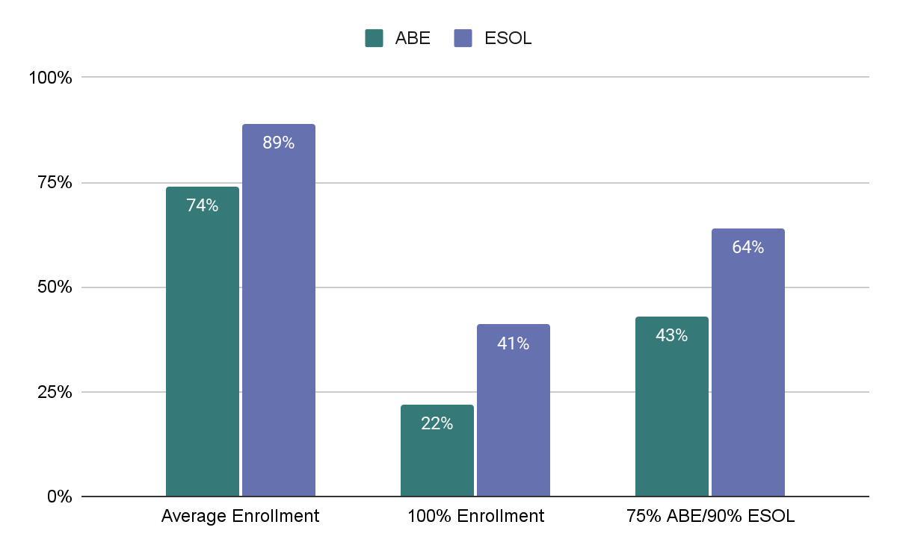
Enrollment Ranges: ABE: 18% - 122% | ESOL: 27% - 185%

Chart 2 | Eligible Adults Enrolled in Adult Education Programs
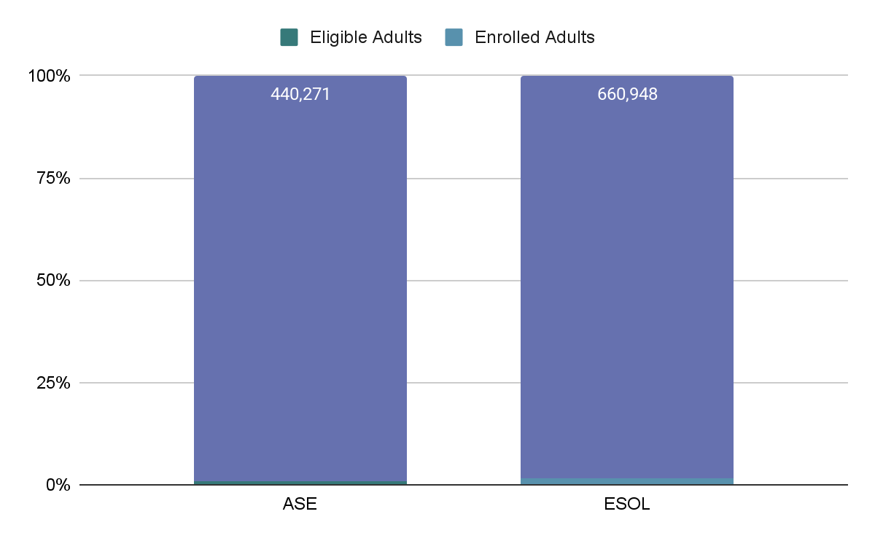

Data for Protocol: FY22 Student Outcomes
Chart 3 | Negotiated vs. Actual Levels of Performance: Massachusetts, FY22
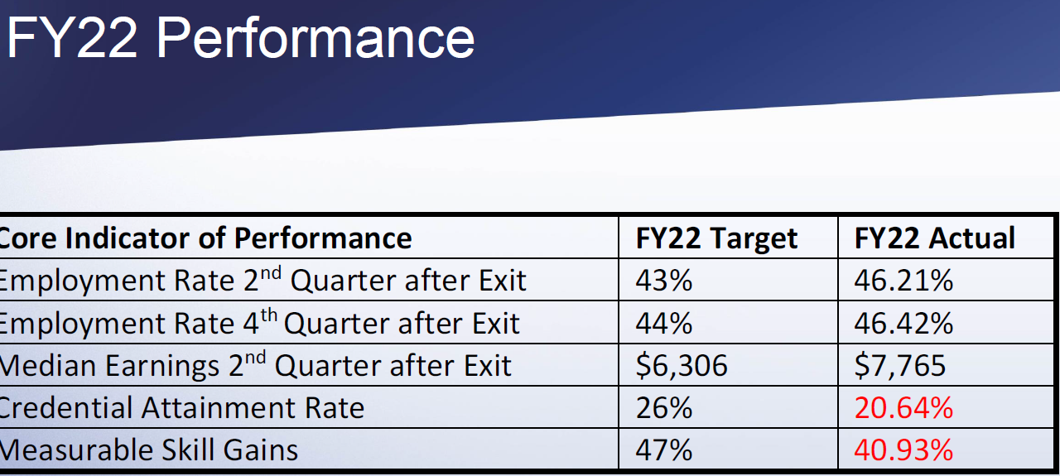

Chart 4 | Posttest Rates, Massachusetts, FY22
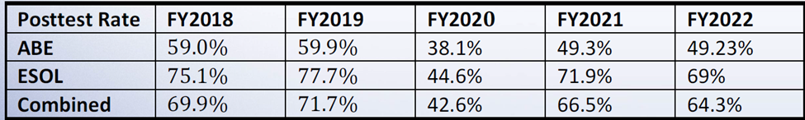

Chart 5 | MSG Achievement Rates by Program Type, FY22
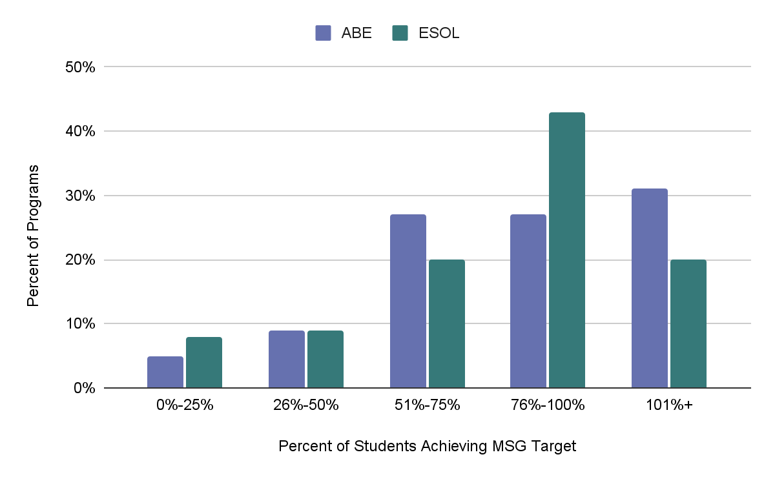

Chart 6 | FY22 MSG Attainment, Calculated Three Ways
Students demonstrating a measurable skill gain, statewide | 40.93%
Percent of MSG target met, statewide average | 81%
Programs meeting MSG target | 25%

Additional Context:
- Students demonstrate MSG when they hit a benchmark, not necessarily when they post a certain gain.
- Program targets are calculated based on past performance.

Handout 8 | Sources of Data by IPQ
IPQ | Types of Data | Data Sources | Qualitative/ Quantitative | Answers questions about…
Indicator 1  Program Design  The program, in alignment with its mission, implements the services approved by ACLS. | - Class focus  - Design options (e.g., in person, distance or hybrid)  - Student barriers to participation  - Class size  - Actual vs. target enrollment  - Outreach efforts and partners  - Wait list | - Desk Reviews  - Class Records (e.g., EFLs, class size, tutor hours and matches, cost per student)  - Staffing charts  - Budgets  - Community Partners for Recruiting and Support | Qualitative and quantitative | - Do our program services align with the proposed design and the purposes for which it was funded?  - Does our program provide adequate supports and options that enable students with barriers to participation to attend?  - Is our program design of adequate intensity to promote student outcomes?
Indicator 2  Equitable Access  Guided by data and a responsibility for diversity, equity and inclusion, the program ensures that all adult learners in the local workforce area have equitable access to high quality educational services. | - Student demographics  - Enrollment  - Class levels  - Dropout rate  - MOAs with partners  - Local employment (and other) needs and assets  - High need regional employment sectors | - Desk Review  - LACES Reports  - Program Records  - Local WDB Plan  - NRS Tables 2, 6  - Accommodations  - Census Equity Data  - Community Resilience Estimates  - Household Pulse Surveys  - Statistical Atlas  - MA Occupational and Industry Projections | Quantitative, can also be qualitative | - Who are the adults in need of classes in our community?  - Among those, who do we serve? Who are we not serving?  - Is our program responsive and accessible to those in the community most in need of services? How do we know?  - How do we address the needs of applicants/learners with diagnosed or self-disclosed learning and other disabilities?
Indicator 3  Career Pathways Collaboration  The program ensures all staff understand the essential role that the program plays to access career pathway opportunities as outlined in the local plan. | - Student goals  - Referrals to and from WIOA partners  - IET participants and Industry Recognized Credentials earned  - Transitions to postsecondary education, training, or employment  - Median income | - Desk Reviews  - Integrated advising curriculum  - Job descriptions and/or staff handbook that describe the process for identifying and sharing student goals across the program  - Formal partnerships with WIOA partners  - WDB Local Plan  - Student goals, advising records, and outcomes  - NRS Table 5a; 9 for workplace programs and 10 for AECI  - Notes and results from meetings with local partner agencies (education, WFD, training, social services) | Qualitative and quantitative | - Are all staff engaged in the process of helping students understand career pathways and options?  - Is our process for advising students on next steps effective?  - Do employers, WIOA partners, and other key community organizations know about our program?  - Do all staff in our program know about relevant community organizations, services, resources, and key employers?  - Are there clear, seamless pathways for students to be referred to WIOA partners and for their clients to be referred to us?  - How do we monitor, capture, and communicate student progress toward meeting their next step goals across the program?
Indicator 4  Curriculum  Curriculum is standards-based, vertically and horizontally aligned in all content areas and levels, contextualized and relevant, and supports the diverse needs of all learners. | - Curriculum aligned to CCRSAE or MA English Language Proficiency Standards (MA ELPS)  - Curriculum that show proficiency indicators within and across levels  - Online/digital tools, resources, and devices  - Curricula/resources that reflect students’ diverse identities/cultures | - Curricula, Lesson Plans  - Digital literacy integrated into instruction  - Examples of accommodations  - Evidence of differentiation in instruction  - Instructional materials and resources that reflect the diversity of learners in the program | Qualitative | - Do we have high expectations for all students at all levels? How do we know?  - Is curriculum aligned to CCRSAE and/or the MA ELPS?  - Do students see themselves reflected in the materials we use in our classes?
Indicator 5  Instruction and Assessment  The program consistently uses high quality instructional strategies to meet all students’ academic needs and prepare them for family sustaining employment and/or postsecondary education, and civic engagement. The program has an assessment system to inform planning and decision-making, monitor and communicate learner progress, and improve teaching and learning. | - Lesson Plans with formative and summative assessments  - Processes and tools for formally and informally assessing learners  - Processes for sharing assessment results with students | - Teacher observations with feedback  - Formative and summative assessments  - Standardized/NRS assessments  - Assessment results  - Formalized process for teachers to analyze and share assessment results with students that informs both teaching and learning | Qualitative and quantitative | - How do curriculum and standards drive instruction?  - How well are our students learning?  - How do assessment results inform and strengthen teaching and learning?  - How can we improve learner gains?  - Is instruction of adequate rigor to help students successfully transition to further education, training, and employment?  - Are students empowered to take control of their own learning?  - Do we celebrate achievement?
IPQ 6  Student Progress  The program consistently meets or exceeds state student performance targets for academic growth, and for postsecondary education, training, and employment. | - Follow-up process for tracking student outcomes  - Student Learning Data: MSG is only one measure, but an important one  - HSE attainment  - Transitions to PSE, training, or employment but also broader than that  - IET/Industry-recognized credentials | - Pre- and post-test %  - % of Social Security numbers collected  - Assessment scores  - Formative and summative assessments  - Teacher checklists of student competencies  - Portfolios  - Desk Review  - NRS Reports 4, 4b, 4c  - Advising records  - Data matching  - Focus groups  - Surveys | Qualitative and quantitative | - Are students’ meeting their purposes for attending AE classes?  - Do we provide the necessary supports to prepare students for next steps?  - What role do our WIOA and other community partners play in creating opportunities for our learners?  - Do we help students persist long enough to meet their goals?  - Is our follow-up process efficient enough?
Indicator 7  Advising and Student Support Services  The program ensures effective and equitable delivery of advising and support services. | - Student demographics  - Student goals and barriers  - Information about community resources  - Student attendance and persistence | - Advising curriculum  - Advising notes  - Student outcomes (see also IPQs 3, 4, and 5)  - MOAs and other partnerships  - Student persistence rates  - Student attendance | Qualitative and quantitative | - What are students’ barriers to learning and next steps?  - What resources/partnerships do we leverage to help students overcome barriers?  - Do all students have access to advising and other supports they need?  - Do students use/take advantage of advising services? If not, why not?
Indicator 8  Organizational Support The organization’s policies, practices, and facilities sufficiently support the adult education program. | - Suitable and safe, classroom space  - Accessibility and safety guidelines  - Minimum staff requirements for level of education, experience, and professional licensure  - New staff onboarding process  - Staff compensation and benefits  - Type of classroom, advising, office, and other space  - Staff longevity  - Staff PD plans  - Meetings with agency leaders  - Devices and technology infrastructure for staff and students | - Accessibility checklist  - Job descriptions with minimum qualifications  - Staff retention vs. turnover rates  - Staff and student handbook policies  - Staff salaries and benefits  - Number of full-time and part-time positions and staff  - Staff credentials and experience  - Number/% of staff with relevant K-12 or ABE licensure  - Classroom, office, advising, and record-keeping space  - Staff PD participation and completion records  - Continuous improvement data and plans | Qualitative and Quantitative | - Are the organizational systems in place compliant and effective?  - Do we have suitable and appropriate space for classes, private advising, offices, and secure record keeping?  - Do all staff meet minimum requirements?  - Does our staff compensation package and other relevant working conditions allow us to attract and retain high quality staff?  - Is space accessible to all current and potential staff and students?  - Do our staff attend PD that supports professional growth and program goals?  - What is the impact of PD learning on classroom and program effectiveness?
Indicator 9  Educational Leadership  Educational leaders guide a continuous improvement planning process that supports high quality practices and a shared vision for student and staff success with the goal of improving student outcomes. | - Staff and student perceptions of quality  - Values, beliefs, and attitudes  - Staff and student feedback  - Program Continuous Improvement Plans (CIP), data, and progress reports  - Staff observation protocols, schedules, and tools  - Mission and Vision Statements  - Support for all staff to engage in high quality professional learning and support for them to implement new learning  - Data-driven professional learning plans based on what students need to know and be able to do  - Transparent and high expectations for all staff and students | - Desk reviews  - Staff observation notes and reflections  - Surveys  - Focus groups  - Program handbooks  - Student Leadership structure and process  - PQR reports  - Site visit summaries  - Data-driven program continuous improvement plans developed through an inclusive process that engages all stakeholders and holds everyone accountable for the programs’ effectiveness  - Plan for creating a an inclusive program culture that is welcoming of diverse staff and students  - PD budget and plans | Qualitative  and quantitative | - Do we have a quality program? How do we know?  - Are our mission, vision, and values transparent and understood by all?  - Do we practice what we say we value? What evidence is there that we do or we don’t?  - Do we improve every year?  - Do we have high expectations of all staff, students, and other stakeholders?  - Do we believe that every student can succeed?  - Is program and instructional practice regularly informed by student data?  - Do all staff, students, and other key stakeholders have opportunities to contribute in meaningful ways to the success of the program?  - Do all staff, students, and other key stakeholders understand their role in being accountable for the success of the program?  - How do we use data to the benefit of staff, students, and the program?
Indicator 10  Fiscal and Data Accountability  The organization maintains a stable financial condition operating in a financially sound and publicly accountable manner. The program has a system for collecting and reporting data that ensures its integrity. | - Organizational and program fiscal procedures and oversight policies  - Budget balances and line item expenditures (grant funding, match, donors, other)  - Process for approving payroll, expenditures  - Process for capturing and entering data into LACES | - Desk Reviews: Year-to-date total funding vs. expended funds  - GEM$: Monthly drawdown amounts  - Internal budget records, including match  - Time sheets/staff time records  - Org chart with oversight structure  - Annual audit and tax returns  - LACES Reports  - Fiscal Audits | Mostly quantitative | - Are we efficiently managing our budget consistent with funded purposes?  - Do our accounting procedures comply with funder requirements and with regulations related to the use of public monies?  - Are we making the best use of our funding?  - Can we afford to do “X”…?

Handout 9 | References

Berinato, Scott. (2019, January-February). “Data Science and the Art of Persuasion.” Harvard Business Review. Retrieved from https://hbr.org/2019/01/data-science-and-the-art-of-persuasion
Blink, Rebecca. (2007). Data-Driven Instructional Leadership. New York: Routledge Eye on Education
Holcomb, Edie L. (2004). Getting Excited about Data Second Edition: Combining People, Passion, and Proof to Maximize Student Achievement. Thousand Oaks, CA: Corwin Press
Roser, Max and Esteban Ortiz-Ospina (2016). “Education Spending.” OurWorldInData.org. https://ourworldindata.org/financing-education

