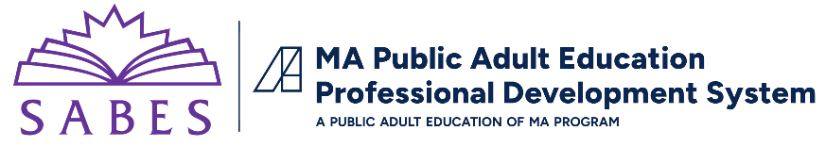

Discussion Questions: Blue Hills ELA Instructional Video
Video: Evidence-based Reading Instruction - Comprehension Strategies
Stephanie Gaboury’s Lesson Plan
- The instructor, Stephanie Gaboury, uses the steps of explicit instruction to teach this lesson. Review this graphic illustrating the four steps of the Gradual Release of Responsibility (GRR) model.
  - What did you observe the teacher and students doing during each step of the lesson (explanation/modeling; guided practice; collaborative learning; independent practice)?
  - What more might the teacher have done in this lesson or a subsequent lesson?
  - Do you follow this model when planning units/lessons?
  - In which area would you like to improve?
- Though the lesson focuses on reading comprehension, which of the other components of reading (alphabetics, fluency, vocabulary) are addressed in this lesson? Give examples you observed.
- The lesson covers a “T-chart” comprehension strategy to help students learn how to summarize a reading by finding the topic and main idea of each paragraph.
  - Why is it important for adult learners to learn comprehension strategies?
  - What are some real world/everyday life applications of the specific strategies used in this lesson?
  - How do you feel about trying this comprehension strategy with your class?
  - What EBRI strategies have you incorporated into your own lessons?
- The ELA Proficiency Guide is based on the ABE Professional Standards and contains ELA-specific observable teacher/student behaviors for each of the standards. For each standard, there is a Focus Reflection that can be used to reflect on your own strengths or a colleague’s with respect to a certain professional standard.
  - Review the Focus Reflection for Standard P1.2, Well-Structured Lessons
    - What elements from the KNOW and DO columns did you observe during the lesson?
    - What else might the teacher have done to address this standard?
    - What are your own strengths and weaknesses with respect to this professional standard?
- At the end of the video, the teacher reflects on the lesson.
  - What are some of the reasons that the instructor chose this specific reading?
  - Do you think this reading would be of interest to your class?

