

SABES Study Guide
for the Massachusetts Test for
Education Licensure (MTEL) Adult
Basic Education (55) Test
Developed by:
Meri Holden
Bristol Community College, Attleboro Adult Education Program
Karen Miller
Bristol Community College Literacy Center
November 2020

Overview and Acknowledgments
This document provides information to assist adult educators in preparing for the Adult Basic Education (ABE) subject matter test of the Massachusetts Tests for Educator Licensure (MTEL). We are grateful for the work of Meri Holden and Karen Miller to compile this resource for SABES and for adult educators who are preparing to take the MTELs in pursuit of the ABE Teacher’s License.
Complementary to this Guide is a SABES ABE MTEL Math Study Guide, which provides additional detail and study resources for those wishing to focus on the math portion of the ABE MTEL. The Glossary of Secondary and Primary Language Acquisition Terms will help those who want to focus on the ESOL objectives.

Table of Contents
English Language Arts (15%) 2-4
English for Speakers of Other Languages (ESOL), (25%) 5
Mathematics (25%) 6-13
History and Social Science (10%) 14-16
Science (10%) 17
Application of Knowledge and Understanding (15%) 18

English Language Arts (15%)

Introduction
The MTEL ABE Test will contain 14 – 16 multiple choice questions on English Language Arts. Reading and Writing topics will be included.

Objective 1: Process
Understand the process of written composition.
- Writing for various audiences/purpose
- Processes for generating and developing text
- Prewrite
- Draft
- Revise
- Edit
- Rewrite
- Sentence, paragraph & essay development
- Thesis statement
- Organization
- Transitions
- Details to support
- Style & voice
- Evaluation
- Rhetoric
- Logic
- Voice
- Style
- Content
- Revising
- Unity
- Focus
- Clarity
- Economy of expression

Objective 2: Mechanics
Understand grammar, usage, conventions, structure, and history of edited American English.
  - Grammatical expressions
  - Formal usage
  - Parts of speech
  - Sentence types
- Compound / complex
- Declarative
- Exclamatory
  - Use of verbs
  - Pronouns
  - Modifiers
- Adverbs
- Adjectives
- Prepositional phrases
  - Spelling, capitalization, and punctuation
  - Structure / history of English
- Etymology
- Orthography

Objective 3: Literature
Understand literature written in or translated into English.
- Characteristics of major literary genres
- Fiction
- Nonfiction
- Personal essay
- Poetry
- Drama
- Elements of fiction
- Plot
- Character
- Setting
- Theme
- Point of view
- Literary devices
- Figurative language
- Imagery
- Irony
- Symbolism

Objective 4: Reading
Understand theories and practices related to the development of reading skills and strategies for adult learners.
  - Process
- Phonemic awareness
- Word analysis
- Phonics
- Structural analysis
- Vocabulary skills
- Strategies
- Comprehension
- Literal
- Inferential
- Evaluative
- Literary and expository texts
  - Reading comprehension strategies
- Metacognitive techniques
- Self-questioning
- Paraphrasing
- Relationship
  - Reading & Writing
  - Range of Literary Skills
  - Reading assessment procedures & instruments
  - Instructional strategies

English for Speakers of Other Languages (25%)

Introduction
The MTEL ABE Test will contain 24 – 36 multiple choice questions on English for Speakers of Other Languages.

Objective 5: Language Acquisition
Understand theories of language acquisition and factors that affect second language development.
- Input (child)
- Acquisition – subconscious & intuitive
- Learning - conscious learning from rules
- Speech will emerge
- Attentive processing
- Controlled/ automatic
- Focal / peripheral
- Analysis
- Explicit
- Implicit
- Variability Models
- Capability continuum paradigm
- Variable Competence model

Objective 6: English Language Learners
Understand basic linguistic and sociolinguistic concepts and their application to English language learners.
- Stages and sequences
- Language assessment procedures & instruments

Mathematics (25%)

Introduction
The MTEL ABE Test will contain 24 – 36 multiple choice questions on Mathematics.

Objective 7: Number Sense
Understand number sense and operations.
- Place value
- Number base 2 and 10
- Order relations (Order of operations)
- Parentheses
- Exponents
- Multiplication and Division in the order they appear
- Addition and Subtraction in the order they appear
- Prime and composite numbers
- Equivalent forms of numbers
- Integers
- Fractions
- $\frac{numerator}{denominator}$
- Decimals
- Percents
- 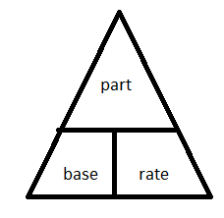
- $\frac{Part}{Base}=\frac{Rate \%}{100\%}$
- Ratios
- a to b a:b $\frac{a}{b}$
- Proportion
- $\frac{a}{b} = \frac{c}{d}$
- Cross multiplication
a x d = b x c
- Radicals
- Exponent (5³) and square root ($\sqrt{4}$)
- Scientific notation
- Absolute value
- Related operations
- $+ and -$are inverse operations
- $× and ÷$ are inverse operations
- Multiplication is repeated addition
- Division is repeated subtraction
- Computational algorithms
- Estimation
- Word problems
- Calculator use
- Assessment of number sense & operations

Objective 8: Algebra
Understand basic concepts of algebra.
- Use of patterns in math & contextual situations
- Algebraic symbols & expressions
- Properties of functions & relations
- Words, tables, graphs, rules
- Equations / systems of equations
- Graph properties
- Quadratic expression ( x2 + 2x + 3)
- Factoring (FOIL – First, Outer, Inner, Last)
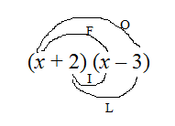
First: x²
Outer: -3x
Inner: +2x
Last: -6
- Application of linear, quadratic & exponential functions
- Assessment of algebraic concepts
- Solving inequalities ( $< ≤ > ≥$)
- Linear equations y = 2x + 4

Objective 9: Geometry
Understand geometry and measurement.
- Measurable attributes of objects (shapes, angles, lines)
- Units, systems and processes of measurement
- Application of techniques, tools and formulas to determine measurement
Perimeter
Area
Surface area
Volume
- Types of angles
Acute (less than 90º)

Right (90º)

Obtuse(greater than 90º and less than 180º)

Straight (180º)

Reflex (greater than 180º)

- Angle relationships
Complementary(add to 90º)
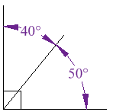
Supplementary (add to 180º)
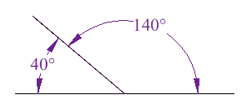
- Perpendicularity – intersecting lines that meet at a right angle (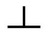)
- Parallelism – lines that will never intersect ( 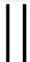 )
- Congruence – means equal measure ($≅$)
- Similarity – same shape not same size ($\sim )$
- Congruent angle relationships
Opposite or vertical angles are congruent
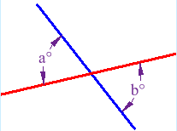
- Angle relationships (continued)
Parallel lines cut by a transversal
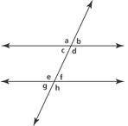
- Alternate Interior (c & f, d & e)
- Alternate Exterior (a & h, b & g)
- Corresponding (a & e, b & f, c & g, d & h)
- Proving theorems
Pythagorean Theorem (only for right triangles)
$$a^{2}+b^{2}=c^{2}$$
- Geometric figures
Triangles
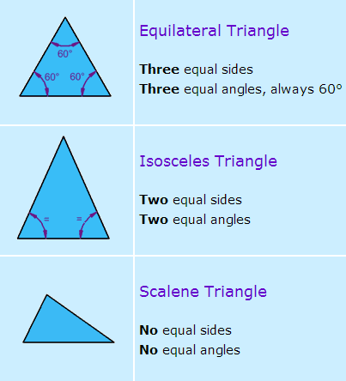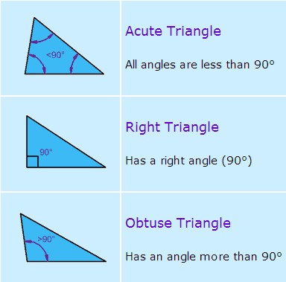

Quadrilaterals
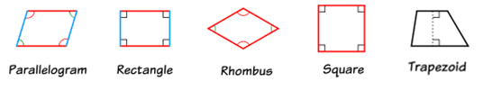
Circles
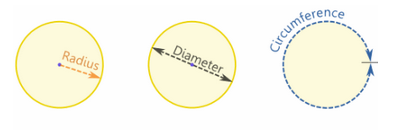
- Geometric properties
- Use of transformations and symmetry
- Coordinate geometry
- Ordered pair (x-value, y-value)
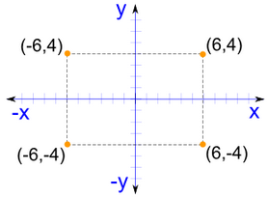
- Slope-intercept form of a line
where m is the slope and b is the y-intercept
$$y=mx+b$$
- m is the slope of the line
$$\frac{rise}{run}= \frac{y_{2} -y_{1}}{x_{2} -x}$$
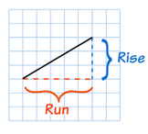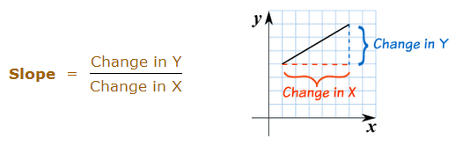

- Assessment of geometry and measurement concepts

Objective 10: Data Analysis
Understand data analysis, statistics, and probability.
- Organizing data
- Charts
- Graphs
- Tables
- Statistics and trend terminology
- Central tendency (mean, median, mode, range)
- Reading and interpreting data
- Frequency distribution & percentile
- Data analysis
- Bias factors & graph distortion
- Probability (represented as %, ratio, fraction, or decimal)
- $P= \frac{favorable}{total possible}$
- Independent vs. dependent probability

US Length Measures
The following facts will help you convert units of length:
- 1 foot (ft) = 12 inches (in)
- 1 yard (yd) = 3 ft
- 1 mile (mi) = 5280 ft ←This is generally the most unfamiliar fact
Tip: These units of length are all linear measures because they measure distance in one direction (i.e. a line). You cannot use them to convert square (Area) or cubic (Volume) measures without modifying them.

US Liquid Volume Measures
The following facts will help you convert units of liquid volume:
- 1 cup (c) = 8 fluid ounces (fl oz)
- 1 pint (pt) = 2 c
- 1 quart (qt) = 2 pt
- 1 gallon (gal) = 4 qt

US Weight Measures
The following facts will help you convert units of weight:
- 1 pound (lb) = 16 ounces (oz)
- 1 ton (t) = 2000 lb

Time Measures
The following facts will help you convert units of time:
- 1 minute (min) = 60 seconds (sec)
- 1 hour (hr) = 60 minutes (min)
- 1 day = 24 hr
- 1 week = 7 days
- 1 year = 12 months = 365 days

Metric System
Tip: It’s actually much easier to convert units in the metric system than in the U.S. measurement system. You simply need to move the decimal point the appropriate number of decimal places.
To convert to smaller units, move the decimal point right
kilo-  1000 | hecto-  100 | deka-  10 | meter  gram  liter | deci-  ¹/₁₀ | centi-  ¹/₁₀₀ | milli-  ¹/₁₀₀₀
To convert to larger units, move the decimal point left

Area Formulas
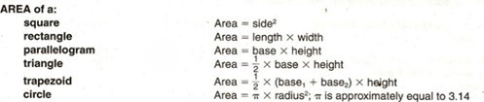

Perimeter Formulas
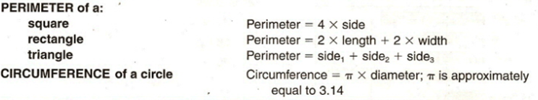

Volume Formulas
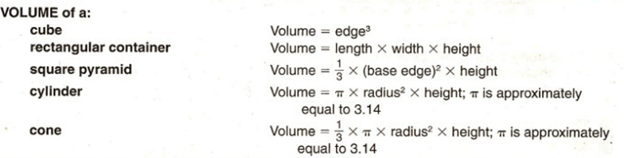

Coordinate Geometry
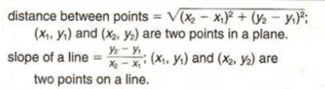
Slope of a horizontal line is 0; vertical line has no slope.
All lines with the same slope are parallel.
Slope-intercept form of a line (where m is the slope and b is the y-intercept)
$$y=mx+ b$$

Pythagorean Relationship
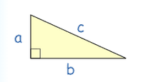
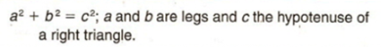

Measures of Central Tendency
mean = x₁ + x₂ +. . . x_{n} where the x’s are the values for which a mean is
n desired, and n is the total number of values for x.

median = the middle value of an odd number of ordered scores, and halfway between the two middle values of an even number of ordered scores.
mode = greatest frequency
range = largest - smallest

Distance
Distance = rate x time

Cost
Total cost = (number of units) x (price per unit)

Interest
Interest = principal x rate x time
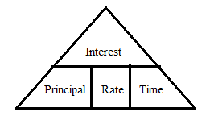

History and Social Science (10%)

Introduction
The MTEL ABE Test will contain 9 – 11 multiple choice questions on History and Social Science.

Objective 11: History
Understand chronology, major developments, and individuals in Massachusetts, United States, and world history.
- Characteristics & contributions of ancient civilizations
- Major transformations in human history
- Agricultural Revolution
- Scientific Revolution
- Industrial Revolution
- Information Revolution
- Major political, social, & economic developments & conflicts in US & World History since 1500
- Renaissance
- Reformation
- Colonization
- Civil Rights
- Breakup of USSR
- European Exploration & Settlement of the West
- Age of Enlightenment
- Great Depression
- U.S. as a world power
- Individuals who shaped MA history
- John Adams (1735 – 1826)
- 2nd President
- Founding father
- Abbey Kelley Foster
- Abolitionist
- Women’s rights
- Henry Knox (1811 – 1887)
- Springfield Armory
- Women’s Rights Convention 1850
- Individuals who shaped U.S. history
- Thomas Jefferson
- Frederick Douglas
- Abraham Lincoln
- Susan B. Anthony
- Franklin D. Roosevelt
- Rosa Parks
- Ann Hutchinson - dissenter
- Roger Williams - RI – dissenter
- Horace Mann – state system of schools
- Individuals who shaped U.S. history (continued)
- Thoreau
- Emerson
- Individuals who shaped World history
- Pericles (461 – 429 BC)
- Greek statesman / Acropolis democracy
- Galileo
- Simon Bolivar (1783 – 1830)
- Venezuela Independence
- Mohandas Gandhi
- Mao Zedong
- Margaret Thatcher
- Nelson Mandela

Objective 12: Government
Understand basic principles and institutions of American government and their relation to the founding documents of the United States.
- Declaration of Independence 1776
- Concept & purpose
- U.S. Constitution
- Created 1787; ratified 1788; put into effect 1789
- 7 articles
- Bill of Rights – first 10 amendments 1791
- 27 Amendments in all
- Government structure and functions
- Local, state, national
- U.S. Electoral System
- Elements & operation
- Role of political parties & interest groups
- Citizens’ role in political process
- Rights and responsibilities of U.S. citizenship
- Contemporary issues in American democracy

Objective 13: Geography
Understand basic geographic principles and concepts, and major physical features of the world.
- Land masses & bodies of water
- Shape, location & relationship
- Major political units & divisions
- Geographic terms & concepts
- Region, location, plateau
- Resources
- Almanac, atlas, maps, globes

Science (10%)

Introduction
The MTEL ABE Test will contain 9 – 11 multiple choice questions on Science.

Objective 14: Physical and Life Science
Understand basic principles and concepts of physical and life sciences.
- Fundamental principles
- Conservation of energy
- Adaptation
- Properties of matter
- Forms of energy
- Mechanical
- Chemical
- Sound
- Heat
- Motion of objects
- Earth atmosphere & space concepts
- Organization of living things
- Heredity
- Evolution
- Ecology
- Human body & its systems

Objective 15: Scientific Inquiry
Understand basic principles and procedures of scientific inquiry.
- Generating questions
- Forming hypotheses
- Methods of observation
- Collecting & organizing data
- Measuring instruments & procedures
- Drawing conclusions
- Making generalizations
- Interpreting data, graphs, charts & tables
- Evaluating scientific claims & arguments

Application of Knowledge and Understanding (15%)

Introduction
The MTEL ABE Test will contain 2 open response questions on Application of Knowledge and Understanding.

Objective 16: Textual Evidence and Critical Thinking
Analyze and evaluate the organization, focus, unity, and/or expression of ideas in a written text AND apply critical thinking skills (i.e., analysis, interpretation, synthesis, and evaluation) to a written passage that presents an argument related to an ABE content area.
- Analysis of flaws related to the organization, focus, unity, or expression of ideas in a written work
- Identification and correction of errors of usage or mechanics in written texts
- Application of critical thinking skills to narrative, descriptive, and persuasive texts on a variety of topics
- Analysis
- Interpretation
- Synthesis
- Evaluation

