Created with funding from the Adult and Community Learning Services division of the Massachusetts Department of Elementary and Secondary Education by the SABES Mathematics and Adult Numeracy Curriculum & Instruction PD Center, which is managed by TERC, Inc.

These materials are meant to be done with your teacher over the phone or computer.

Remote Learning Packet for GLE 2–4
Introduction to Geometry

Geometry is the part of math where we study shapes, sizes, and positions.

Shapes

Side
B

A

Angle

Rectangles
A
C
B

D

E

What do these shapes have in common? | What has this shape in real life?
Draw two more rectangles. | Draw two shapes that are NOT rectangles.

Find the Rectangles

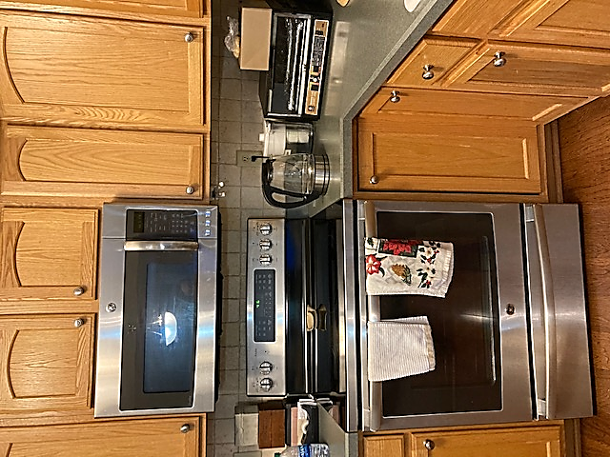

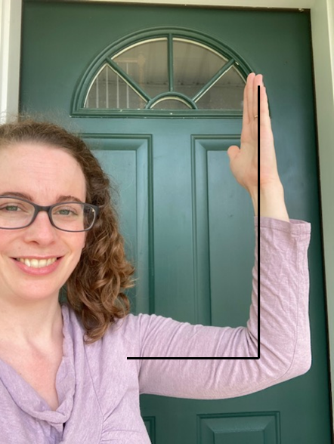
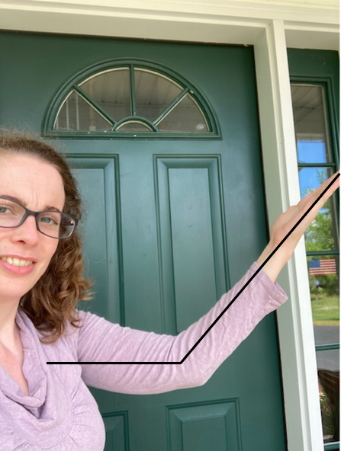
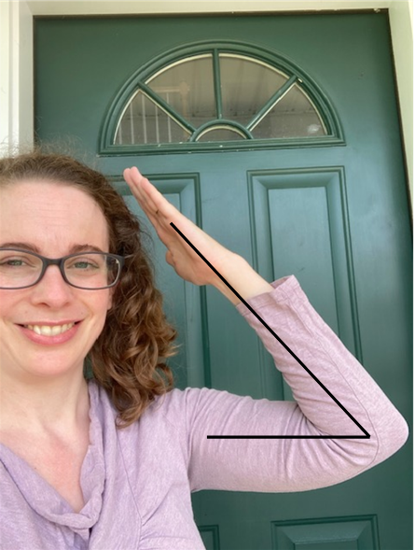
Angles in the Body

Small Right Large

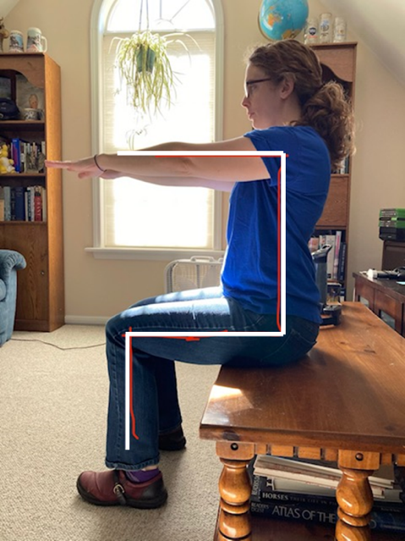
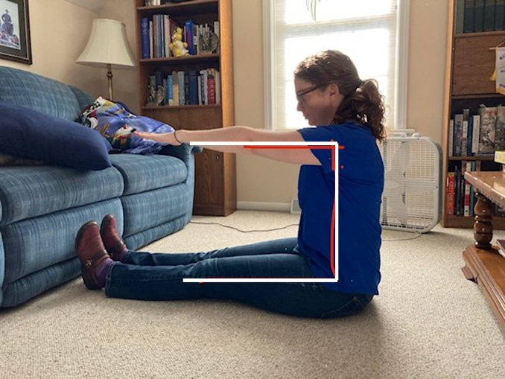

Which joints are making right angles?

Right Angles

A right angle looks like the corner of a square.
You can check for a right angle because the corner of a piece of paper will fit into it perfectly.

Paper test:
Does the corner of a paper fit?
Yes? It’s a right angle!

Use the paper test to see if the angles below are right angles.
A
B
C
D

Trapezoids
C
A

B

E
D

What do these shapes have in common? | What has this shape in real life?
Draw two more trapezoids. | Draw two shapes that are NOT trapezoids.

Trapezoids
Match each photo to the trapezoid shape seen in the photo.
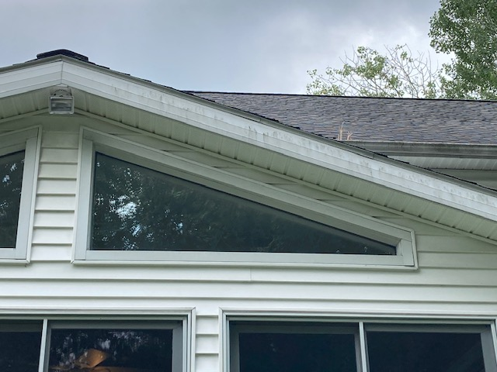
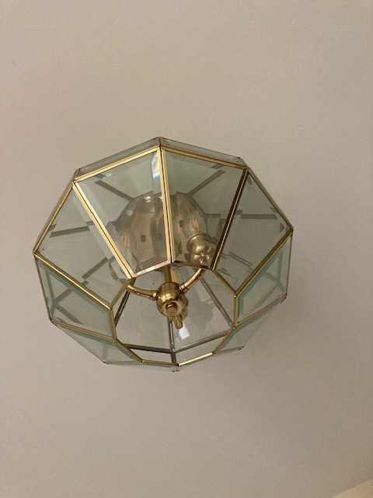
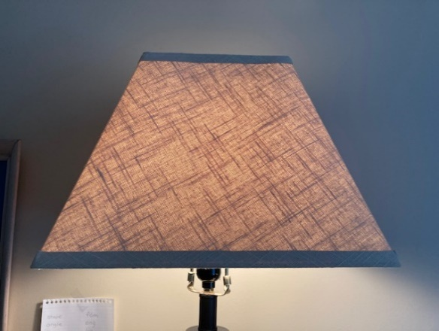
4.
3.
2.
1
A
B
C
D

Parallel or Not?
Parallel lines go the same direction. They are always the same distance apart. They will never meet.

These are examples of parallel lines.

These are examples of lines that are not parallel. If you continued the lines, they would cross.

Checking for Parallel Lines
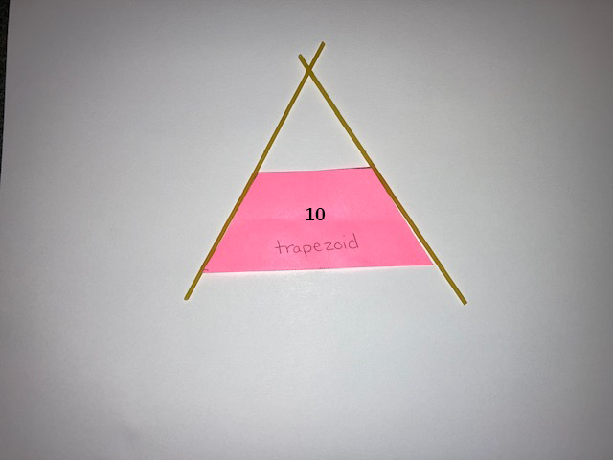
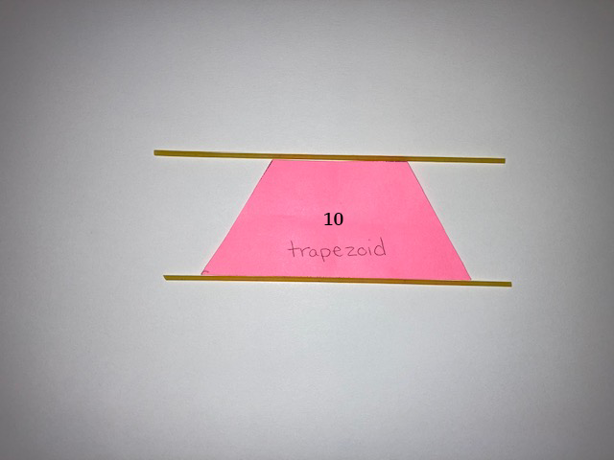
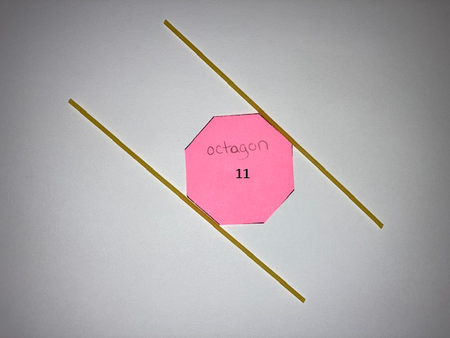
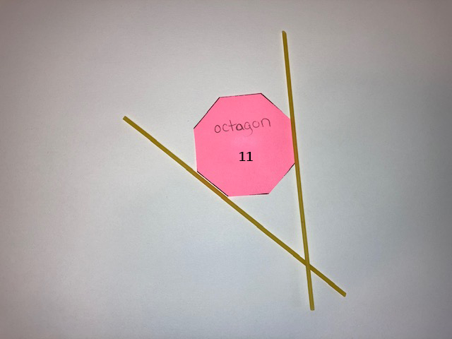
You can use spaghetti, or something else long and skinny, to check if two sides of a shape are parallel.
not parallel
parallel
not parallel
parallel
Parallel
These are pairs of sides that are parallel. The lines will never cross.

Not Parallel
These are pairs of sides that are not parallel. The spaghetti shows that the lines, if they continue, will cross.

Parallel Lines at Home

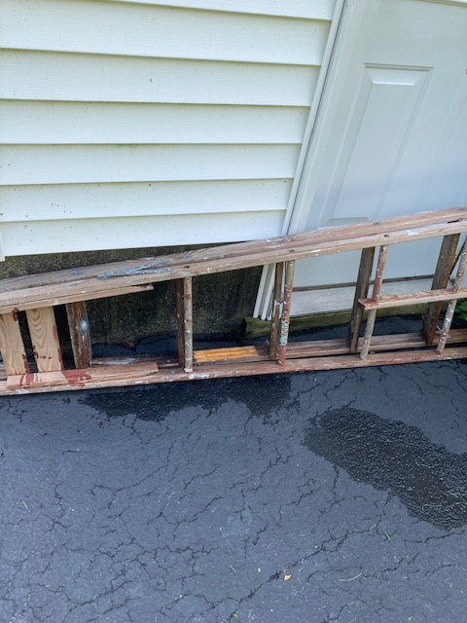
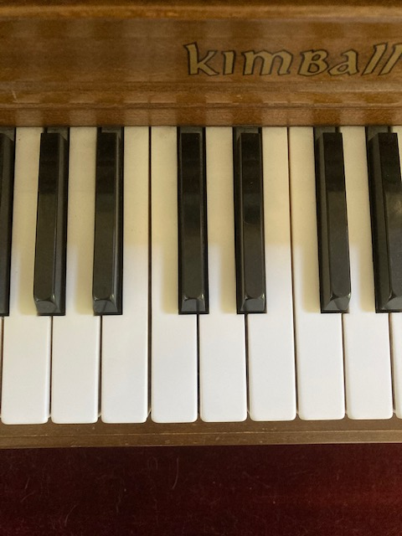
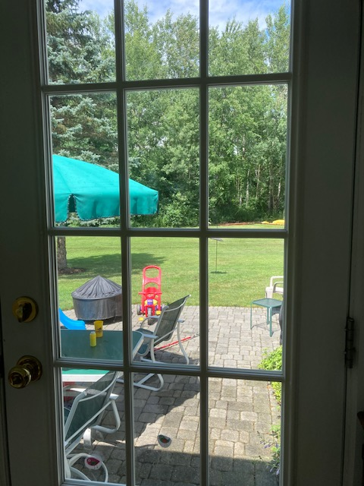
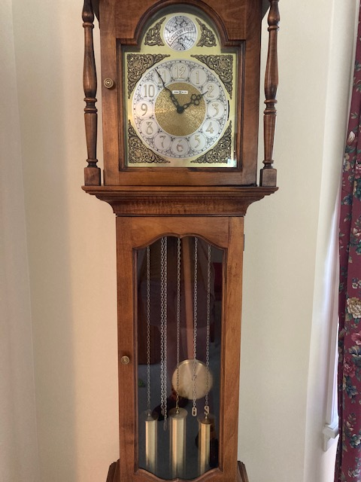
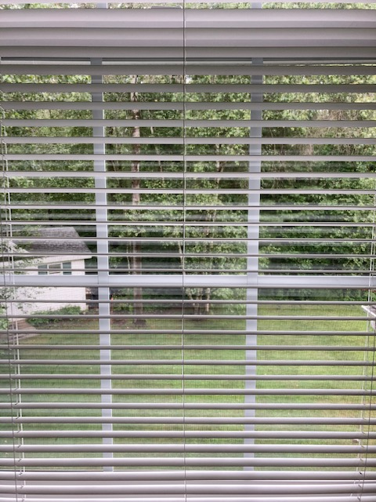
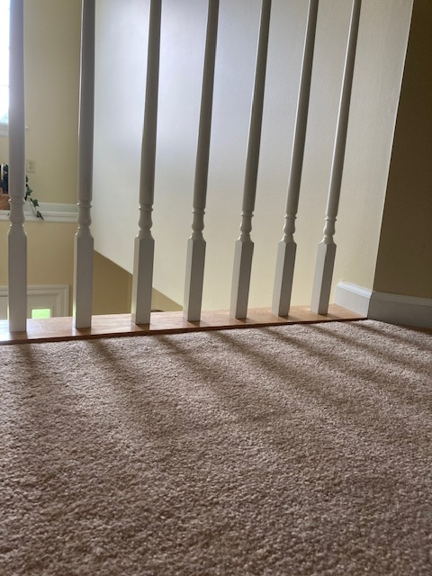

Triangles
C
A

B

D
E

What do these shapes have in common? | What has this shape in real life?
Draw two more triangles. | Draw two shapes that are NOT triangles.

Triangles: Same and Different
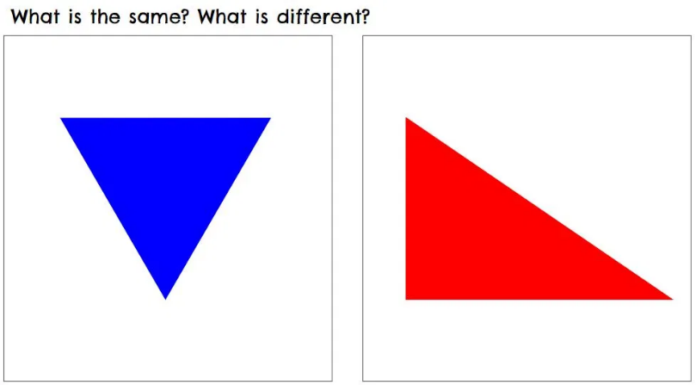
On a piece of paper, make two columns. In one column, list the things that are the same in this picture. and in the other column, list the things that are different.

Things that are the same | Things that are different
(Credit: Brian Bushart, https://samedifferentimages.wordpress.com)

Flags
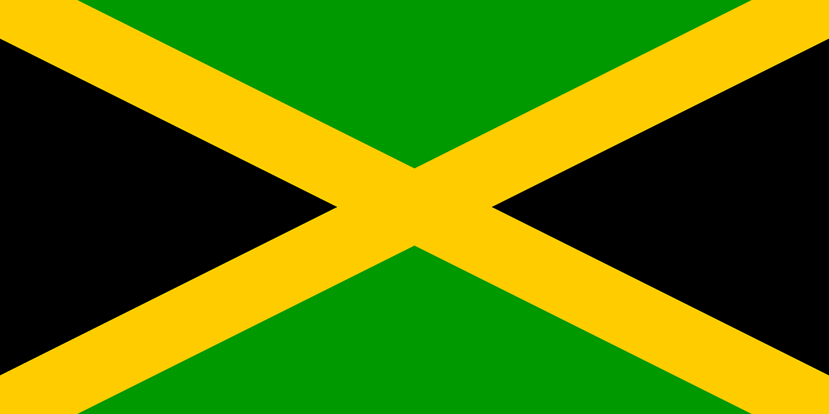
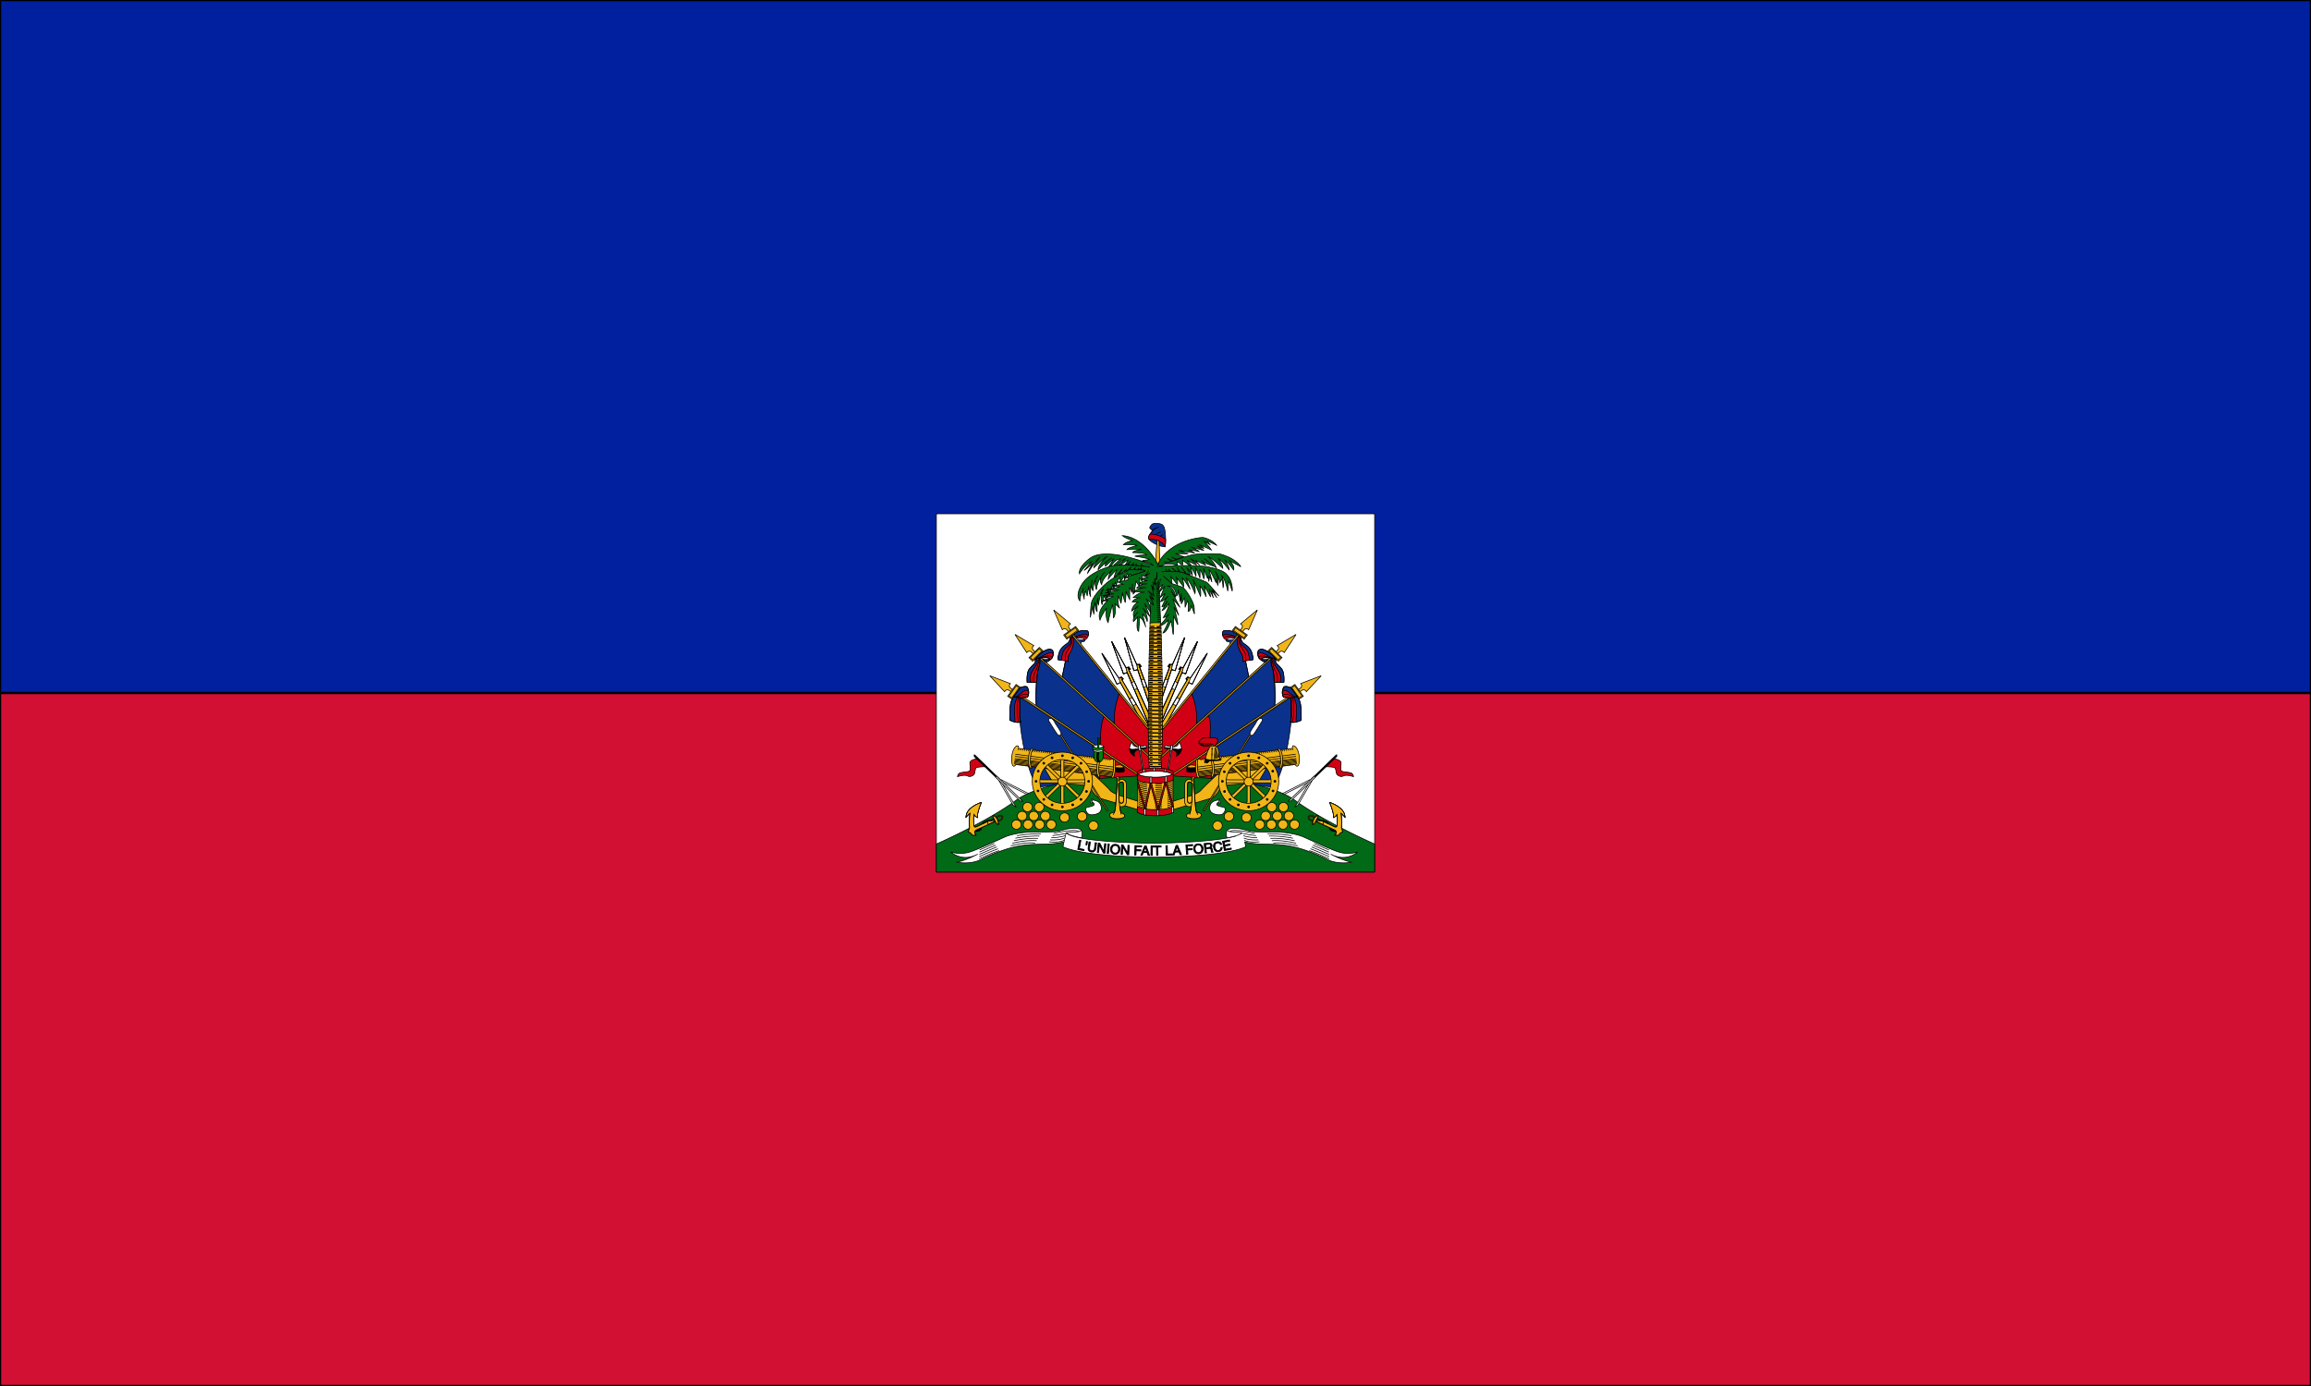

Jamaica
Haiti
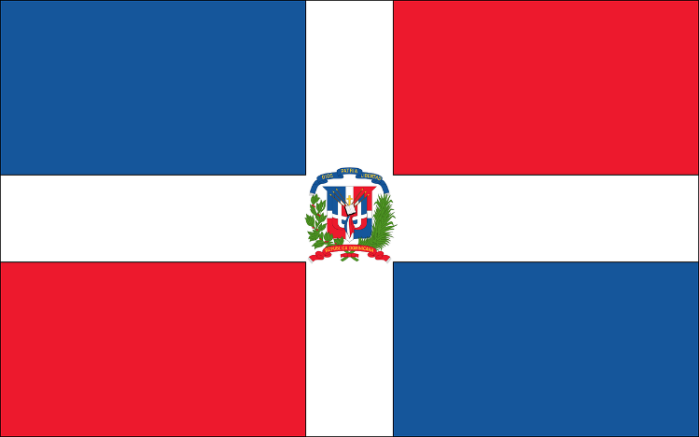
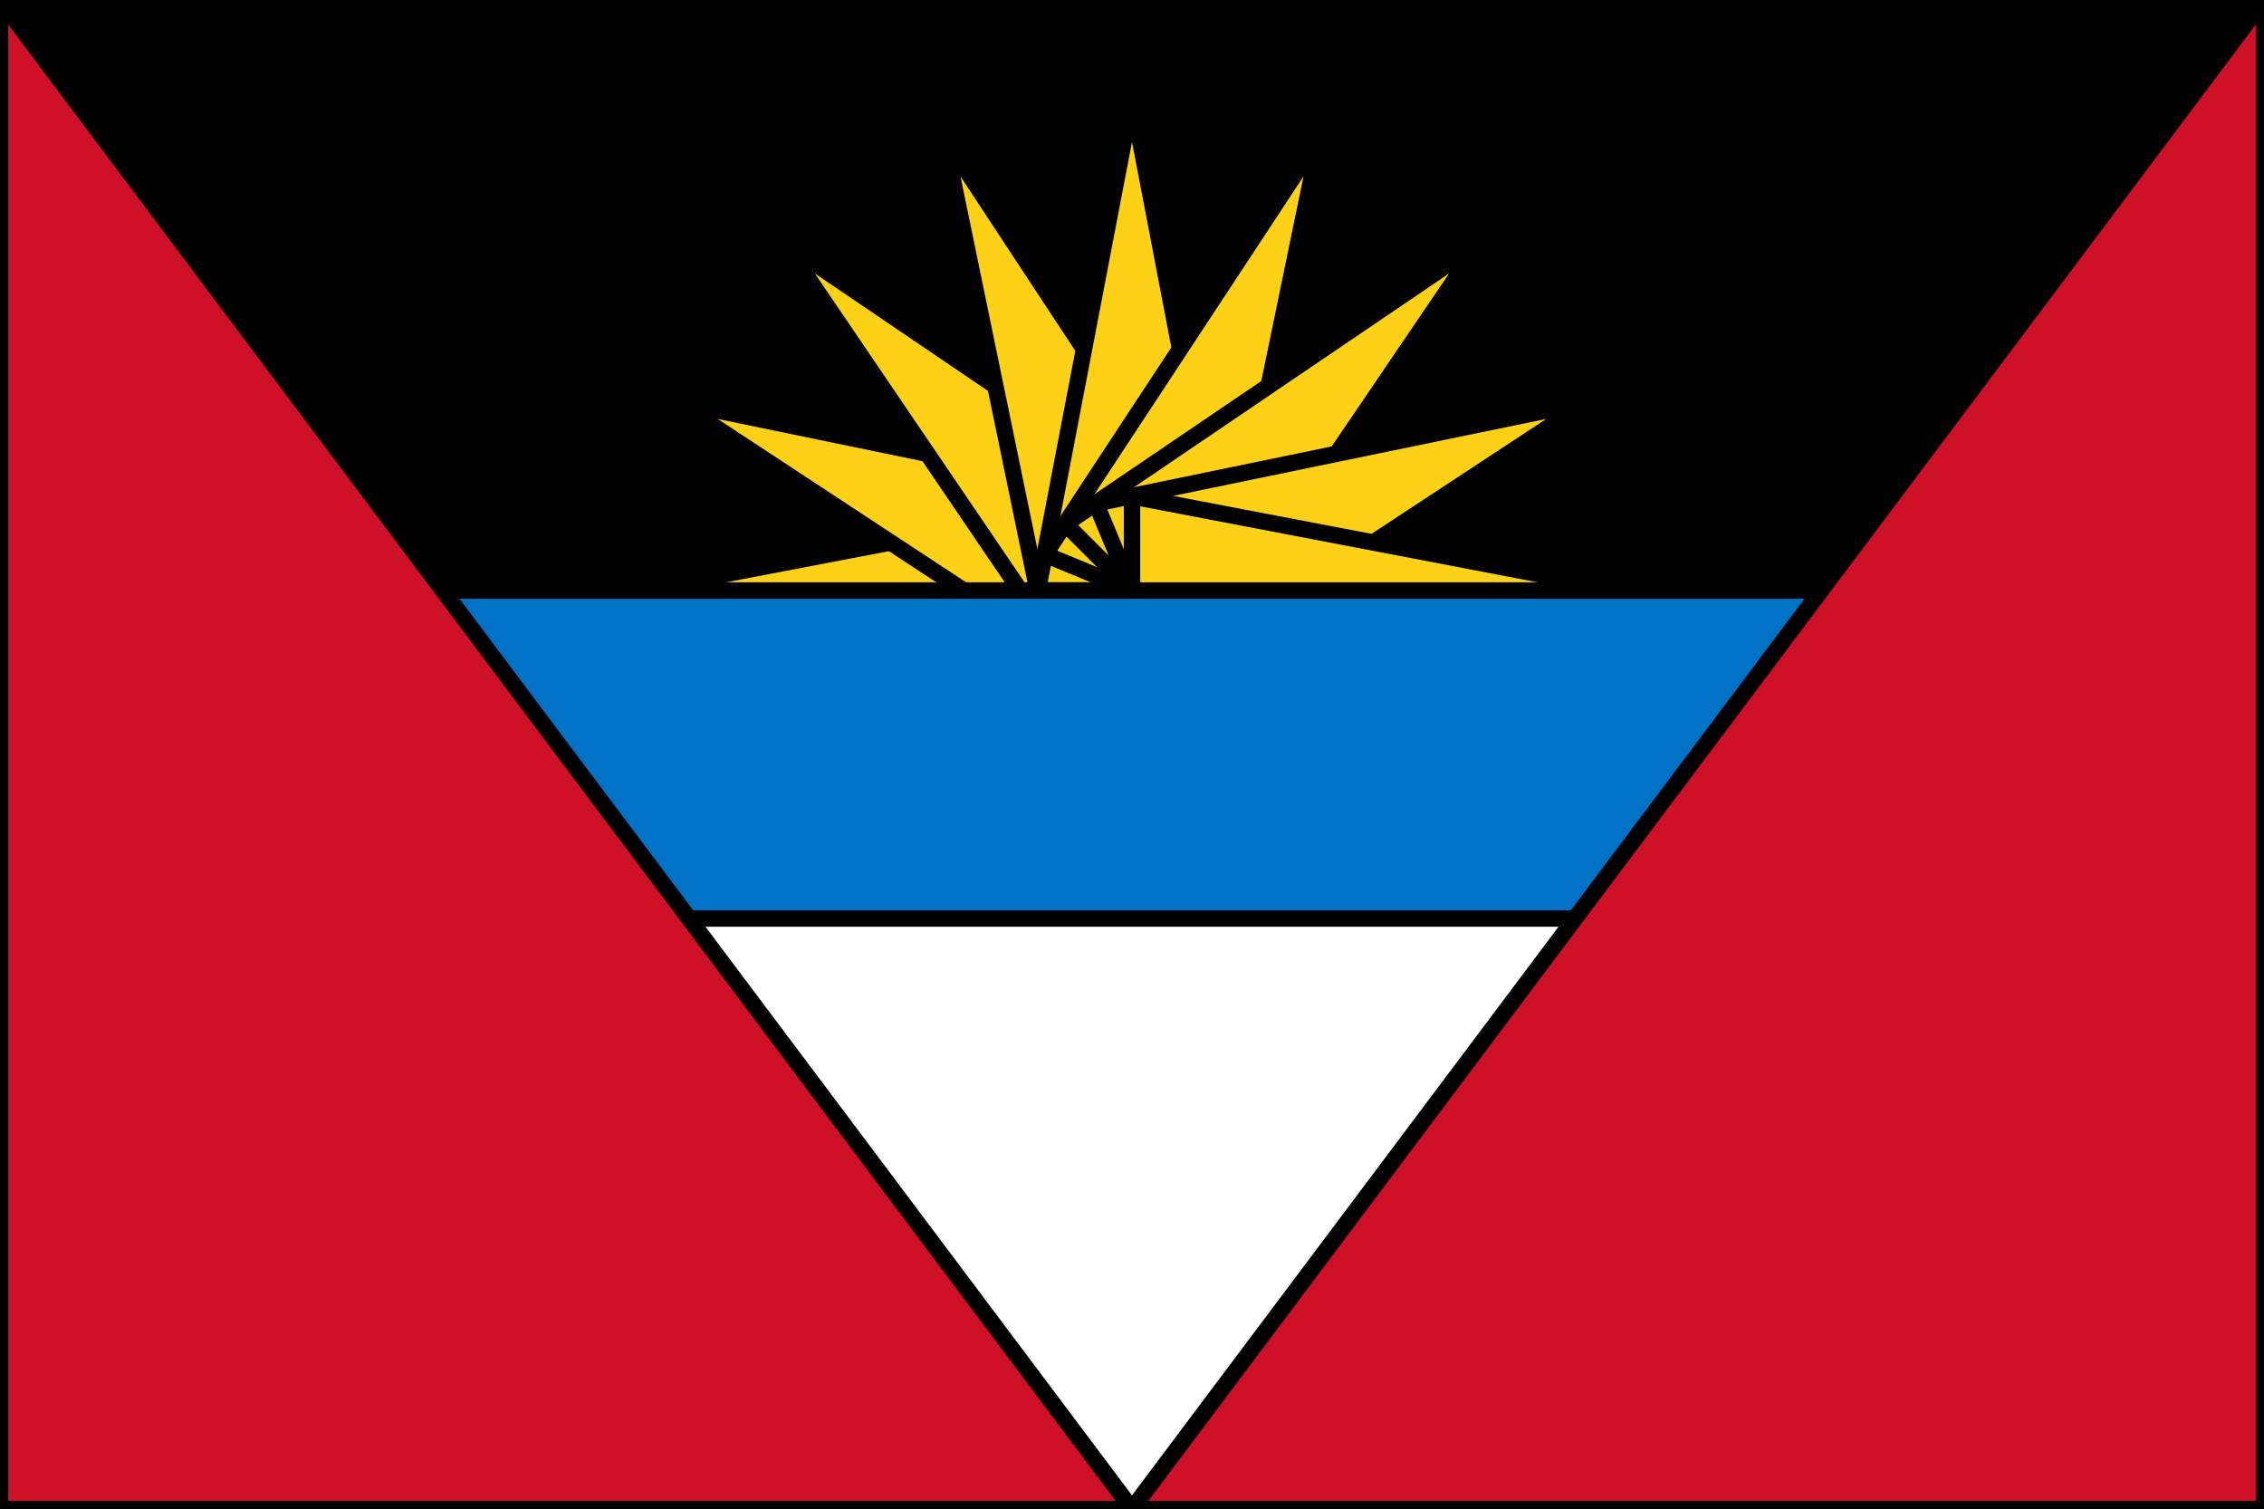

Dominican Republic
Antigua
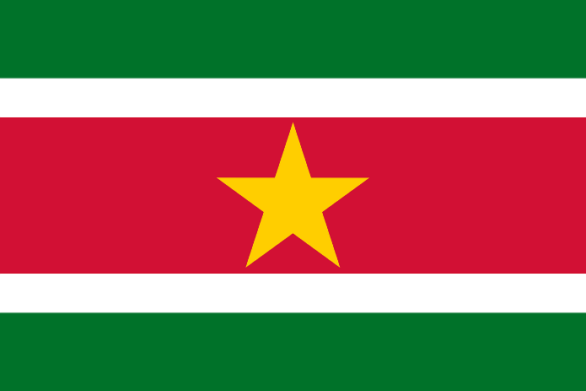
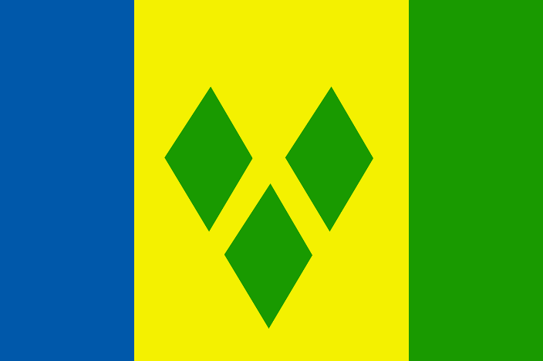

St. Vincent
Suriname

Making Symmetrical Shapes
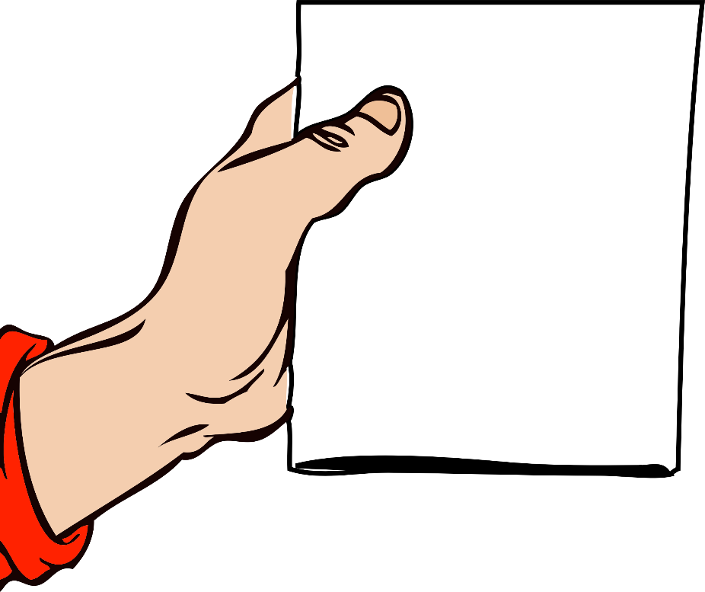
Fold
Fold a piece of paper.
Hold the paper on the folded side.

Use scissors to cut the paper around your hand.

Unfold the shape that you cut out.

You have a symmetrical shape.
The fold is the line of symmetry.

Symmetry
Symmetry is when a shape or image is the same when folded over a line. The line is called a line of symmetry. The shape is said to be symmetrical.

Are the dashed lines below lines of symmetry?
U Y P A

Lines of Symmetry
Is the dashed line a line of symmetry?

Symmetrical or Not?
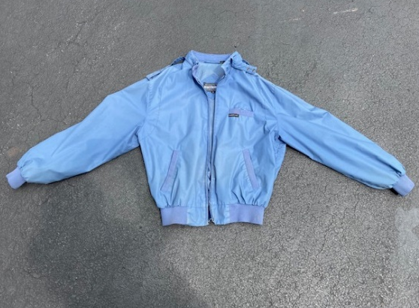

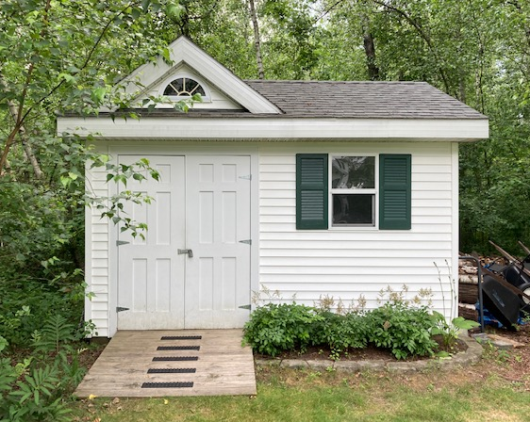
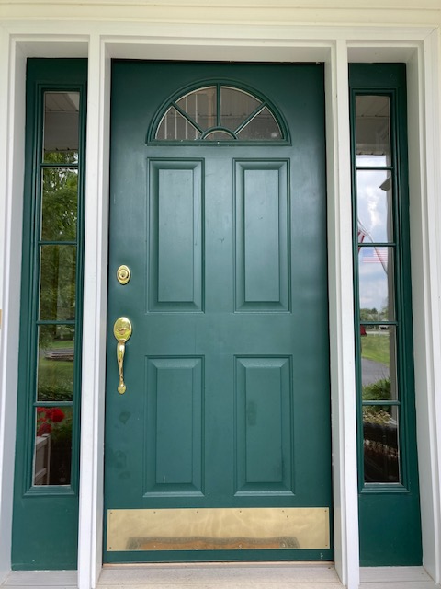

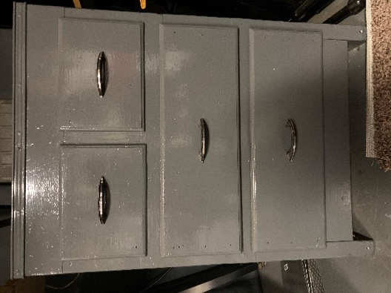
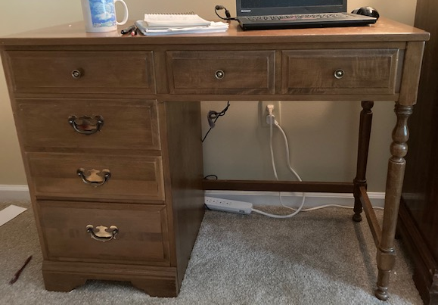

Symmetry in Nature
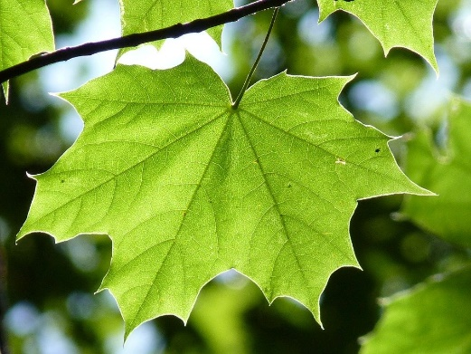

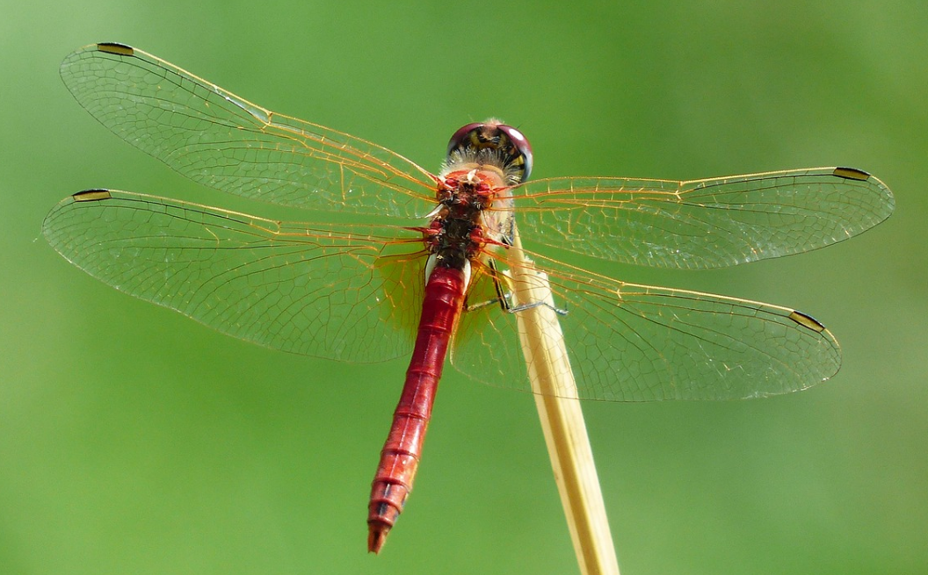

Where else do you see symmetry in nature?
Explain and draw a picture.

Front and Side Views
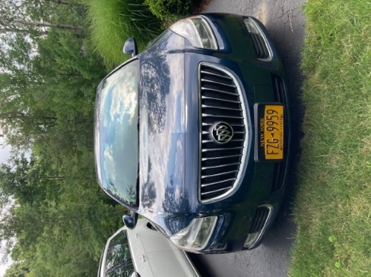
Is it a line of symmetry? Write yes or no.
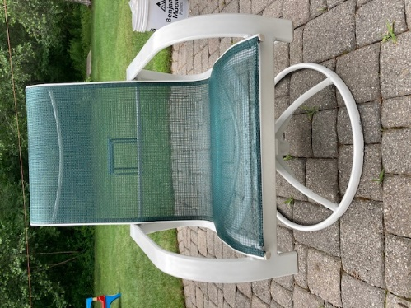
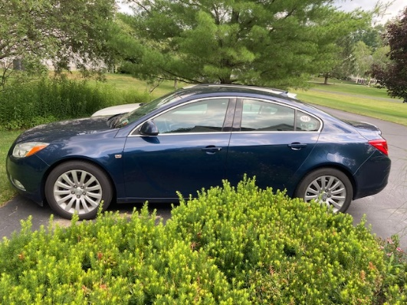
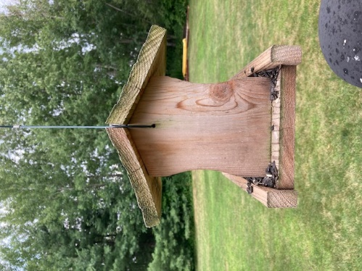
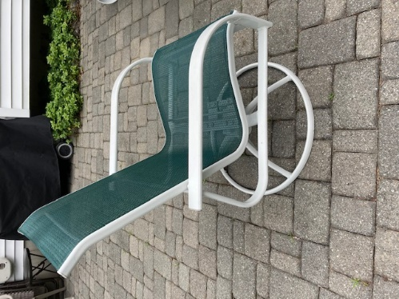
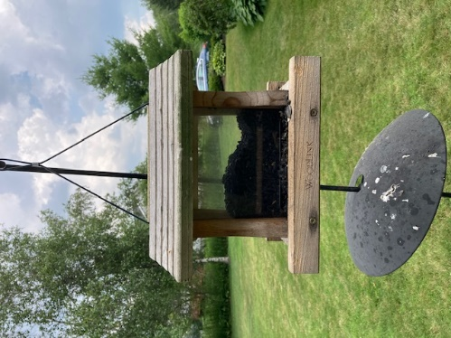
Bird Feeder
Chair
Car

Finish the Shape
Draw the other side of each symmetrical shape.
Example:

Draw two of your own symmetrical shapes below.

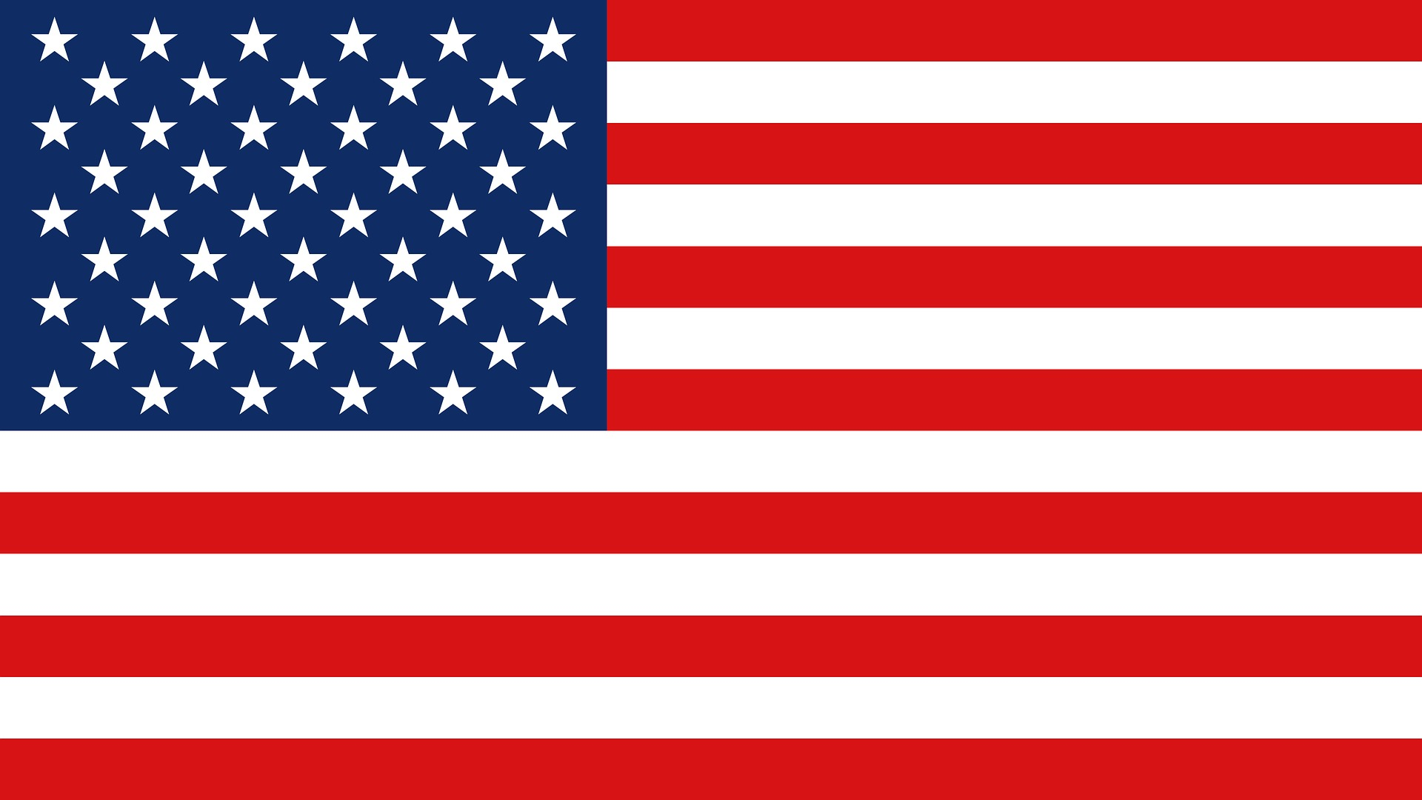
U.S. Flag Review

What shapes do you see in this flag?

What types of angles do you see?

Do you see any parallel lines?

Are there any lines of symmetry?

Shapes with More Sides
B
C
A

F
E
D

A pentagon has 5 sides and 5 angles. Which of the shapes above are pentagons? | A hexagon has 6 sides and 6 angles. Which of the shapes above are hexagons? | An octagon has 8 sides and 8 angles. Which of the shapes above are octagons?
Where have you seen a pentagon in real life? | Where have you seen a hexagon in real life? | Where have you seen an octagon in real life?

Shapes with More Sides: Examples
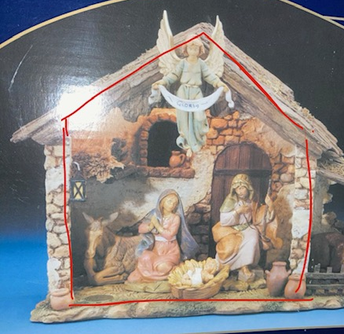

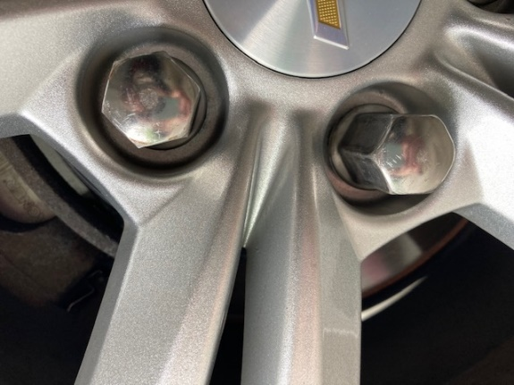
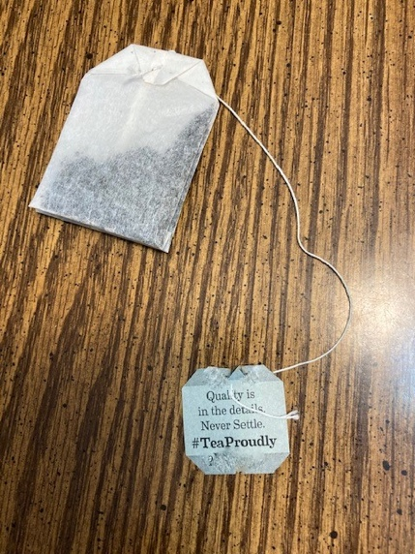
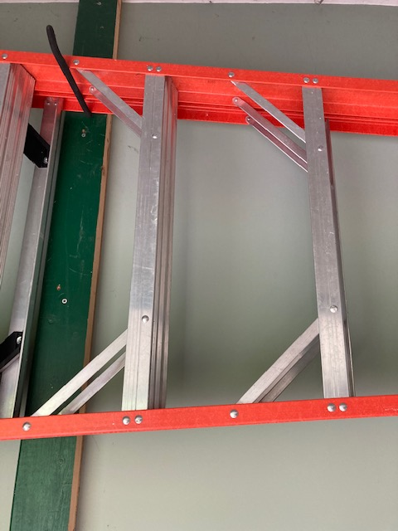

Which One Doesn’t Belong?
Choose one shape in this picture that you don’t think belongs with the others. Explain why.
Can you pick another shape and give a different reason?
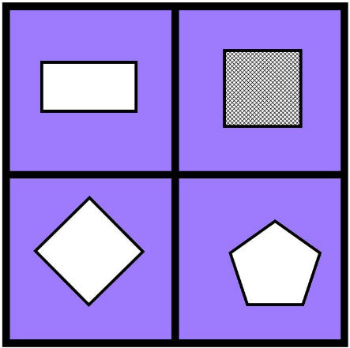

B
A

D
C

(Source: wodb.ca)

Road Signs

Write the letters of the road signs that have each shape.
Square Rectangle Triangle

Octagon Pentagon

(From EMPower Over, Around, and Within, Student Book, p. 14)

Shape Puzzles
Build the outlined shape using the shapes in your Shape Set. You can turn and flip over the shapes if you need to.

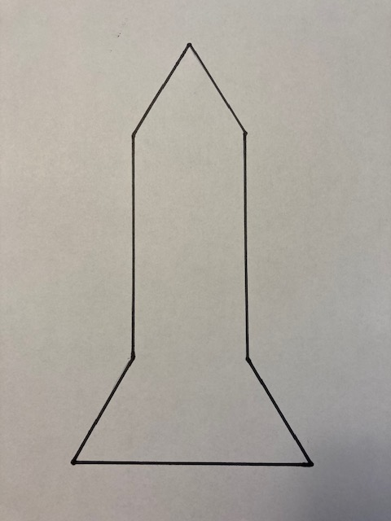
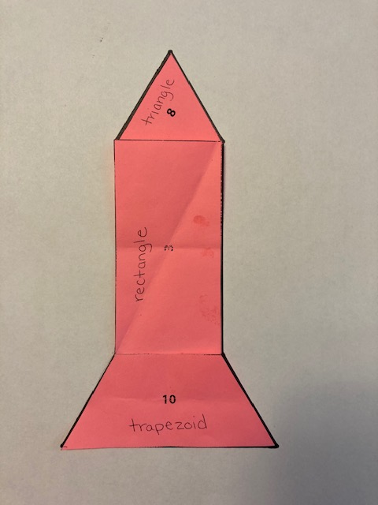
Here is an example:

Shape Puzzle Possible Solution

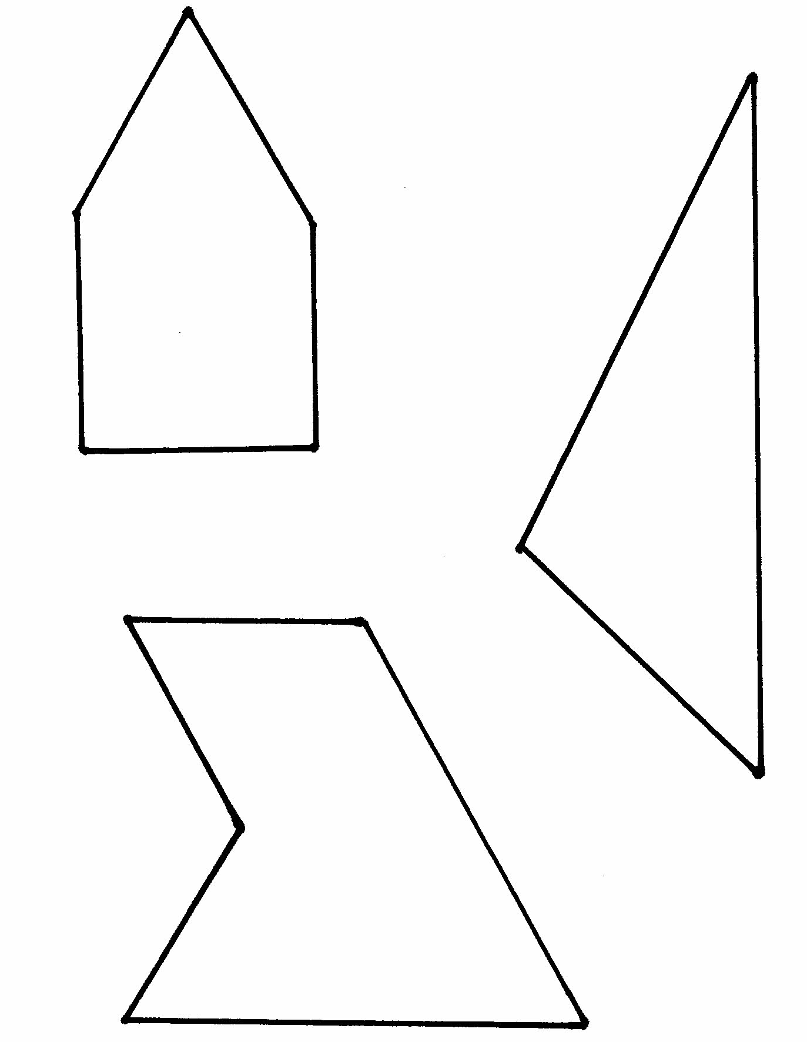
Shape Puzzles
B
A
C

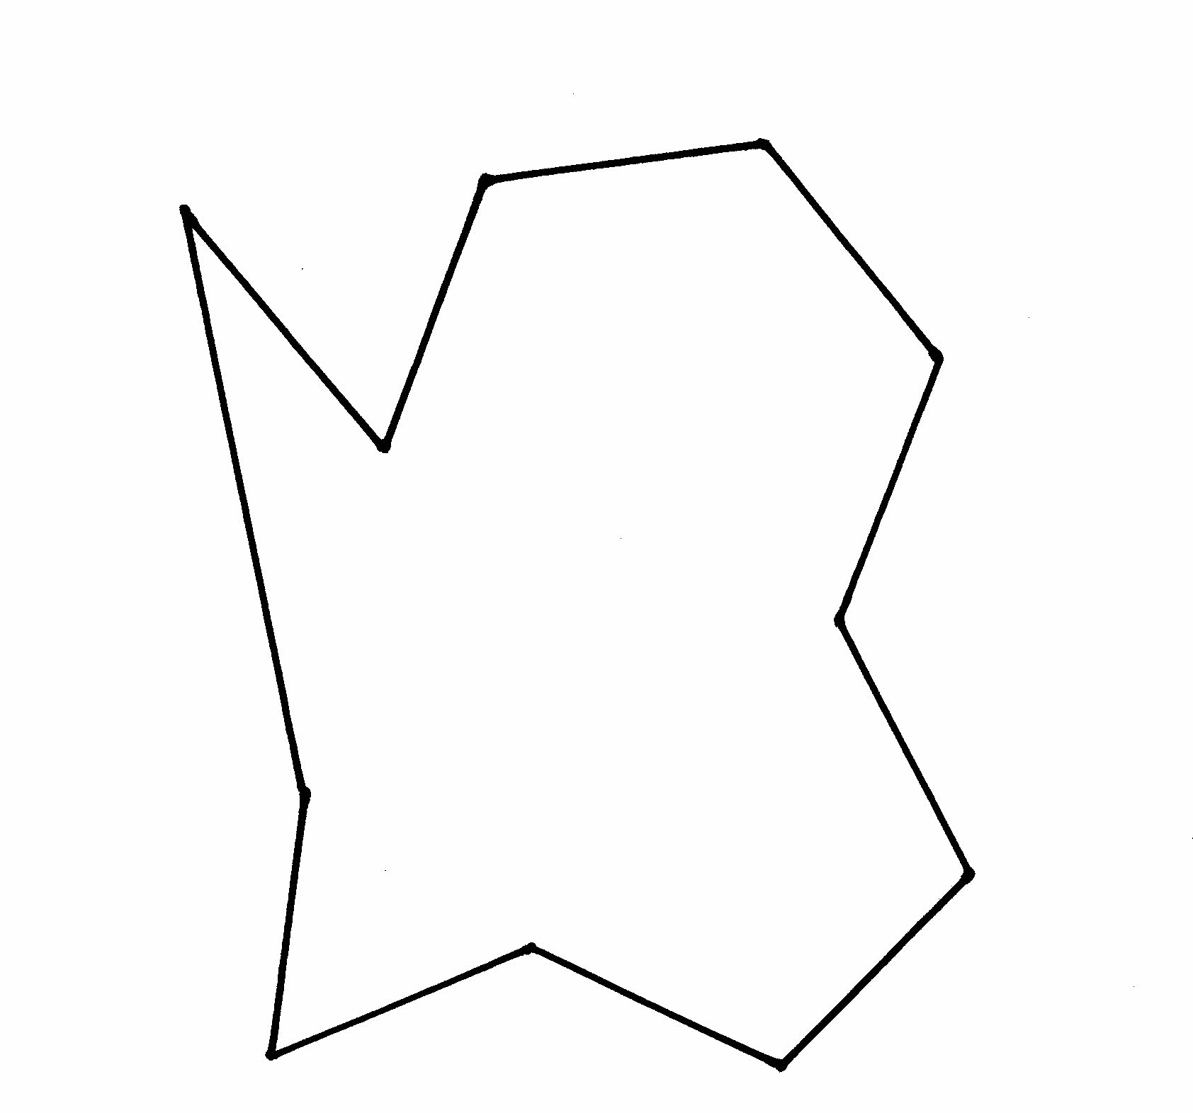
Shape Puzzles
D

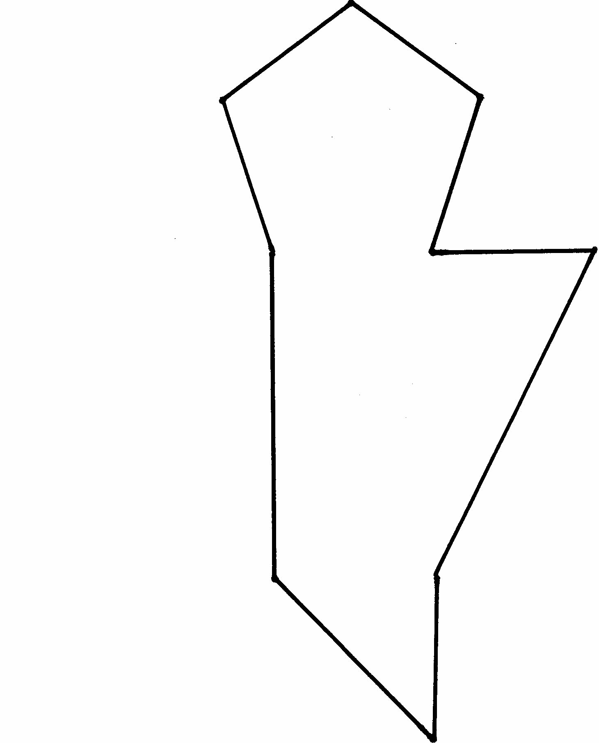
Shape Puzzles
E

Shape Puzzles
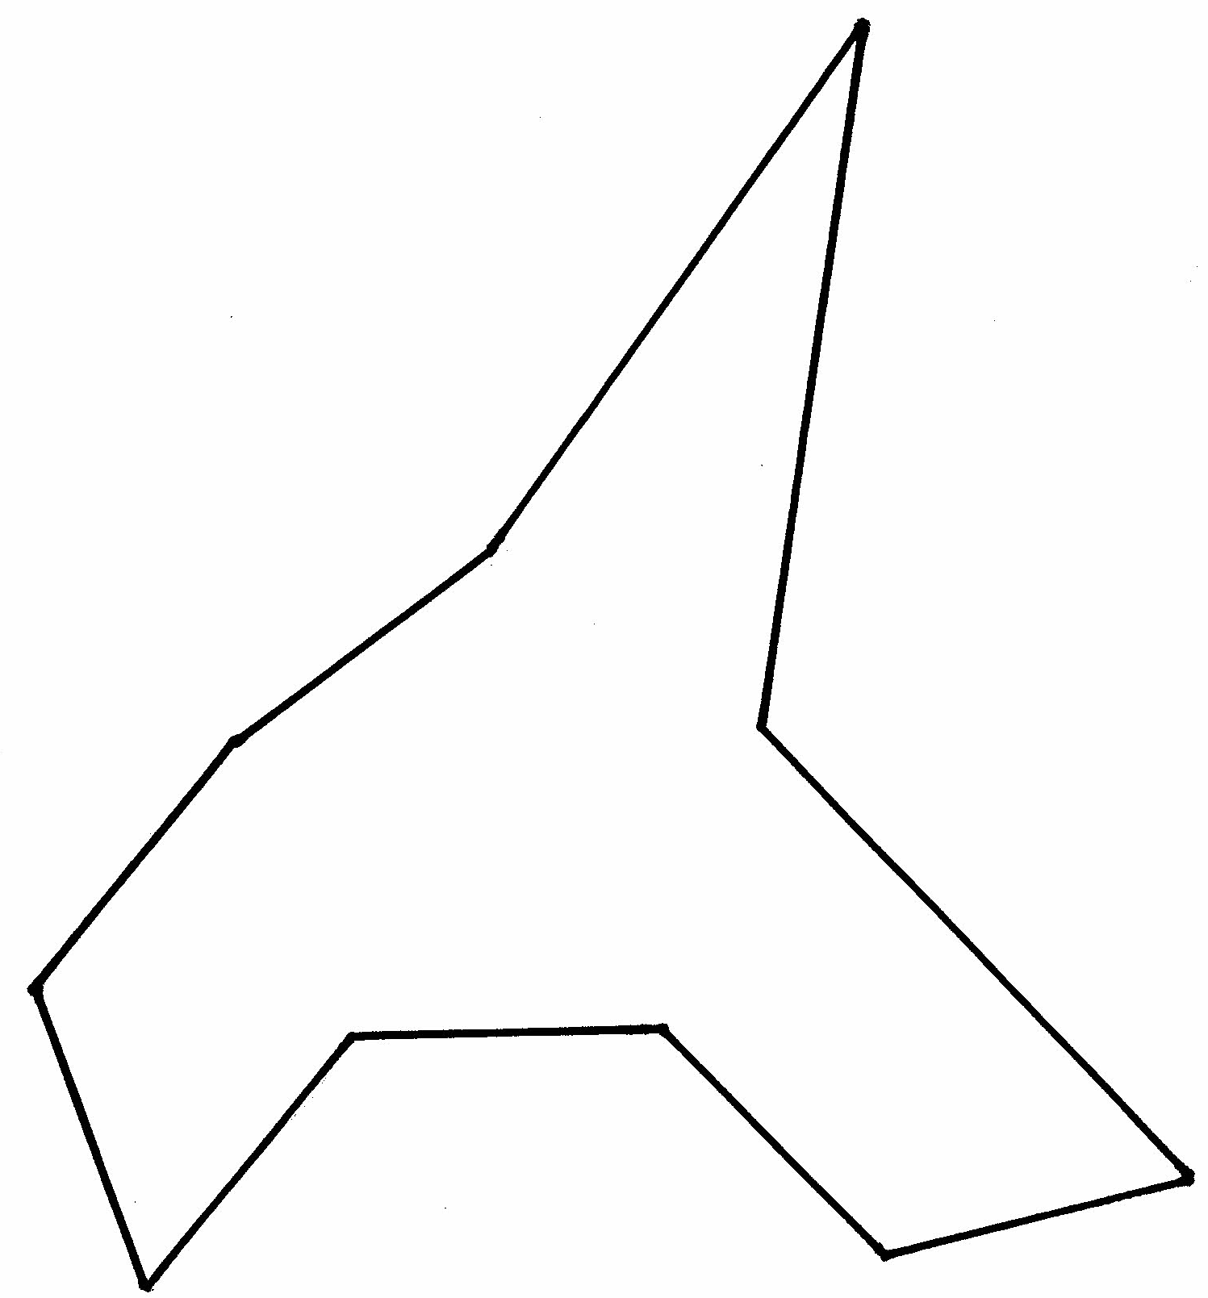
F

Shape Puzzles
G

Square

Rhombus

Compare Shapes

A
B

How are these two shapes alike?

How are they different?

How would you describe the angles in each shape?

(From EMPower Over, Around, and Within, Student Book, p. 14)

Shape Scavenger Hunt

Look around your home. Where do you see…
Squares | Rectangles
Triangles | Right angles
Parallel Lines | Symmetry

Sort Shapes

Creating Shapes

Study Strategy
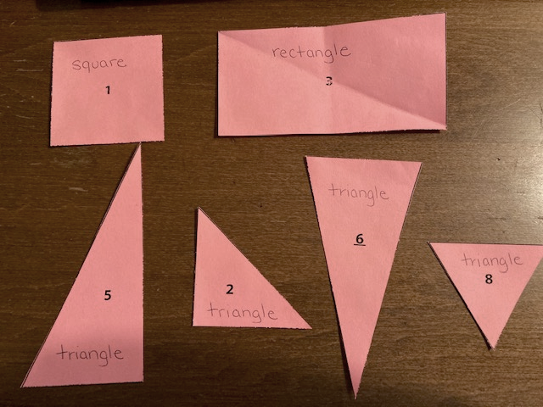
1. Label the shapes in your Shape Set with the name of each shape.
trapezoid
triangle
octagon
triangle
rhombus
hexagon
triangle
pentagon
triangle
rectangle
square
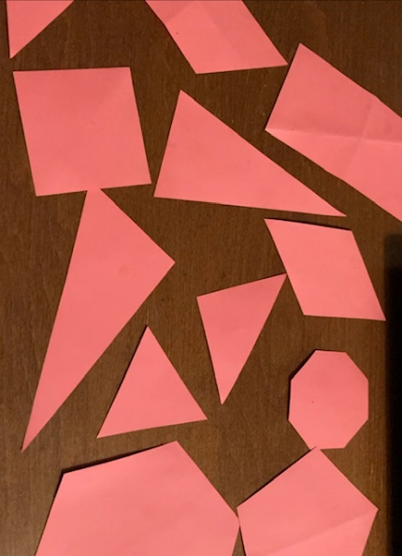
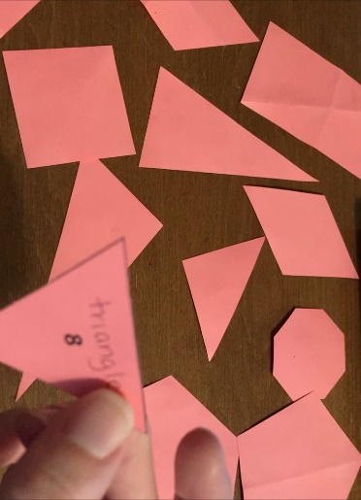

2. Turn the shapes over so that the names are facing down.
Can you find the
- triangles?
- square?
- rectangles?
- trapezoid?
- rhombus?

3. Check each one by flipping it over to see if you are correct.

Common Shapes

 | Name of shape | Describe it | Where do you see this shape?
A | Square
B | Rectangle
C | Triangle
D | Trapezoid

 | Name of Shape | Describe it | Where do you see this shape?
E | Pentagon
F | Rhombus
G | Hexagon
H | Octagon

Is It a Rectangle?
A rectangle is a shape with four sides and four right angles.
The opposite sides are equal length.

For each shape, decide if it is a rectangle. Check three things:
- Does it have four sides?
- Does it have four right angles?
- Are the opposite sides equal length?
C
B
I
G
D
A
E
F
H

Design Challenge

(From EMPower Over, Around, and Within, Student Book, p. 18)

Create a Design
Use the shapes in your Shape Set. Trace the shapes on a blank piece of paper to create a design. Try to cover as much of the paper as possible.

Here is an example:
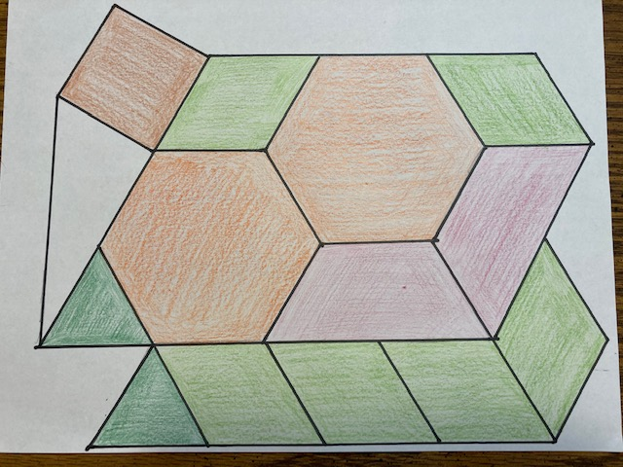
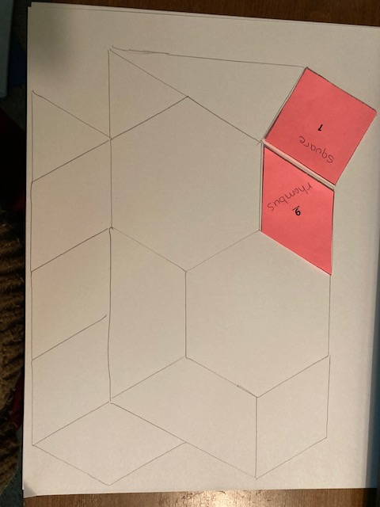

Which shapes were the easiest to fit together?

Which shapes were the hardest to fit? Why?

Geometry Quiz

1

3
2

4
5

Square Dot Paper – Large

Square Dot Paper – Large

Square Dot Paper – Small

Square Dot Paper – Small

Triangle Dot Paper – Large

Triangle Dot Paper – Large

Triangle Dot Paper – Small

Triangle Dot Paper – Small

