In response to multiple requests from the field, we’ve asked instructors who have been teaching math remotely to suggest a list of manipulatives that students can use at home. We’ve included a wide range of options for different learner levels. You will need to decide which ones are appropriate for your students.

Items already available at home (check with your students)

- Scissors
- Scotch tape
- Measuring tapes
- Scrap paper
- Items for counting
(pennies, buttons)
- Measuring cups and spoons
- Different size "cups"
- Different size containers
(pint, quart, half gallon, gallon, liter)
- Rulers
(see below for printable rulers)

To be provided by program
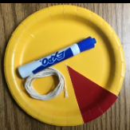
- String (enough length to be used for multiple purposes)
- Paper plates (for data activities; see Paper Plate Pie Chart instructions here)
- Graph paper (grid size —for example, 1-cm grid vs. ¼-inch grid —depends on the task and level of students. See next page for printable templates if not buying in a pad or pack.)
- Homemade whiteboards (made of clear plastic sleeves with card stock inside to give rigidity; useful for when students want to write and hold up their work to a computer screen or phone camera)
You can use inserts with the whiteboards, depending on your needs, such as plain white paper to give the appearance of a whiteboard, grid paper, fraction strips, or a number line, etc.

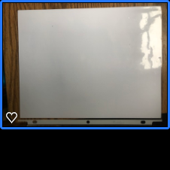
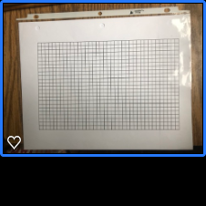
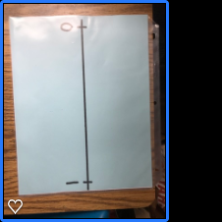
Photos: Heather Palmer, Middlesex Community College

Don’t forget to include dry erase markers and erasers (pieces of felt work, too) so students can reuse their ‘whiteboards’.
Printable Items
For items that will be used as manipulatives, we suggest printing on cardstock to improve durability.

- Grid and Dot Paper
https://incompetech.com/graphpaper/
- Rulers (Be sure to print "Actual Size".)
https://printable-ruler.net/all-rulers/
- Pattern Blocks
http://www.raebear.net/goodies/patternblocks/printableblocks/
- Protractor (Be sure to print "Actual Size".)
https://www.inchcalculator.com/printable-protractor-download/
- 1-inch Square Tile Graph Paper
(can be cut into 1-inch tiles for making arrays, etc.)
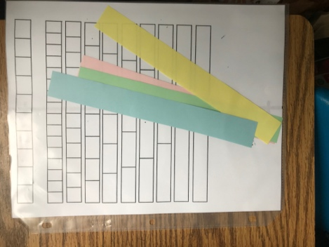
https://free-printable-paper.com/1-inch-graph-paper/
- Dice (for statistics as well as number sense activities).
http://www.clipartbest.com/download?clipart=7TaogbGbc
- Fraction Strips printable template
(or create your own using strips of colored paper)
https://tinyurl.com/RemoteMathManipulatives
- Algebra Tiles
https://tinyurl.com/RemoteMathManipulatives
Photo: Heather Palmer, Middlesex Community College

