BeCALM Part 1:
Number Sense
Beginning Curriculum for Adults Learning Math Remote-Ready Curriculum for GLE 2–4
STUDENT PACKET

Created with funding from the Adult and Community Learning Services division of the Massachusetts Department of Elementary and Secondary Education by the SABES Mathematics and Adult Numeracy Curriculum & Instruction PD Center, which is managed by TERC, Inc.

Created with funding from the Adult and Community Learning Services division of the Massachusetts Department of Elementary and Secondary Education by the SABES Mathematics and Adult Numeracy Curriculum & Instruction PD Center, which is managed by TERC, Inc.
Acknowledgement
The titles in the BeCALM series were developed by Melissa Braaten for the SABES Mathematics
and Adult Numeracy Curriculum & Instruction PD Center, with contributions from Sherry Soares.

Excerpts and adaptations from the EMPower series title Everyday Number Sense: Mental Math and Visual Models © TERC. Used with permission.

Estimation is the ability to judge the size or amount of something. Estimation does not give us an exact answer, but helps us to have an idea of “about how much” we have.
I get paid $11.25 per hour.
When I see my schedule, I multiply the number of hours I work by 10
to estimate what my paycheck
should be.

I never use measuring cups
when I cook, but I know how full the pot should look and how much water to add, and the rice always comes out right.

Share an example of when you estimate in your daily life.

Number sense is the ability to break apart and put together numbers in useful ways that make them easier to work with.
OK, that’s 86 dollars in tips.
I have to split them with Ayanna. So if
we share the $80, we each get $40, and if
we share the $6, we each get $3.
We should each get $43.
I worked
8 hours

8 hours and I get paid $16
per hour. Let’s see... I know that $10 times 8 hours is $80, and $6 times 8
hours is $48, so I should get
paid $128.

Share an example of how you use number sense in your everyday life.
“Street Math” and “School Math”
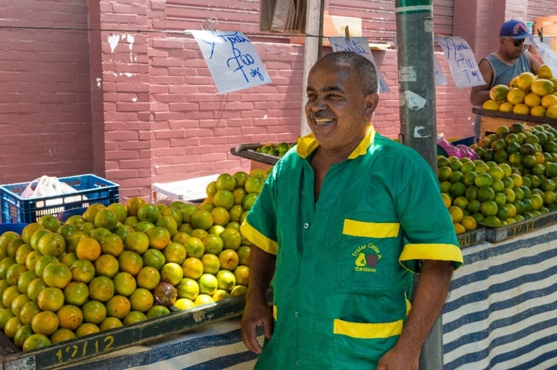
street vendors:
people who sell something, like food or clothing, out of a stall or a cart instead of a store

accurate: correct, exact

Street vendor in Saúde Street Market, São Paulo, Brazil.
Photo by Wilfredor, CC license

Some children work as street vendors in Brazil. Researchers studied how they did math. When they were selling, they did math differently than when they were in school. When they were selling, they used strategies to break down numbers in their heads. They could calculate without paper. In school, the same children did math on paper, using the steps they were taught. When these children did math in their heads while selling, they were much more accurate than when they did math in school.

Source: Adapted from Mathematics Learning - Numeracy And Culture - School, Cultural, Teachers, and Children - StateUniversity.com https://education.stateuniversity.com/pages/2205/Mathematics-Learning-NUMERACY-CULTURE.html#ixzz6WhZj0qb9
Questions for Discussion
- Do you have strategies for using math in your daily life that are different from the steps you learned in school?

- Where do you see examples of people using “street math” in the culture or community you grew up in?

- The children they studied were more accurate when they were using their own strategies than when they were following the steps they were taught in school. What is the value of math education for these children? What do you think their math education should look like?

UNIT 1: Estimation and Adding
Saving Money on Coffee
By Rahaf Almasri
My typical day can’t start without a cup of hot coffee. Buying my coffee from a coffee shop would cost me $2.50 daily, which would add up to $75 a month. However, one cup of homemade coffee costs about $1, which would add up to $30 per month. So, to save some money, I will make my coffee at home.
Rahaf Almasri was a student in the TASC program at the Central Library in Brooklyn, NY. She is a Syrian mother who chose to take a chance on education in hopes of becoming a mathematics teacher to help immigrant students. The paragraph above appears in her article, “Math in Our Daily Lives”, published
in The Change Agent, Issue 47 “Math”, September 2018.
Do you think Almasri is using estimation to help her figure out the cost of coffee? Why?

Have you ever tried to estimate the monthly cost of something you use daily? How could that be helpful?
About How Much?

$1.95 + $3.95 a) $4 b) $5 c) $6

$12.75 + $3.19 a) $15 b) $16 c) $17

$1.05 + $6.00 + $19.99 a) $25 b) $27 c) $29

Source: EMPower book Everyday Number Sense: Mental Math and Visual Models
Agree or Disagree?
These are the amounts that Lianne spent on groceries over the past four weeks.

$109 $25 $76 $18

She wants to know her total for the month.

Source: EMPower book Everyday Number Sense: Mental Math and Visual Models
Which One Doesn’t Belong? 1

Choose one item in this picture that you don’t think belongs with the rest. Explain why.

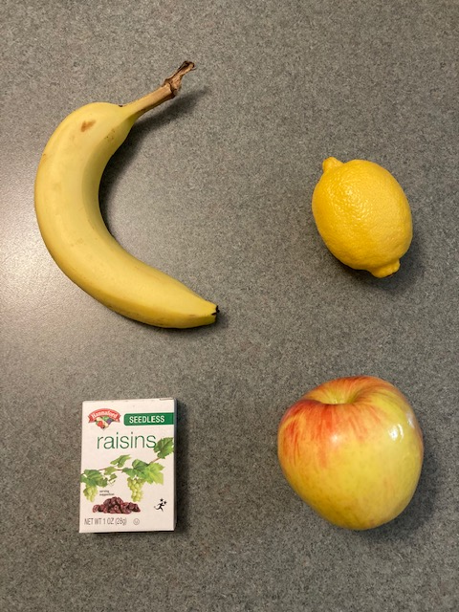
Now pick another item and explain why it doesn’t belong.

Adding Two-Digit Numbers

Directions: Using the digits 1 to 9 at most one time each, fill in the boxes to make the smallest (or largest) sum.

Source: https://www.openmiddle.com/ - Robert Kaplinsky
Open Middle© problems are licensed under a Creative Commons Attribution-NonCommerical-ShareAlike 4.0 International License

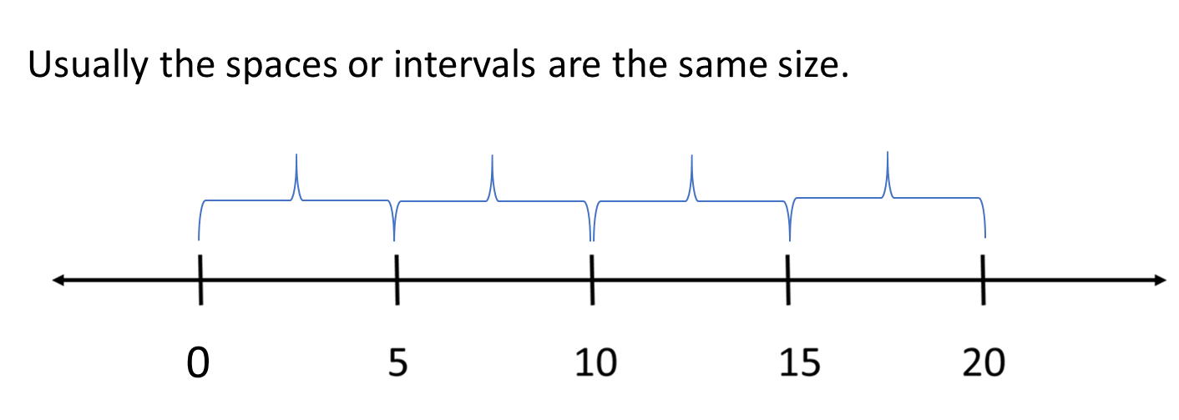
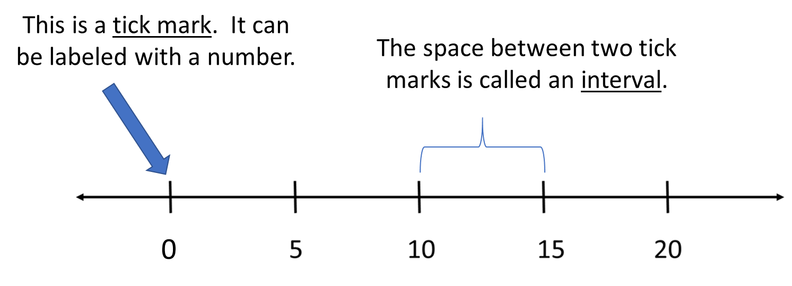
Introduction to Number Lines
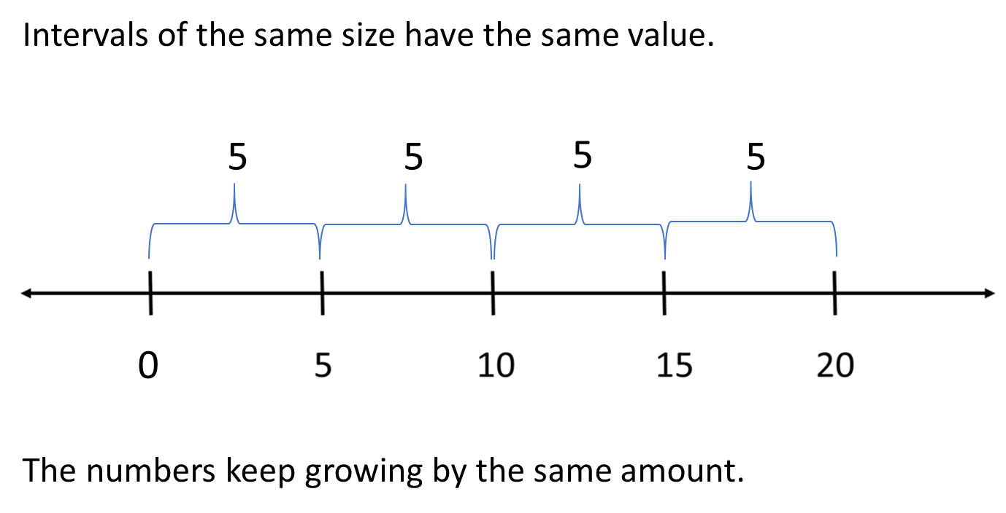

Number Line Puzzles 1a
Fill in the missing numbers.
A

15
12
6
3

B

15
10
0

C

125
75
0
25

Create your own number line puzzle below.

Number Line Puzzles 1b
Fill in the missing numbers.
A

16
12
4
0

B

20

80
60

C

375
325
300

425

Create your own number line puzzle below.

Name ____________________ Date ________________

Number Sense: Unit 1, Estimation and Adding

Objective | My Progress  (Struggling, Learning, Mastery)
- I can estimate the total when adding several amounts.
- I can explain my strategy for estimating to others.
- I can give a reason why one choice doesn’t belong with the group.
- I can keep working on a challenging problem even if I don’t understand it right away.
- I can fill in missing numbers on a number line.

UNIT 2: Rounding
Rounding at the Grocery Store
I use rounding when I am food shopping. I always round, for example, if something is $2.79, I round it to $3. When I am in the grocery store, I always over-round, I never under-round. It helps me with money management, to make sure that I always have enough and don’t go over. For example, if I have $150 to spend, I make sure that I don’t go over $140, because of tax. Rounding makes it quicker to keep track in my mind, and I don’t have to use a calculator.
— Kimberly, adult education student, Boston, MA

Questions for Discussion
- Do you ever use rounding to help you make numbers easier to work with? Where and when do you do this?

- The author said, “I always over-round.” What might be the advantage of always rounding up in this situation?

Is It Closer to... ?

$0.75

$2.39

$4.85

$8.67
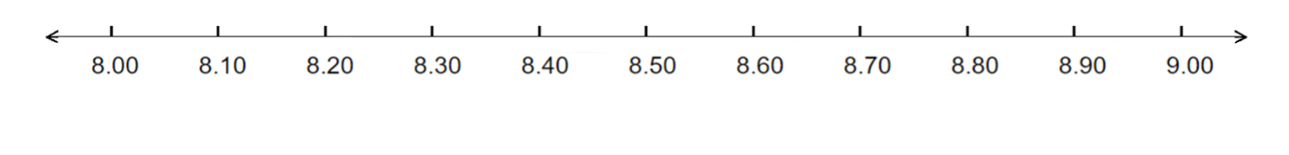
$0.33

$12.55

$17.85

$201.14
Notice that the numbers at the arrows are $1.00 apart.
This is called rounding to the nearest dollar.
Rounding to the Nearest Dollar

Source: EMPower book Everyday Number Sense: Mental Math and Visual Models
Is It Closer to…? Part 2
7

57

63

98
3

102
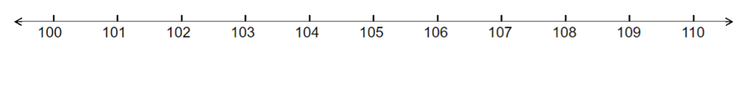

124

769

Notice that the numbers at the arrows are 10 apart.
This is called rounding to the nearest ten.
Rounding to the Nearest 10

Example: $19 $20

- $46 ________________
- $29 ________________
- $85 ________________
- $91 ________________
- $108 ________________
- $226 ________________
- $272 ________________
- $391 ________________
- $412 ________________

Which One Doesn’t Belong? 2

Choose one shape in this picture that you don’t think belongs with the rest. Explain why.

Now pick another shape and explain why it doesn’t belong.

Missing Digits

Fill in the blanks with digits to make the answer closer to 200 than 300.
Source: https://www.openmiddle.com/ - Marilyn Burns and Graham Fletcher
Open Middle© problems are licensed under a Creative Commons Attribution-NonCommerical-ShareAlike 4.0 International License

Number Line Puzzles 2
Fill in the missing numbers.
A

$1.04
$1.06
$1.10

$1.02

B

$2.00
$2.10

$2.20

C

$2.00

$3.50

$3.00

Create your own number line puzzle below.

Name __________________ Date ______________

Number Sense: Unit 2, Rounding

Objective | My Progress  (Struggling, Learning, Mastery)
- I can round to the nearest dollar or the nearest ten dollars.
- I can give a reason why one choice doesn’t belong with the group.
- I can keep working on a challenging problem even if I don’t understand it right away.
- I can fill in missing numbers on a number line.

UNIT 3: Combining

Help Me, Mom!
By Abir Yousef
When I was a small girl, I said, “Mom, please help me with my math homework.” I didn’t have anyone to help me. She cried because she didn’t go to school when she was a girl. This was so hard for me. I practiced by myself for a long time. I feel I am strong in life. Math is important. I did well in math. I remember my teacher in school told me, “In the future, you must study to be an engineer.”
My children like math and they do well too. Sometimes they tell me, “Mom, please help us.” But I feel sad because it is hard to help them. I need more English. When my children were small, I could teach them math. As they’ve gotten older, some of the problems are too hard. Sometimes, it takes me one hour to find the right answer. Now I learn English to help me in math also. I use math all the time in my life. I want to find a job very fast and math will help.
Abir Yousef is a student at the IRIS Mother & Child ESOL Program in New Haven, CT. She is from Syria, where she studied psychology at Damascus University. When she went to Jordan, she worked for the International Rescue Committee helping refugees. Now she wants to study to be an ultrasound technician in the USA and work part-time because she has seven children. The piece above was published in The Change Agent, Issue 47 “Math”, September 2018.
Reflect: What was your experience as a child getting help with math? What is your experience as an adult helping children with math?

Closest Answer

Source: EMPower book Everyday Number Sense: Mental Math and Visual Models
How Much Money Is in the Jar?
Write down five combinations that equal one dollar.

Use mental math to add the following amounts.

$0.10 + $0.20 + $0.30 + $0.40 + $0.60 + $0.70 + $0.80 + $0.90 =

$0.05 + $0.15 + $0.25 + $0.75 + $0.85 + $0.95 =

Source: EMPower book Everyday Number Sense: Mental Math and Visual Models
How Much Money Is in the Jar? Larger Amounts
Write down five combinations that equal $10.

Use mental math to find the total.

$1 + $2 + $3 + $4 + $5 + $6 + $7 + $8 + $9 =

$10 + $20 + $30 + $40 + $50 + $60 + $70 + $80 + $90 =

Source: EMPower book Everyday Number Sense: Mental Math and Visual Models
Which One Doesn’t Belong? 3

Choose one die in this picture that you don’t think belongs with the rest. Explain why.

Now pick another die and explain why it doesn’t belong.

Pyramid Puzzle 3
Each number in the Pyramid is the sum of the two numbers below it. Fill in the missing numbers in the Pyramid. Numbers may repeat.

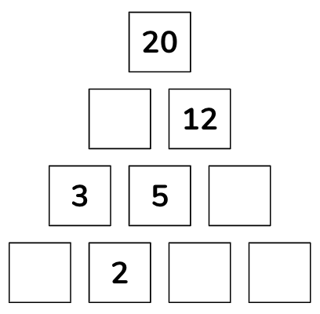

Created by Math for Love. More available at mathforlove.com
Number Line Puzzles 3
Fill in the missing numbers.
A

$66

$78
$62

B

$220
$225
$215

C

$2.75
$2.60

$2.30
$2.15

Create your own number line puzzle below.

Name ____________________ Date ________________

Number Sense: Unit 3, Combining

Objective | My Progress  (Struggling, Learning, Mastery)
- I can find pairs of numbers that add together easily.
- I can estimate the total when adding several amounts.
- I can explain my strategy for estimating to others.
- I can give a reason why one choice doesn’t belong with the group.
- I can keep working on a challenging problem even if I don’t understand it right away.
- I can fill in missing numbers on a number line.

Number Sense Quiz (Units 1–3)
- Estimate a total.
- $11.88 + $18.00
- $4.00 + $8.95 + $5.75

- Round to the nearest dollar.
  - $3.68
  - $56.13

- Round to the nearest $10.
- $23
- $247
Ground Beef for $8.79
Rolls for $3.05
Macaroni Salad for $6.99

- You have $20. Do you have enough to buy these items? Show how you know.
- Add these numbers. Explain or show your strategy.

- 3 + 5 + 5 + 7 + 2 + 4 + 6 + 8
- 25 + 10 + 60 + 40 + 75 + 90

UNIT 4: Gauges

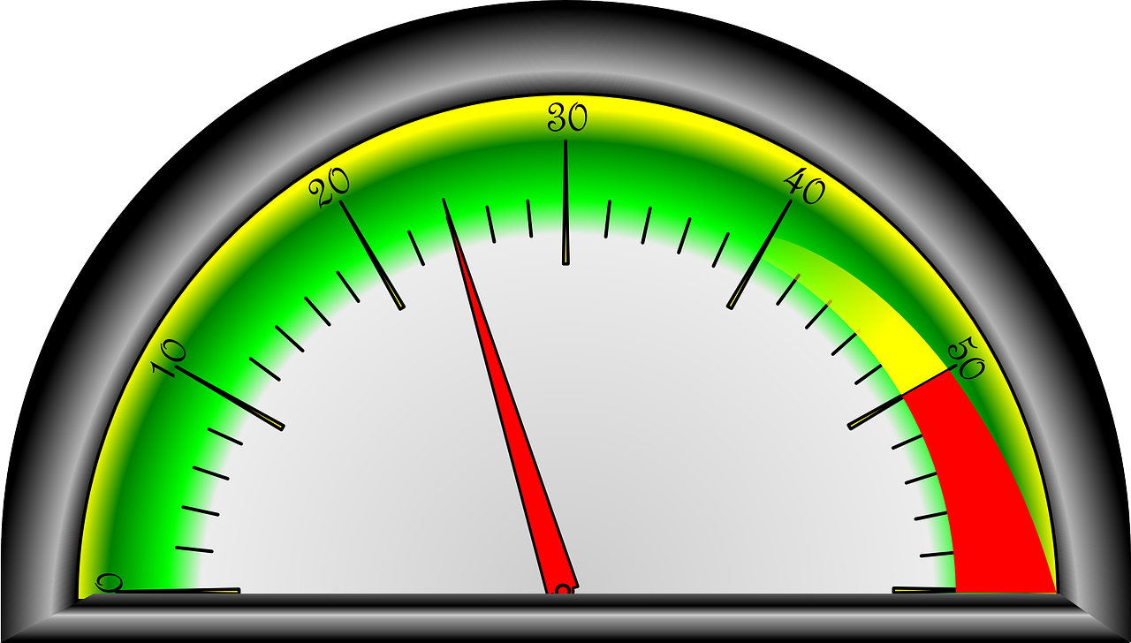

This is a gauge. A gauge is any tool that uses a number line to measure something.
Look closely at the gauge above. What do you notice? What do you wonder?

What do you think this gauge might be measuring?
Examples of Gauges
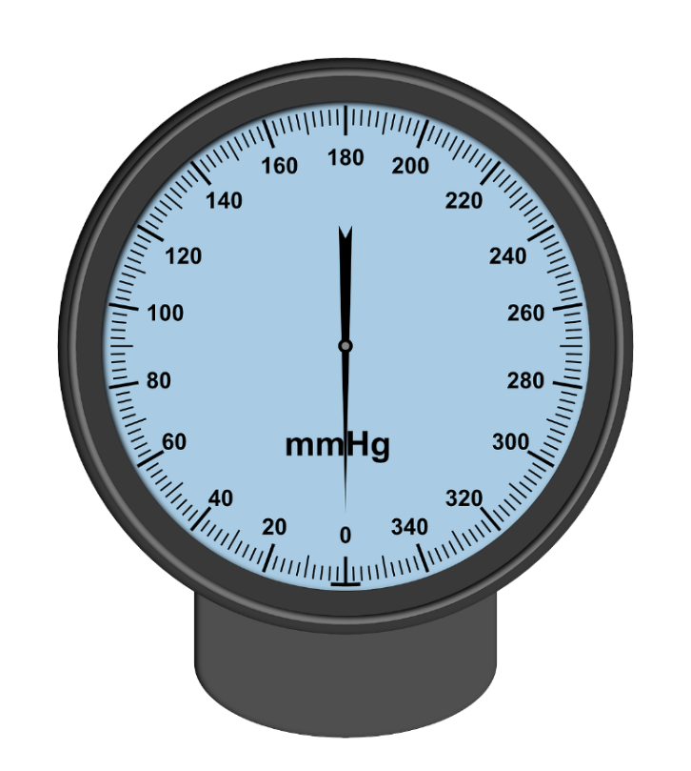
For each gauge, consider:
- What is the smallest interval worth?
- Which numbers are labelled?
- What is are the smallest and largest amounts that this gauge can measure?
- What do you think this gauge would be used for?
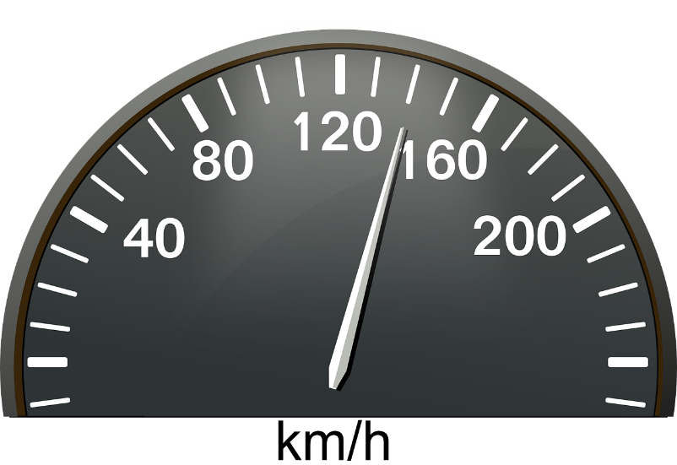
Practice: Reading Gauges
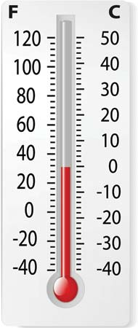
4. What is the temperature shown on this gauge in Fahrenheit degrees? What is the temperature in Celsius degrees?

Explain your reasoning.

Digital Read-out

Source: EMPower book Everyday Number Sense: Mental Math and Visual Models
Which One Doesn’t Belong? 4

Choose one number in this picture that you don’t think belongs with the rest. Explain why.

1 | 5
45 | 150

Now pick another number and explain why it doesn’t belong.

Pyramid Puzzle 4
Each number in the Pyramid is the sum of the two numbers below it. Fill in the missing numbers in the Pyramid. Numbers may repeat.

Created by Math for Love. More available at mathforlove.com
Gauge Puzzles

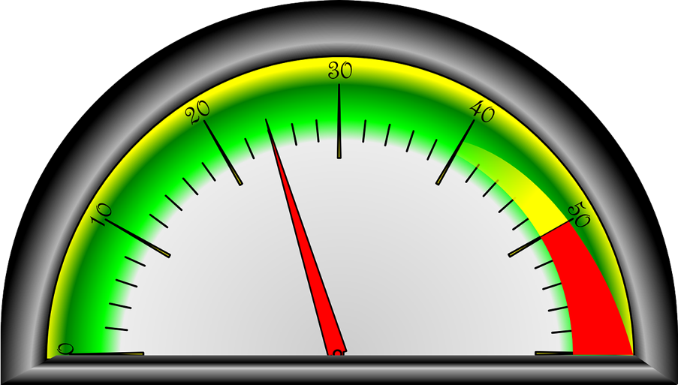

Name ____________________ Date ________________

Number Sense: Unit 4, Gauges

Objective | My Progress  (Struggling, Learning, Mastery)
- I can read a gauge.
- I can give a reason why one choice doesn’t belong with the group.
- I can keep working on a challenging problem even if I don’t understand it right away.
- I can fill in missing numbers on a number line.

UNIT 5: Equations

These are equations.

12 + 3 = 15 1 = 20 – 19

10 + 5 = 6 + 9 0 + 3 + 1 = 2 + 2 – 0

What do they have in common?

What is different? Do any of them surprise you?

What Is an Equation?
An equation is a math sentence. It says that both sides of the equal sign have the same value.

5 + 5 = 3 + 7

This has a value of 10. This has a value of 10.

Equations can look like this, with a single number on one side:

10 + 5 = 15 15 = 8 + 7

or like this, with operations on both sides:

5 + 10 = 8 + 7 2 + 5 = 9 – 2

All of these are true equations, since both sides of the equals sign have the same value.
Make It True

Source: EMPower book Everyday Number Sense: Mental Math and Visual Models
Check Both Sides of the Equal Sign

What’s going on in these equations?

Write another equation that follows this pattern.

Source: EMPower book Everyday Number Sense: Mental Math and Visual Models

Fast Actions with 10 or 100

When you add ten, pay attention to the tens place.
489 + 10 = 499

When you add 100, pay attention to the hundreds place.
489 + 100 = 589

Source: EMPower book Everyday Number Sense: Mental Math and Visual Models
Fast Actions with 9 or 90

Source: EMPower book Everyday Number Sense: Mental Math and Visual Models
Which One Doesn’t Belong? 5
Choose one equation in this picture that you don’t think belongs with the rest. Explain why.

5 + 10 = 15 | 15 = 10 + 5
7 + 8 = 10 + 5 | 15 = 15

Now pick another equation and explain why it doesn’t belong.

Make It Equal

Directions: Using the digits 1 to 9 at most one time each, place a digit in each box to create a true statement.
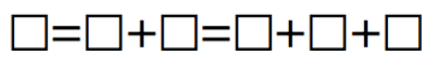
Source: https://www.openmiddle.com/ - Molly Rawding
Open Middle© problems are licensed under a Creative Commons Attribution-NonCommerical-ShareAlike 4.0 International License

Adding Two-Digit Numbers Given One

Directions: Using the digits 0 to 9 at most one time each, fill in the boxes to make a true equation.

Source: https://www.openmiddle.com/ - Robert Kaplinsky
Open Middle© problems are licensed under a Creative Commons Attribution-NonCommerical-ShareAlike 4.0 International License

Number Line Puzzles 5
Fill in the missing numbers.
A

14

21
42

B

400

100

C

36
48
24

Create your own number line puzzle below.

Name ____________________ Date ________________

Number Sense: Unit 5, Equations

Objective | My Progress  (Struggling, Learning, Mastery)
- I can write a true equation.
- I can give a reason why one choice doesn’t belong with the group.
- I can keep working on a challenging problem even if I don’t understand it right away.
- I can fill in missing numbers on a number line.

Test Practice
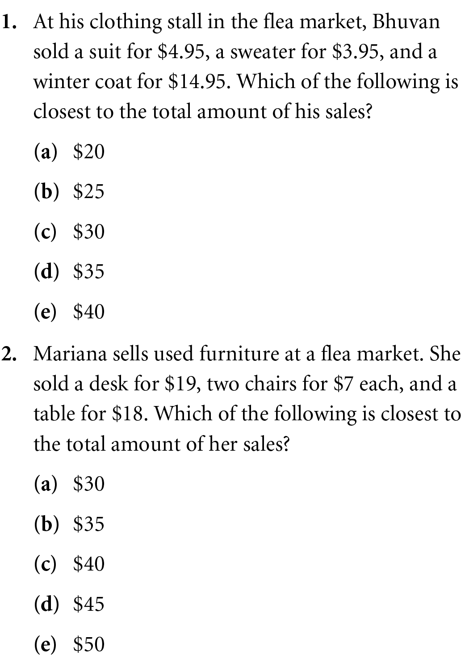

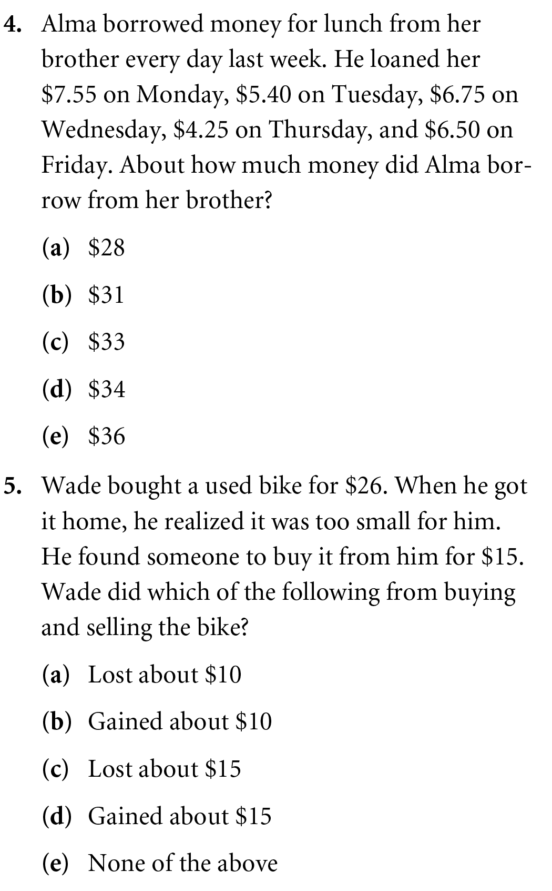
Source: EMPower book Everyday Number Sense: Mental Math and Visual Models
Number Sense Quiz (Units 4 & 5)
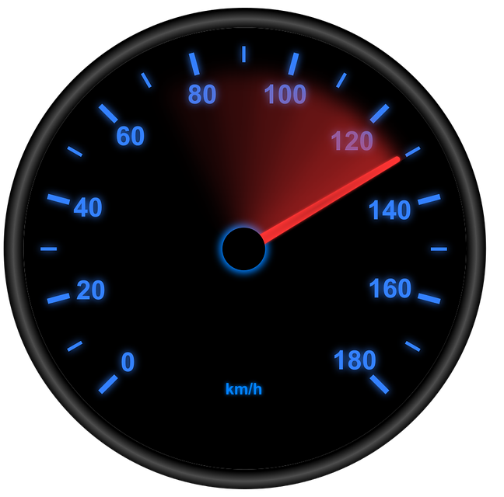
1. This is a speedometer. How fast is the car going?

How do you know?

2. Are the following equations true or false? For each one, explain why.

- 5 = 3 + 2
- 5 + 7 = 12 + 1
- 5 + 6 = 12
- 3 + 2 = 5 + 1 = 6

Blank Number Lines

