Will This Be

on the Test?
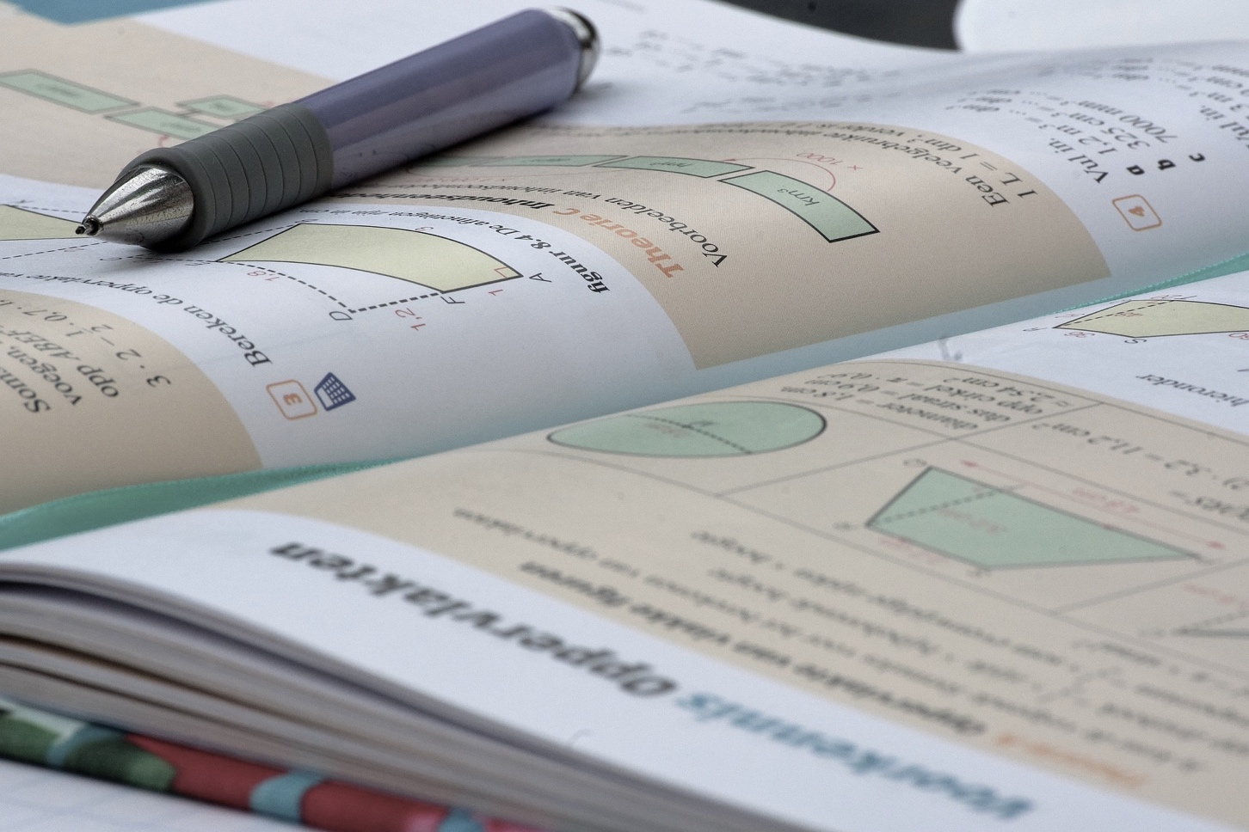

INSPIRATION FOR TACKLING STANDARDIZED TEST QUESTIONS CONCEPTUALLY AND CREATIVELY

Acknowledgements
“Will This Be on the Test?” was developed by the SABES Mathematics and Adult Numeracy Curriculum & Instruction PD Team, managed by TERC, Inc., with funding from the Public Adult Education System of Massachusetts. Copyright © 2024 Commonwealth of Massachusetts.
Authored by Aren Lew
Contributions by Connie Rivera and Yvonne Readdy
Layout and design by Sherry Soares
This document is available for download at https://sabes.org/content/will-be-test-inspiration-tackling-standardized-test-questions-conceptually-and-creatively

“Will This Be on the Test?” would not be possible without the creative mind of Aren Lew of the SABES Mathematics and Adult Numeracy Curriculum & Instruction PD Team. This document is based on their series of the same name, a regular feature on the blog of TERC’s Adult Numeracy Center. Thanks also go out to the blog review team of Heidi Schuler, Donna Curry, and Sherry Soares.
Follow the blog at https://www.terc.edu/adultnumeracycenter/blog/

Introduction
The College and Career Readiness Standards for Adult Education (CCRSAE) call for us to embrace three key shifts in teaching math: focus, coherence, and rigor.
Focus means focusing strongly where the standards focus, not building a curriculum that is “a mile wide and an inch deep”.
Coherence calls us to build strong connections between concepts, helping students build on and extend prior learning to new ideas.
Teaching with rigor means addressing conceptual understanding, procedural fluency, and application all with equal intensity.
What the CCRSAE do not tell us is how to do all of these things and at the same time prepare students for a critical test that will have a huge impact on their future and that covers topics from throughout the K–12 curriculum, especially when our students are with us for a short time or their attendance is inconsistent. It can feel like we have no other option than to focus solely on the test.
However, research shows that it is possible to prepare students for success on standardized tests without making the test the primary focus of our instruction:
In a longitudinal study I conducted in England students worked on open-ended projects for three years (ages 13 through 16) leading to national standardized examinations. They did not take tests nor was their work graded. Students encountered short questions assessing procedures in the last few weeks before the examination, as the teachers gave them examination papers to work through. Despite the students’ lack of familiarity with examination questions or working under timed conditions of any kind, they scored at significantly higher levels than a matched cohort of students who spent three years working through questions similar to the national exam questions and taking frequent tests (Boaler, 1998, 2015).
A curriculum that embraces the three shifts, that digs into conceptual understanding and uses rich tasks that engage students in problem-solving and flexible thinking will prepare students for the math on the test and the math of life. However, it may feel impossible or impractical to ignore high-stakes tests as we plan our lessons. A test is the driving factor for many students. Students’ performance on standardized tests may affect our programs’ funding. And exposure to and practice with the kinds of questions students will see on a high-stakes test can give them a big confidence boost going into it.
The good news is that we can give students that exposure and practice without abandoning our commitment to focus, coherence, and rigor. We can use standardized test questions to help students deepen conceptual understanding, develop procedural fluency, see applications, and build connections between ideas. We can empower students to make sense of test questions that appear to be math they have never seen before. This is not about remembering and reproducing the correct approach to answering a question but about making sense of the task and finding an approach that works.
Of course, there will be questions that students just do not have the necessary background to answer, but there will be many that they can navigate even if they haven’t been taught the specific skill the question is testing. Part of being successful on the test is identifying questions that are not worth a student’s time and making a quick guess on those so as to have more time for those that students can figure out. (See appendix 1 for more on this.) An even bigger part of being successful on the test is having the confidence to think flexibly and attempt questions that look intimidating at first but are actually accessible.

The Test Talk Routine
In this packet, we offer you an instructional routine that will help you create and nurture a classroom culture that values flexible thinking and conceptual understanding and at the same time explicitly prepare students to apply their learning in the context of standardized tests. The bulk of this packet is examples of test-like questions you can use with this routine. Read and attempt them yourself before sharing them with your students. (The test-like questions in this packet can also be found in the ongoing blog series Will This Be on the Test? found at https://www.terc.edu/adultnumeracycenter/blog/. To find posts in this series, use the “search” function at the top of the webpage and type the words “will this be on the test”.)
This routine is called Test Talk and it has a strong focus on sharing and justifying thinking. This promotes Standard for Mathematical Practice #3: Construct viable arguments and critique the reasoning of others. This is especially important when it comes to preparing for standardized tests because, in a test situation, students may panic and resort to a strategy of “number grabbing”—taking the numbers they see in the question and applying some operation haphazardly to get to an answer quickly. Panic can make it difficult or even impossible to reason, so practicing reasoning calmly and constructing viable arguments when faced with test questions will prepare students both mathematically and emotionally for the test.
As with any routine, students are likely to struggle or even be resistant the first few times you do it. Be patient and encouraging. You may offer more support at the beginning to help students get used to the idea that they can approach any test question even if it looks at first like something they are not prepared to answer.
Below is a suggested outline for a Test Talk. It may take about 30 minutes, but this can vary depending on your students and your choice of question. Feel free to adapt it to suit your students.

Test Talk

Purposes:
To help students apply and extend their learning in the context of standardized test questions.
- To solidify learning and act as a formative assessment.
- To empower students to think flexibly and creatively in test situations.
- To build students’ capacity to make sense of problems and persevere in solving them (Standard for Mathematical Practice #1 in the CCRSAE.)
Note: The purpose of a Test Talk is not to teach students how to approach specific test questions or question types.

Process:
- Select a question. Choose a test-like question to present to your students. (There are many examples in this packet.) Choose a question that:
- You have not explicitly taught your students how to do. (A Test Talk is meant to help students learn to think flexibly and creatively in a test setting, so it is important that they be placed in a situation that requires thinking.)
- You believe your students have the fundamental understanding necessary to find a path to the solution.
Further guidance on choosing an appropriate question:
- Many of these questions can be used at almost any point in your curriculum. It is not necessary that the question you choose be connected to work your class is doing currently.
- Choosing a question that is connected to current work can help students build connections and apply and extend their learning or activate prior knowledge at the beginning of a lesson or unit.
- Choosing a question that is not connected to work your class is doing currently can give students good practice making sense of questions without cues about what topic or domain they come from – which they will need to do on the test.
- Set expectations. Share your expectations with your students. Say something like, “I’m going to give you a question like something you might see on a high-stakes test. This may look unfamiliar or intimidating, but I believe you have the skills to make sense of it. I’m going to give you plenty of time to work on it, and I want you to choose the answer you think is correct and be ready to explain why you chose it. This is not about remembering what to do but about using your good thinking brain to figure out a strategy that makes sense.”
- Assign students a question. Share the question and answer choices with your students. This packet includes a handout for every question. (Ensure that everyone understands the words in the question.)
- Give think time. Give students plenty of time to work. Circulate and observe. Offer support and encouragement to students who appear to be frustrated or unable to get started, but do not do the work of making sense of the question for them. (This should become less necessary as students get used to Test Talks.) Here are some ways you can offer support without doing the work for the student:
- Suggest that students read the question again and then try restating it in their own words.
- Encourage students to think about what a reasonable answer might be and to evaluate the answer choices for reasonableness to see if they can eliminate any.
- Encourage students to draw a picture to help them understand relationships in the question.
- For story questions, encourage students to think about what they would do if they were in the situation described in the question.
- Encourage students to focus on what they do know rather than what they don’t know.
- Acknowledge that this is challenging and possibly new and unfamiliar. Remind students that they are capable of dealing with new and unfamiliar things.
- Remind students that it is okay to take their best guess, but that they should have a reason for their guess even if they are not 100% sure it is the right answer.
- Encourage students to use their think time to make sense of the question or to identify what is making them feel stuck.
- If any students find an answer quickly, encourage them to look for other paths to the solution.
- Facilitate strategy sharing. When students have had enough time to come up with an answer and an explanation, invite students to share their thinking out loud or at the board (or shared digital space). (If you must scribe for a student, record their ideas and write their name next to their work, e.g., “Tina’s strategy.”) Elicit as many different approaches as possible. (Do not add or subtract from the student thinking with your own answers or correct wrong answers. All students should agree on the correct answer by the end of the discussion.)
- Share additional strategies. If there is an approach that students did not describe that your students would benefit from seeing, share that approach after all students have shared their ideas. It is not necessary to share all possible strategies, only those that would be accessible and helpful to your students.
- Ensure students have a strategy they like. Make sure all students agree on the correct answer and have seen at least one strategy that makes sense to them. Emphasize that the important thing is that each student is able to make sense of the question and at least one strategy. Students should not worry about making sense of every strategy they see. This is a good place to point out that math can be flexible and creative and the same kind of reasoning is not going to resonate with everyone.
- Encourage notetaking. Have students record their favorite strategy for approaching the question and why they liked it. Give several minutes for students to do this thoughtfully. This will help students connect with and internalize the strategy that made the most sense to them.
- Facilitate a wrap-up discussion. Invite students to share which strategy was their favorite and why. This helps students solidify their learning from the routine and gives them a chance to lift each other up, building community and confidence.
(For formative assessment, you may wish to collect students’ work and review it. However, do not grade or evaluate their work.)

A note about calculators: Unless students are preparing for a test on which they will not be allowed to use calculators, they should be allowed to use them during Test Talks, but you should encourage them to use their calculators judiciously and to support their reasoning.

A Note on Teaching for Equity and Inclusion
Test Talks represent a departure from traditional ways of preparing for the test, and students may resist this shift, especially at first. Students may be invested in traditional ways of teaching and learning because it is all they have ever known. Students may conflate succeeding in math with succeeding in a traditional classroom even if that model has not worked for them, has led them to hate math, or has convinced them that they are not good at it. As teachers, we may feel the same way—holding a loyalty to the way we experienced math as learners even if we see that it doesn’t work for our students. It is hard to break away from how we have known math education.
Some fundamental principles of traditional math education are that there is a proper way to do each problem and that students should practice following the steps until they become automatic. We or our students may have been taught not to use our own reasoning (e.g., “You got the right answer, but you didn’t do it the way you were supposed to do it.”) We may have even been taught implicitly or explicitly not to think for ourselves or ask questions—through learning “tricks” that are meant to make the work easier or save us from having to think. How many of us learned to divide fractions with some variation on “Ours is not to reason why; Just invert and multiply!”? What message did that send us about our own ability to make sense?
It is worth taking a minute to consider where these restrictive ideas about math teaching and learning come from. The traditional ways of teaching evolved in a system that has been guided by the dominant culture, a culture that privileges white, middle-class, heteronormative norms. These are norms that were not chosen by our students. They weren’t even chosen by us as teachers. They have just been the way things are for so long that we have internalized them. And they continue to privilege a particular cultural perspective and exclude people who don’t come from that cultural tradition.
A good place to learn about the norms and characteristics of the dominant culture and how they affect us is at www.whitesupremacyculture.info. There you will find a list by Dr. Tema Okun of “characteristics of white supremacy culture” that are present in many organizations. They show up in math classes, too. One that is particularly prevalent in math classes is “the belief in one right way.”
The belief that there is only one right way to do math, which is a dominant culture norm, runs strongly through traditional ways of teaching and learning math and is reinforced by test-taking and test-preparation culture. It inhibits students. It gets in the way of their growing their own capacity for creative, flexible thinking. And it reinforces the damaging idea that their job is to listen, remember, and reproduce, and not to be thinkers in their own right.
When we teach with Test Talks and other approaches that center students and prioritize conceptual understanding, we are pushing back against the “one right way” toxic belief. We are doing more than preparing our students for the test—we are changing the culture of math class and taking a stand for making math class an equitable and inclusive place for all learners.

Addressing students’ concerns
Your students may have some concerns about Test Talks. Here are some concerns that may arise and some possible responses.
Q: On the test I won’t be able to take as much time as I want for each question. There is a time limit!
A: To do your best on the test, you should give each question that is accessible to you the time it needs for you to get it right. Some questions you’ll just guess on and move on. Others you will take time with and feel sure you have them right. You don’t have to get every single question right or spend the same amount of time on each question. Also, by taking your time and practicing strategies now, you will get faster at reasoning through test questions.
Q: Why do I have to learn all these different strategies?
A: You don’t have to learn many different strategies, but seeing different ways of approaching each question will help you be open-minded and flexible when you see an unfamiliar question on the test. Concentrate on the strategies that really make sense to you and review the reasoning in those strategies – not to memorize, but to understand. Everybody thinks differently, and by sharing our ideas with each other, we can all build our strengths.
Q: Why can’t you just teach us how to answer the test questions?
A: If I teach you my way to do each question, I will be doing the hard work of making sense of the question for you, and you will only know how to do the questions I taught you. To succeed on the test, you need to practice making sense of questions yourself. Through this practice, you will become capable of making sense of questions you haven’t seen before. By struggling with challenging and unfamiliar questions, you are preparing for challenging and unfamiliar questions on the test. You are also making your brain stronger and more flexible. This kind of learning will help you succeed on the test and use your math in the real world or in college.
Q. I’m not good at or won’t have time to draw pictures on the test.
A. Your pictures don’t have to be beautiful, but drawing a picture can help you see the question in a way that you may not from just reading the words or writing down the numbers. It can be hard to remember what to do to answer a question, or you might have never learned what to do in a particular question, but drawing a picture of it can help you see patterns and relationships and you may be able to figure out what to do. Drawing pictures helps you get information into your brain in a different way so it gives you more options for how to think about the question.
Q. But aren’t there questions where I just need to know how to do it?
A. Yes. There will be questions that you won’t be able to answer unless you have learned a specific skill. But what we are doing here is preparing to answer questions that you can figure out. You will probably see questions that are beyond your reach, but that is okay because you don’t have to answer every single question right. Sometimes, you will just take a guess and move on to a question that you can figure out. (See the appendices for more about these types of questions.)

The Questions
In this section, you will find example questions you can use for Test Talks. With each question, you will find:
The understandings students need to make sense of the question
- This is not a list of things to pre-teach but a gauge to help you decide if the question will be a good fit for your students.
- These are the bare minimum understandings students need to be able to have at least one entry point into the question. Often questions are designed to target a particular skill or strategy, but students who learn to think flexibly and creatively can find ways to answer the question even if they haven’t learned that approach. (For example, a question that is solvable using an algebraic equation can also be solved with other approaches.)
A list of several strategies for approaching the question
- These strategies use conceptual understanding, flexible thinking, and visuals as ways to reason about the question. While many of these questions can also be answered using a procedure, you will not find those procedural approaches here. Students who know the procedures to answer specific questions will not struggle with those questions, but Test Talks are meant to help students prepare for those questions for which they do not have a memorized procedure.
- The list of strategies is not meant to be comprehensive. You or your students may come up with exciting approaches that are not listed here!
After the teacher write-up for each question, you will find a corresponding student handout.

Table of Contents

Question 1: Julia’s Photocopy…………………………………………………………………….Page 11
Question 2: José’s Backyard …………………………………………………………….……… Page 15
Question 3: Job Training Application ………………………………………………….…… Page 18
Question 4: Pencils and Erasers ………………………………………………………….…… Page 21
Question 5: Exponent Equivalence …………………………………………….…..……….. Page 24
Question 6: Snail Trail I …………………….…………………………………………………….. Page 27
Question 7: Snail Trail II …………………………………………………….……………………. Page 30
Question 8: Souvenir Sales ……………………………………………………………..………. Page 34
Question 9: Running Laps ……………………………………………………………..………… Page 37
Question 10: Choosing Your Marbles ……………………………………………….……… Page 40
Question 11: Finding “x” ……….……………………………………………………………..…. Page 43
Question 12: Park Playground ………………………………………………………..……….. Page 47
Question 13: Dorothy’s Test Scores ………………………………………………….……... Page 52
Question 14: Alicia’s Earnings ………………………………………………….……………... Page 58
Question 15: Icicles by the Inch ………………………………………………………………. Page 63
Question 16: Mark’s Garden ………………………………………………………………….… Page 67
Question 17: Ordered Pairs ……………………………………….……………….……………. Page 70
Question 18: TV Speed …………………………………………………………………….………. Page 74
Question 19: How Old Is Paulina? …………………………………………………….……… Page 77
Question 20: Price of Pens ………………………………………………………………….…… Page 80
Question 21: Kitty Litter …………………………………………………………………….……. Page 83
Question 22: Alicia’s Appliances …………………………………………………….….……. Page 87
Question 23: A Perimeter Problem ………………………………………………….….…… Page 91
Appendices
Appendix 1: Learning to Let Some Questions Go ……………………………………. Page 95
Appendix 2: On Vocabulary ……………………………………………..…………………….. Page 97

QUESTION 1
Julia uses a photocopier to enlarge a business logo. The original dimensions of the logo were 2” by 3”. Which of the following could not be the dimensions of the enlargement?
- 4” by 5”
- 4” by 6”
- 6” by 9”
- 8” by 12”
- 10” by 15”

Basic understandings needed
Students should have an idea of what it means to enlarge an image. Some of the strategies presented use a more formal understanding of proportional reasoning, but students will likely be able to navigate this with an informal understanding as well.

Strategies students might use
- Draw pictures. A student might sketch rectangles with all the sets of dimensions including the original and eyeball them to see which one looks like it’s not the same shape as the rest of them.
2”
3”
6”
4”
4”
4”
5”
6”
9”
8”
12”
10”
15”
(Original)

- Start with a known enlargement. A student might start by drawing a picture showing a simple enlargement. The simplest way to enlarge a picture is to double both dimensions.
2”
3”
4”
6”
× 2

Based on this picture, a student might reason that there is only one proper enlargement with a 4” height and since doubling the dimensions gave one that is 4” by 6”, an enlargement that is 4” by 5” would not work.
- Compare fractions visually. A student might look at the ratio of the length to the width of the logo as a fraction and visually compare the fractions for each enlargement.
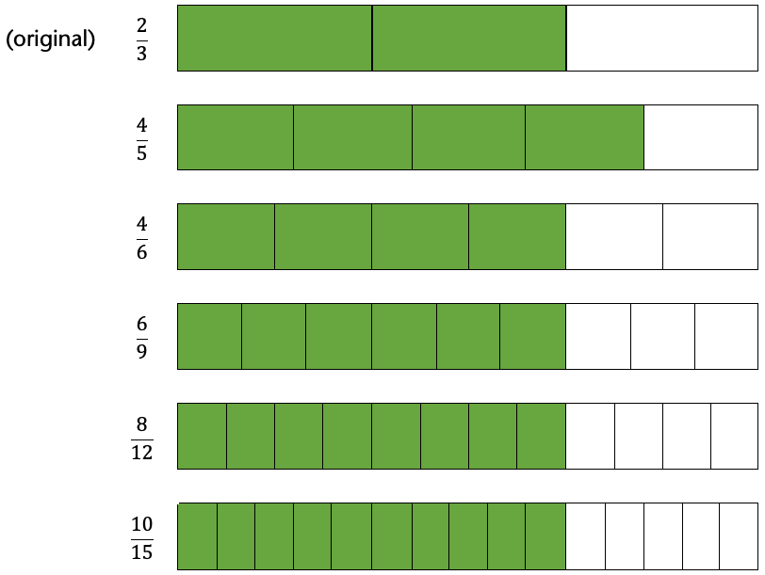

- Look for structure. A student might reason that you enlarge a picture by multiplying both dimensions by the same number and notice that answer choice A is the only one where the second dimension is not a multiple of 3. If they then check by trying to set up equal ratios, their suspicions would be confirmed.
?
times 2
not times 2

$$\frac{2}{3} = \frac{4}{5}$$

My Strategy:
QUESTION 1
Julia uses a photocopier to enlarge a business logo. The original dimensions of the logo were 2” by 3”. Which of the following could not be the dimensions of the enlargement?
- 4” by 5”
- 4” by 6”
- 6” by 9”
- 8” by 12”
- 10” by 15”

My Favorite Strategy:

I like this strategy because:

Basic understandings needed
QUESTION 2
José’s backyard is a rectangle that measures 5 yards by 8 yards. How many square feet of sod will he need to cover the backyard?
- 13
- 40
- 120
- 360
- 400
Students should know the relationship between feet and yards (something you can tell them when presenting the question if necessary). Students should also know what area means and what a square unit is and be able to make sense of “5 yards by 8 yards.” It is not necessary for students to know how many square feet are in a square yard or to have reasoned about these units before.

Strategies students might use
- Estimate using prior experience. A student might rely on real world experience to estimate a solution to this. A student who has experience with landscaping, yard work, flooring, tile, etc., may have an intuitive understanding of about how big this backyard is and about how many square feet of sod it would take to cover it. It is important to connect the math that students learn in the classroom to the math they encounter in the real world. Without this connection, students may come to see “school math” as something separate from their lived experience. They may not realize that they can apply what they already know in a testing situation. A student who does not make this connection can end up panicking over trying to remember a formula instead of using their own mathematical intuition.
- Draw a picture—reasoning about feet and yards.
5 yards or 15 feet
8 yards or 24 feet
A student might start by drawing a picture of the backyard with the dimensions shown in yards, and then divide each yard into feet to see that they should multiply 15 by 24 to find the number of square feet.

- Draw a picture—reasoning about square units. A student might start by drawing a picture of the backyard with the dimensions marked in yards and then figure out how many square feet are in a square yard. Using the knowledge that there are 3 feet in a yard, they could visually divide up the square yard and see that it contains nine square feet. They might then convert the area of the backyard from square yards (40) to square feet by multiplying 40 × 9. Alternatively, they might calculate total square feet in another way, like finding how many square feet are in each column and then adding all the columns together.
5 yards
8 yards

My Strategy:
QUESTION 2
José’s backyard is a rectangle that measures 5 yards by 8 yards. How many square feet of sod will he need to cover the backyard?
- 13
- 40
- 120
- 360
- 400

My Favorite Strategy:

I like this strategy because:

Basic understandings needed
QUESTION 3
A job training program accepted $\frac{4}{5}$of the people who applied.
If 60 people were accepted, how many people applied?
- 12
- 48
- 75
- 80
- 125
Students should understand the meaning of fractions—that the relationship between the numerator and the denominator is the relationship between a part and the whole. Students do not need to know any fraction operation procedures to have an entry point into this question

Strategies students might use
- Estimate! A student who takes the time to make sense of this question and think about which answers are reasonable, will quickly narrow the possibilities down to two answer choices. It takes a little time and effort to figure out the relationships in this question, but it’s worth it. A student might do a quick sketch of the fraction in the question and use it to figure out what they have and what they are looking for:
The whole circle is all the applicants.
The blue parts are the 60 people who got in.
The whole circle must be a little bigger than 60.

Three of the answer choices are bigger than 60 but answer choice (E) is more than twice as big and the sketch shows that the whole circle is only a little bit bigger than the shaded part, so the answer must be (C) or (D).
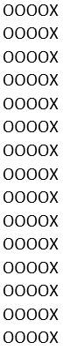
- Think about and draw ratios. A student might interpret the fact that $\frac{4}{5}$ of the applicants were accepted as meaning that four out of every five applicants were accepted. In other words, for every four that got in, one did not. A student might try drawing all the applicants—using quick symbols, it doesn’t take as long as you might think. How many X’s and O’s are in the picture? A student could count them one at a time, count by fives, or think of this as an array and multiply the dimensions.
It’s also possible that after drawing the first few sets a student might start to see some patterns and regularity and ask themself, “how many of these will I have to draw?” Since the student already knows that there are five “people” in each row, answering that question will be a quick way to get to the total. (And here is a place where a calculator might be helpful. Since there are four accepted people in each row, and 60 accepted people total, the number of rows can be found by dividing 60 by 4. Then the total can be found by multiplying the number of rows by 5. Calculators, used judiciously, can help students use their time well and stay focused in test situations.)
- Draw a bar model (or Singapore strip diagram). Bar models are great for making sense of parts and wholes. When students are comfortable drawing and reasoning with them, they provide a way of making sense of the structure of the question that makes answering it fairly intuitive.
People who were accepted (60)
Total people who applied (?)

To answer the question, a student would figure out how many people each box represents. (Four boxes represent 60 people, so how many people are represented by a single box?) Since the total number of people who applied is represented by the whole bar or five boxes, once a student knows how many people each box stands for, they will be able to find the whole in just one more step. (For a similar example using a model like this, see How I Learned to Stop Worrying and Love Percents. Look here for more information on using bar models for problem solving.)

My Strategy:
QUESTION 3
A job training program accepted $\frac{4}{5}$ of the people who applied.
If 60 people were accepted, how many people applied?
- 12
- 48
- 75
- 80
- 125

My Favorite Strategy:

I like this strategy because:

Basic understandings needed
QUESTION 4
Jason bought 3 pencils and 2 erasers for $1.90. Irita bought 4 pencils and 4 erasers for $3.20. How much does 1 eraser cost?
- $0.10
- $0.20
- $0.30
- $0.40
- $0.50
Students should be able to reason with money. Students may benefit from having some intuition about proportional reasoning.

Strategies students might use
- Start by reasoning proportionally, then deduce the cost of a pencil. A student might reason proportionally that if 4 pencils and 4 erasers cost $3.20, half as many pencils and erasers would cost half as much. That means 2 pencils and 2 erasers cost $1.60.



Then the student might compare the cost of 2 pencils and 2 erasers to the cost of 3 pencils and 2 erasers (a picture really helps):
Same number of erasers
One more pencil
$1.60
$1.90
30 cents more

If the only difference between the two pictures is a single pencil and the difference in price is 30 cents, the pencil must cost 30 cents! Once they know the cost of a pencil, the student would have several options for using other information to figure out the cost of an eraser.
- Reason proportionally to find the cost of one pencil and one eraser, then guess and check. A student might reason that they could figure out what 1 pencil and 1 eraser cost together by dividing the cost of 4 pencils and 4 erasers by 4. The combined cost of a single pencil and eraser is $0.80. Knowing what they cost together means that you can find the cost of one if you know the cost of the other. This paves the way for a pretty efficient guess-and-check.
  - If the eraser costs $0.10, then the pencil costs $0.70. This means that the cost of Jason’s purchase would be 3($0.70) + 2($0.10) = $2.40. That’s way too much. (Jason only spent $1.60.)
  - Since the first guess was way off, the student might jump to answer choice c or d. Here’s an exploration of answer choice (C): If an eraser costs $0.30, then the pencil would cost $0.50. This means that the cost of Jason’s purchase would be 3($0.50) + 2($0.30) = $2.10. That’s closer, but still too much.
At this point there are only two possible answer choices. Trying either one will get a student to the correct answer, either directly or by eliminating the other possibility.
- Guess and check. One way to approach this with guess and check is to pick a cost for an eraser based on the answer choices and then figure out the cost of a pencil and see if it makes sense in both purchases. For example, a student might guess that the eraser costs $0.20 (answer choice (B)). Then they might look at Jason’s purchase: 3 pencils and 2 erasers cost $1.60. If the erasers are $0.20 each, they would account for $0.40 of the cost, leaving the remaining $1.20 as the cost of 3 pencils. This means that the pencils must cost $0.40 each. Now the student could check to see if these two costs work out in the larger purchase. 4 pencils at $0.40 each and 4 erasers at $0.20 each would total $2.40. This doesn’t match Irita’s cost, so the guess was wrong.
The student might keep track of their thinking in a table like this (based on starting with Jason’s purchase and then checking with Irita’s purchase):

 | Must add to $1.60
Eraser cost  (guess) | Cost of 2 erasers | Cost of 3 pencils | Cost of 1 pencil | Cost of 4 pencils and 4 erasers | Does it match $3.20?
$0.20 | $0.40 | $1.20 | $0.40 | $2.40 | NO

That was a lot of work to eliminate just one answer choice but remember that there will be questions on the test that are not within students’ reach at all. It’s okay to spend some extra time on a question they have a good chance of getting right.

My Strategy:
QUESTION 4
Jason bought 3 pencils and 2 erasers for $1.90. Irita bought 4 pencils and 4 erasers for $3.20. How much does 1 eraser cost?
- $0.10
- $0.20
- $0.30
- $0.40
- $0.50

My Favorite Strategy:

I like this strategy because:

Basic understandings needed
QUESTION 5
Which expression is equivalent to
$$x^{4}⋅x^{5}$$
- $x^{9}$
- $x^{20}$
- $2x^{9}$
- ${2x}^{20}$
- $20x$

Students should know what an exponent is and be comfortable with the idea that a letter can stand for an unknown number. Students should understand what it means for expressions to be equivalent. It is not necessary for students to have learned or memorized rules about operations with exponents.

Strategies students might use
- Try it with a number. Just because the question is written with variables doesn’t mean it has to be solved that way. One important understanding about equivalent expressions is that they will have the same value no matter what the value of the variable is. This means that a student can change $x$ to a number, like 2, and work out a more concrete question.
$$2^{4}⋅2^{5}$$
$$16⋅32$$
512
Now the student only needs to figure out which answer choice has a value of 512 when $x$ = 2.
Note: Even with a small number like 2, the value of the expression is going to be pretty big, so students might want to use a calculator. (Choosing 1 is not a good idea. Why is that? Could your students see why?)
- Write it out the long way. A student who knows the meaning of an exponent can write equivalent expressions to $x^{4}$ and $x^{5}$ like this:
$$x^{4}=x⋅x⋅x⋅x$$
and
$$x^{5}=x⋅x⋅x⋅x⋅x$$
The student can now multiply the longer expressions together like this:
$$x^{4} x^{5}$$

$$x⋅x⋅x⋅x⋅x⋅x⋅x⋅x⋅x$$

$$Nine x's$$
Now the student can turn their answer back into an exponential expression to match one of the answer choices.
- Figure out the rule on the fly. One of the most powerful tools in a mathematician’s toolbox is being able to figure out how complicated things work by thinking about simpler things. A student who is empowered to think of themself as a mathematician may realize that they have the power to discover or recreate the rule by looking at simpler cases. A student might do a few quick experiments with expressions similar to the one in the question to find out what is going on:

$2^{3}⋅2^{2}=2⋅2⋅2⋅2⋅2=2^{5}$ (Check by hand or with a calculator—that works!)

$2^{3}⋅2^{3}=2⋅2⋅2⋅2⋅2⋅2=2^{6}$ (Check by hand or with a calculator—that works, too!)

Hmmm… the exponents tell me how many 2’s will be in the long expression. It looks like adding the exponents gives me the total number of 2’s, so I can add the exponents to get the final exponent.

My Strategy:
QUESTION 5
Which expression is equivalent to
$$x^{4}⋅x^{5}$$
- $x^{9}$
- $x^{20}$
- $2x^{9}$
- ${2x}^{20}$
- $20x$

My Favorite Strategy:

I like this strategy because:

QUESTION 6
It takes a snail $\frac{3}{4}$ of an hour to get $\frac{3}{5}$ of the way across a garden. If it keeps moving in the same direction at the same rate for another 15 minutes, what fraction of the garden will it have crossed all together?
- $\frac{1}{5}$
- $\frac{9}{20}$
- $\frac{27}{20}$
- $\frac{5}{4}$
- $\frac{4}{5}$

- $0.10
- $0.20
- $0.30
- $0.40
- $0.50
Note: For a question that can be solved with similar reasoning but using less-friendly numbers, see Question 7 (Snail Trail II).

Basic understandings needed
Students should understand the meaning of a fraction and the meaning of rate. Having some benchmark fractions like $\frac{1}{2}$ and $\frac{1}{4}$ and $\frac{3}{4}$ is also helpful.

Strategies students might use
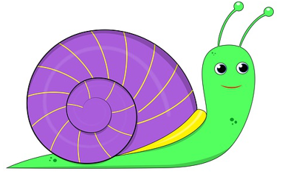
- Estimate! The snail has been traveling for $\frac{3}{4}$ of an hour already and is only going to travel for another 15 minutes or $\frac{1}{4}$ of an hour. Would it get a little farther? A lot farther? Twice as far? A quick sketch could help a student get a handle on what kind of answer might be reasonable:
$\frac{3}{5}$ of the garden in $\frac{3}{4}$ of an hour

The snail is already more than halfway across the garden, so answer choices a and b don’t make sense because they are less than half. Answer choices c and d are both more than one, and it doesn’t look like the snail is going to make it past the end of the garden in only more 15 minutes, so those don’t make sense either. That leaves only one possible answer! (What fraction understandings were used here?)
- Use a bar model (or Singapore strip diagram). A student might start with a bar representing the $\frac{3}{5}$ of the garden the snail has already crossed. (Notice that it bears a resemblance to the sketch above—both show $\frac{3}{5}$.)
Fraction of the garden already crossed

A student who understands that $\frac{3}{4}$ of an hour means three groups of $\frac{1}{4}$ of an hour, will be able to recognize that if the snail traverses three blocks in $\frac{3}{4}$ of an hour, it is covering one block every $\frac{1}{4}$ of an hour. (This is a non-trivial understanding and is important enough to have its own standard in the CCRSAE: Understand a fraction a/b with a > 1 as a sum of fractions 1/b. (4.NF.3))
Filling in the fact that the snail covers one block every $\frac{1}{4}$ of an hour will show the student the total fraction of the garden the snail will have covered after 15 more minutes.
$\frac{1}{4}$ hour
$\frac{1}{4}$ hour

$\frac{1}{4}$ hour

$\frac{1}{4}$ hour

Fraction of the garden already crossed
Fraction of the garden crossed in another 15 minutes
Total fraction of the garden crossed

(Look here for more information on using bar models for problem solving.)
- Reason proportionally. This task is about something moving at a constant rate. In other words, the distance the snail covers is proportional to the amount of time it has been traveling. A student might reason that 15 minutes is one-third of 45 minutes so the snail would cross an additional third of the distance it had already covered. A student who understands that $\frac{3}{5}$ is three groups of $\frac{1}{5}$ can recognize that $\frac{1}{5}$ is one-third of $\frac{3}{5}$, so the snail will cover an additional $\frac{1}{5}$ of the garden.

Distance covered in 45 minutes
One-third of the distance is covered in one-third of the time.

My Strategy:
QUESTION 6
It takes a snail $\frac{3}{4}$ of an hour to get $\frac{3}{5}$ of the way across a garden. If it keeps moving in the same direction at the same rate for another 15 minutes, what fraction of the garden will it have crossed all together?
- $\frac{1}{5}$
- $\frac{9}{20}$
- $\frac{27}{20}$
- $\frac{5}{4}$
- $\frac{4}{5}$

- $0.10
- $0.20
- $0.30
- $0.40
- $0.50

My Favorite Strategy:

I like this strategy because:
QUESTION 7
It takes a snail $\frac{2}{3}$ of an hour to get $\frac{4}{7}$ of the way across a garden. If it keeps moving in the same direction at the same rate for another 10 minutes, what fraction of the garden will it have crossed all together?
- $\frac{6}{10}$
- $\frac{26}{21}$
- $\frac{8}{21}$
- $\frac{5}{7}$
- $\frac{6}{7}$

- $0.10
- $0.20
- $0.30
- $0.40
- $0.50
Note: For a question that can be solved with similar reasoning but uses friendlier numbers, see Question 6 (Snail Trail I).

Basic understandings needed
Students should understand the meaning of a fraction and the meaning of rate. Having some benchmark fractions like $\frac{1}{2}$ and $\frac{1}{4}$ and $\frac{3}{4}$ is also helpful.

Strategies students might use
- Estimate! The snail has been traveling for $\frac{2}{3}$ of an hour (or 40 minutes) already and is only going to travel for another 10 minutes. Drawing a quick sketch can help a student think about how much farther it looks like the snail would get. About how far do you think the snail would get in 10 more minutes?
$\frac{4}{7}$ of the garden in $\frac{2}{3}$ of an hour

The snail is already just over halfway across the garden, so answer choice (C) can be eliminated because it is less than half. Answer choice (A) is more than half, but not by much. From the sketch, it looks like the snail will be well past the halfway point in another ten minutes, so answer choice (A) is not likely. Answer choice (B) is more than one, and it doesn’t look like the snail is going to make it past the end of the garden in only more 10 minutes. There are still a couple of possible answers left. Which one would you choose just from eyeballing the picture? What fraction understandings were used here?
- Use a bar model (or Singapore strip diagram). A student might start with a bar representing the $\frac{4}{7}$ of the garden the snail has already crossed. Notice that it bears a resemblance to the sketch above; both show $\frac{4}{7}$.
Fraction of the garden already crossed

This is where it gets a little trickier. The snail traversed those four blocks in $\frac{2}{3}$ of an hour. A student who understands that unit fractions (fractions whose numerator is 1) are single pieces and non-unit fractions are groups of pieces may reason that those four blocks are covered in two chunks of time that are each $\frac{1}{3}$ of an hour. In other words, the snail covers two blocks every $\frac{1}{3}$ of an hour, or every 20 minutes.
Fraction of the garden already crossed
$\frac{1}{3}$ of an hour or 20 minutes
$\frac{1}{3}$ of an hour or 20 minutes
Alternatively, a student might reason that $\frac{2}{3}$ of an hour is 40 minutes, so the snail covers four blocks in 40 minutes, and use that information to fill in the value of a single block and continue the reasoning from there.
(Look here for more information on using bar models for problem solving.)
- Reason proportionally. This task is about something moving at a constant rate. In other words, the distance the snail covers is proportional to the amount of time it has been traveling. A student might reason that the 10 minutes the snail has yet to travel is one-fourth of the 40 minutes it has traveled so far, so the snail would cross an additional fourth of the distance it had already covered. Thinking about finding $\frac{1}{4}$ of $\frac{4}{7}$ of a garden might make your head spin but looking at the picture of $\frac{4}{7}$ represented as four blocks out of seven makes it easier to see that $\frac{1}{4}$ of $\frac{4}{7}$ is one block.
Distance covered in 40 minutes
$\frac{1}{4}$ of the distance was covered in $\frac{1}{4}$ of the time

My Strategy:
QUESTION 7
It takes a snail $\frac{2}{3}$ of an hour to get $\frac{4}{7}$ of the way across a garden. If it keeps moving in the same direction at the same rate for another 10 minutes, what fraction of the garden will it have crossed all together?
- $\frac{6}{10}$
- $\frac{26}{21}$
- $\frac{8}{21}$
- $\frac{5}{7}$
- $\frac{6}{7}$

- $0.10
- $0.20
- $0.30
- $0.40
- $0.50

My Favorite Strategy:

I like this strategy because:

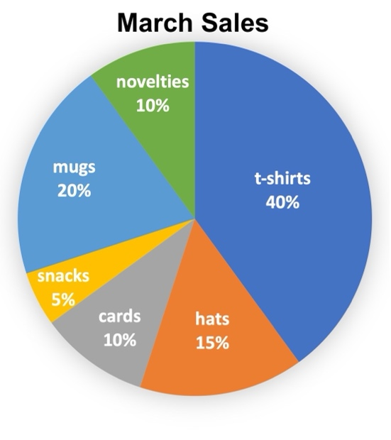
Basic understandings needed
QUESTION 8
Dericia owns a souvenir shop. She made this chart to show the breakdown of the sales she made in March. What is the measure of the central angle of the section of the graph labeled “mugs”?
- 20°
- 40°
- 72°
- 80°
- 200°

Students should understand the meaning of an angle and have some angle benchmarks like 180° and 90°. Students should understand that 100% means the whole.

Strategies students might use
- Estimate! Building familiarity with the sizes of angles, especially by connecting them to things students know in the real world, will prepare students well to eliminate unreasonable answers without any calculation. A student who can eyeball a 90° angle can quickly assess that the angle for the mugs section is less than 90° but not a lot less. How much less? That’s hard to tell but getting down to only two answer choices in the time it takes to eyeball a 90° is a win in a testing situation. (72° and 80° are the only choices that can reasonably be described as a little less than 90°.)
- Measure. Students are not allowed to have protractors in the test and this question is likely on a computer screen, but students can still creatively make use of the tools that they do have. Any student who has a piece of scratch paper can make a quick angle measuring tool by ripping off one corner of the paper and holding it up to the screen. That will quickly show how the angle compares to 90°. Folding the corner in half makes a handy 45° reference. (This is not meant to be a test-taking “trick.” In general, bringing angles into the real world by connecting them to things students know can build understanding and prepare them for the test at the same time. Connecting angles to real objects may help students avoid the trap of confusing the percentage in the section with the measure of the angle.)
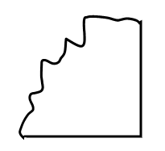
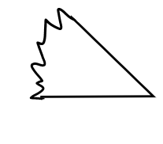
Note: Tearing off the corner of a piece of paper makes a handy reference for 90°. Folding it in half makes 45°.

- Guess and check. A nice follow-up to estimating, whether by eye or with a hand-made reference, is to use guess and check to narrow down those two remaining choices to one correct one. A student might reason like this, adding on groups of 20% until they get to 100%:
If 20% is 80°, then…  40% will be 160°  60% will be 180°  80% will be 240°  100% will be 400°  That’s too much! A full circle is only 360°. | If 20% is 72°, then…  40% will be 144°  60% will be 216°  80% will be 288°  100% will be 360°  That’s just right!
There are other ways to check these guesses. A shorter way would be to multiply each by five because 20% × 5 = 100%. The important thing is that students can bring their knowledge and understandings to bear in a variety of ways.
- Reason proportionally. The guess-and-check strategy is an example of proportional reasoning. Here are some other proportional reasoning approaches a student could take to this task:
  - A student might reason that if 20% is $\frac{1}{5}$ of the whole, then the angle must be $\frac{1}{5}$ of 360°. They could divide 360° by 5 to get directly to the answer.
  - A student could set up and solve a proportion comparing the percent to the whole and the angle to 360°:
$$\frac{20\%}{100\%}=\frac{?}{360°}$$
(Heads up! The cross product is not the only way to solve this using a proportion. There are multiple correct ways to set up this proportion and many solution paths beyond applying the cross product. For example, in this setup a student might notice that the number on the bottom is five times as big as the number on the top in the ratio on the left and reason that they need to find an angle that 360$°$ is five times as big as.)

My Strategy:
QUESTION 8
Dericia owns a souvenir shop. She made this chart to show the breakdown of the sales she made in March. What is the measure of the central angle of the section of the graph labeled “mugs”?
- 20°
- 40°
- 72°
- 80°
- 200°

My Favorite Strategy

I like this strategy because:

QUESTION 9
A lap around a pond is $\frac{2}{3}$of a mile. How many laps does it take to do a 4-mile run?
- 2 $\frac{2}{3}$
- 4
- 4 $\frac{2}{3}$
- 6
- 8

Basic understandings needed
Students should understand the meaning of a fraction. They do not need to have memorized procedures for fraction operations.

Strategies students might use
- Estimate! Estimation is always a good place to start. Even if an estimate doesn’t give a student enough precision to distinguish between answer choices, the process of making one forces them to slow down and make sense of the question. You can’t estimate an answer if you don’t understand the question. Students who are accustomed to estimating will be less likely to panic and just do the first operation they think of with whatever numbers they see. In this case, we are looking for the number of laps needed to run four miles. A student might reason that since one lap around the pond was less than one mile, four laps would be less than four miles. That eliminates two answer choices right away! The student might further reason that since one lap was kind of close to one mile, the answer is more than four but probably not twice as much.
- “Act” it out. The story in this question is pretty straightforward. A student taking a test can’t get up and go find a small pond to run around with a pedometer, but they can draw a picture of it, tracing laps around the pond until they’ve “run” four miles. They could use a table to keep track of the total distance like this.
Laps | Distance Run
1 | $\frac{2}{3}$ miles
2 | $1\frac{1}{3}$ miles
3 | 2 miles

Or they might keep track of the running total like this:

Or they might straighten out the route and keep track of it on a number line:
0
1
2
3
4
1 lap

There are many ways to act out the math on paper! (The scribbled drawing of the laps around the pond may not feel necessary to answering the question, and it may not be necessary, but making a sketch can be a good way of entering a question if you don’t know what else to do. It helps ground your thinking in the context and calm word-problem-induced panic.)
- Reason proportionally. A student who starts “acting out” the situation may get as far as having run 2 miles (3 laps) and realize that they can jump forward. If 2 miles takes 3 laps around the pond, 4 miles should take twice as many since 4 miles is twice as far!
- Divide using a Singapore strip model (bar model). While the approaches we’ve looked at so far mostly relied on repeated addition, this question can also be interpreted as a division task: how many groups of $\frac{2}{3}$ of a mile are there in 4 miles? With a Singapore strip diagram showing four miles divided into thirds, a student can color and count the groups. Every two blocks represents one lap:
Lap 1
Lap 1
Lap 2
1 mile
Lap 2
Lap 3
Lap 3
1 mile
Lap 4
Lap 4
Lap 5
1 mile
Lap 5
Lap 6
Lap 6
1 mile

My Strategy:
QUESTION 9
A lap around a pond is $\frac{2}{3}$of a mile. How many laps does it take to do a 4-mile run?
- 2 $\frac{2}{3}$
- 4
- 4 $\frac{2}{3}$
- 6
- 8

My Favorite Strategy:

I like this strategy because:

Basic understandings needed
QUESTION 10
There are 8 red marbles and 4 blue marbles in a bag. If you choose a marble without looking, what is the probability that you will choose a blue marble?
- $\frac{1}{4}$
- $\frac{1}{3}$
- $\frac{1}{2}$
- $\frac{2}{3}$
- $\frac{2}{1}$
Students’ understanding of probability should include the meanings of these probabilities:
Impossible – probability is 0 or 0%
Unlikely – probability is a small fraction or percent (more than 0 but less than half)
As likely as not – probability is ½ or 50%
Likely – probability is a large fraction or percent (more than half but less than 1)
Certain – probability is 1 or 100%
Students do not need to know probability formulas or procedures to have an entry point into this question.

Strategies students might use
- Estimate! Being deliberate about estimating is a way to develop the habit of making sense of a question before grabbing a calculator or a formula. In this case it’s invaluable because there are several very tempting wrong answers waiting for a student who is in a hurry. A student who pauses to make sense of the question and estimate will quickly realize that since there are fewer blue marbles than red ones in the bag, picking a blue marble is less likely than picking a red marble. This means the probability of picking a blue marble must be less than half, narrowing their options to only two.
- Play “what if?” A student who has gotten off to a good start with an estimate might evaluate the two reasonable answer choices by asking, “what if?” What if the probability of picking a blue marble were $\frac{1}{4}$? What would that mean? It would mean that I would expect to pick a blue marble about $\frac{1}{4}$ of the time if I played many times. Does that make sense with what I know about the marbles in the bag? Looking at what’s there, would I expect to draw a blue marble about one time out of every four or about one time out of every three?
This line of thinking requires another basic understanding of probability—probability tells you what to expect if you do something many times. Things that are unlikely can happen but usually don’t. Things that are likely might not happen but usually do. Want to build this understanding for your students while strengthening their benchmark fractions and percents at the same time? Check out Will It Rain Tomorrow?, a complete contextualized lesson from the SABES Math and Numeracy Team.
- Draw a picture—make groups. Even though the question states that you are supposed to pull a marble from the bag without looking, a student who wants to get a visual handle on the situation can do so by drawing a simple picture using letters to stand for the marbles and make groups like this:
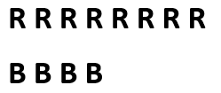

In this picture, each group has only one color of marbles in it and all the groups are the same size. How does this help with understanding the probability? There are three equal groups and only one of them is blue. In other words, one out of three groups is blue, meaning you might expect to draw a marble from the blue group about $\frac{1}{3}$ of the time.


- Draw a different picture—make different groups. Here’s another useful way of visualizing the marbles. To make this drawing, a student might start by drawing the four blue marbles each at the top of a column and then filling in the eight red marbles underneath, keeping the columns even as they go.
In this picture, there are four groups that all look the same. Each has one blue marble and two red marbles. In other words, one marble out of every three in the bag is blue. While the fraction or probability $\frac{1}{3}$ was hard to read in the question, it is a lot more apparent in the pictures.

My Strategy:
QUESTION 10
There are 8 red marbles and 4 blue marbles in a bag. If you choose a marble without looking, what is the probability that you will choose a blue marble?
- $\frac{1}{4}$
- $\frac{1}{3}$
- $\frac{1}{2}$
- $\frac{2}{3}$
- $\frac{2}{1}$

My Favorite Strategy:

I like this strategy because:

Basic understandings needed
QUESTION 11
What is the value of $x$ in the equation?
$$\frac{2}{3}=\frac{x+3}{15}$$
- 2
- 5
- 7
- 10
- 12
Students should have the following two understandings about variables and equations:
- An equation is “true” when the value on each side of the equals sign is the same. This is not a trivial understanding. Many students have the mistaken idea that an equals sign means “do the calculation and put the answer on the other side.”
- The letter in the question above ($x$) stands for a number; there is a number that $x$ can be replaced with that will make the equation true. Students can begin to build comfort with using letters to stand for numbers early by capturing their own generalizations in more formal notation. For example, a student who understands the perimeter of a rectangle as being twice the length plus twice the width can learn to express that relationship as an equation with variables: $P=2×l+2×w$.

Strategies students might use
- Visualize equivalent fractions with bar models. This question looks like a statement about two equivalent fractions, even though one of them has some weirdness going on in the numerator. Setting aside that concern for a moment, a student might try to make sense of the equation by drawing a picture of the fraction $\frac{2}{3}$ and comparing it to a model showing 15ths:

Since the equals sign means that the values on either side must be the same, the number of 15ths must be such that the two fractions are equivalent. The number of 15ths is $x$ and 3 more ($x$ + 3), so a student might count off three blocks on the bottom and then see that the remaining number of blocks is the value of $x$.
3
x
3
x
- Reason about equivalent fractions by multiplying the numerator and denominator by the same number. Students who have developed conceptual understanding of equivalent fractions through working with concrete and visual models (like the bar models above) may reason more abstractly like this:
Multiply by 5
Multiply by 5

$$\frac{2}{3} = \frac{x+3}{15}$$

This means that the value of the circled expression must be 10. At this point a student might ask themself, what number can I add to 3 to get 10? That must be the value of $x$ that makes the equation true.
- Reason about equivalent ratios by making copies of ratios. A student might see this equation as a statement about equivalent ratios instead of equivalent fractions, opening up another avenue of reasoning. The student might make copies of a ratio of 2 to 3 until they had a ratio of something to 15:
1 copy of 2:3
15 triangles all together

As in the first approach, the number of circles is $x$ and 3 more, so the circles can be put into two groups—one with 3 circles and the other with $x$ circles.
3 circles
x circles
This is the $x+3$
This is the 15.

My Strategy:
QUESTION 11
What is the value of $x$ in the equation?
$$\frac{2}{3}=\frac{x+3}{15}$$
- 2
- 5
- 7
- 10
- 12

My Favorite Strategy:

I like this strategy because:

Basic understandings needed
QUESTION 12
What percentage of the area of the rectangular park below is taken up by the square playground?
- 12%
- 30%
- 36%
- 40%
- 75%
Students should understand the meaning of area and be comfortable with a few benchmark percents like 50% and 25%.

Strategies students might use
- Estimate! A student may be able to estimate the percentage of the area taken up by the playground by eyeballing it. How much of the park does the playground appear to take up? It’s tough to say because of how the playground is not centered or lined up with any of the edges of the park, but a student might still eliminate one or two answer choices even from a quick glance.
Note: Different tests have different conventions about drawing diagrams to scale. Your students should know going into a test whether they can expect diagrams to be drawn to scale and should be in the habit of asking themselves whether the measurements appear reasonable before making an estimate based on a diagram. In this case, the length marked 80 ft appears to be more than half of the length marked 150 ft and the lengths marked 60 ft appear to be the same and are less than the length marked 80 ft, so it is reasonable to base an estimate on this diagram.)
- Sketch a new diagram for a better estimate. A student who notices that the placement of the playground makes it difficult to see clearly what fraction of the whole park it takes up might redraw the picture to put the playground in a more convenient place. A rough sketch using some benchmark fractions may make it easier to estimate.
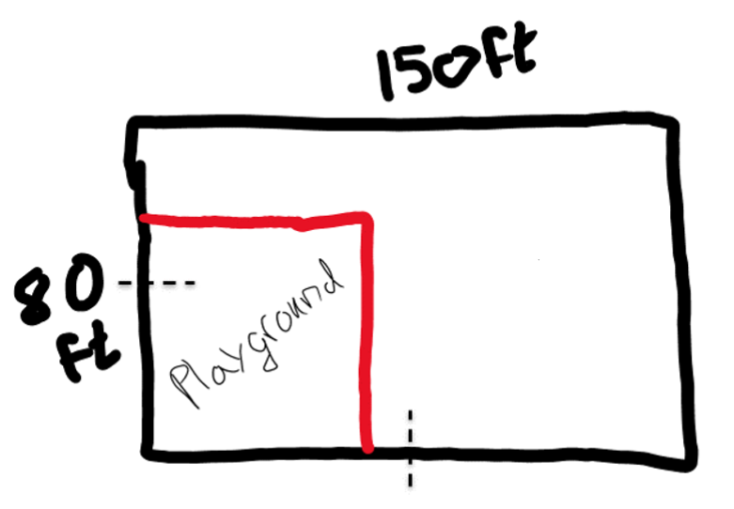
From this sketch, the student may be able to make an estimate they feel more confident about, reasoning that the playground is definitely less than half the area of the whole park, but it appears to be more than half of the left half of the park (or appears to be more than one-fourth of the area because one-fourth is half of a half). See the diagram below if that last sentence was confusing! From here, a student could eliminate any answer choice that is more than half (answer choice E) or less than one-fourth (answer choice A). They might even refine their estimate and eliminate more choices by considering how much less than 50% or how much more than 25% of the park the playground now appears to be.
The playground is more than half the width of the park.
The playground is less than half the length of the park.
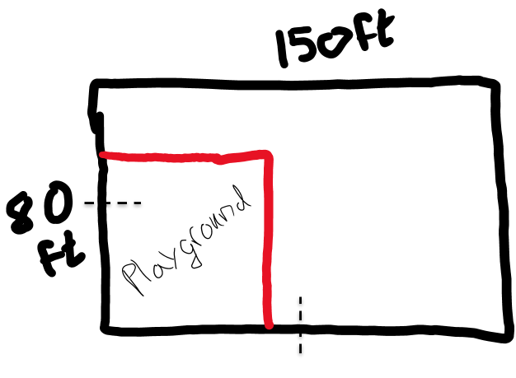
The playground appears to take up more than half of the left half of the park.

- Calculate the areas and estimate with benchmarks. A student could calculate the areas of the playground and the park and use benchmarks to estimate the percent of the park taken up by the playground. The area of the playground is 60 ft × 60 ft = 3,600 square feet. The area of the park is 80 ft × 150 ft = 12,000 square feet. A student might reason about the percent of the park taken up by the playground like this:
The whole park is 12,000 square feet:
12,000 square feet
Half (or 50%) of the park is 6,000 square feet:
6,000 square feet

50%

One quarter (or 25%) of the park is 3,000 square feet:
Playground (3,600 square feet)

50%
25%
?%
The playground is more than 3,000 square feet, but less than 6,000 square feet. It is closer to 3,000 square feet.
3,000 square feet

50%
25%
This model is good enough for a pretty reasonable estimate. In fact, it may be good enough for a student to decide on the most reasonable answer choice.
- Reason about equivalent fractions. One strategy for figuring out percents that is sometimes convenient is creating equivalent fractions until you have a fraction whose denominator is 100. Since a percent is a number of hundredths, rewriting the fraction as hundredths can give you the answer.
Starting with the fraction $\frac{3,600}{12,000}$ a student might reason that the fraction can be read as 36 hundreds out of 120 hundreds and therefore it can be written as $\frac{36}{120}$ because it is 36 things out of 120 things. (In this case, the “things” are hundreds. This way of thinking is more conceptual than the idea of “canceling zeroes” which is often taught a trick.)

From there, one way to get to a denominator of 100 is in two more steps:
Multiply by 5
Divide by 6

$$\frac{36}{120} = \frac{6}{20} = \frac{30}{100}$$

Multiply by 5
Divide by 6

(There are lots of other ways to get to a denominator of 100. How many other ways can you think of? What do you think your students would be likely to do? Many students like to divide numerators and denominators by 2. Could that also be part of a path to a solution?)

My Strategy:
QUESTION 12
What percentage of the area of the rectangular park below is taken up by the square playground?
- 12%
- 30%
- 36%
- 40%
- 75%

My Favorite Strategy:

I like this strategy because:

Basic understandings needed
QUESTION 13
Dorothy has scored 83, 92, 85, and 94 on her first four tests this semester. What does she have to score on the fifth test to have an average (mean) score of 90 for all five tests?
- 88
- 90
- 92
- 94
- 96
Students should understand the meaning of average (mean). They may have one or more ways to find the mean. Several different ways of thinking about mean are used in the strategies below.

Strategies students might use
- Estimate! Estimation is almost always a good entry point into a question that has a “real world” context. In this case, a student who knows that the mean is a way of identifying a “middle” of a set of numbers might start by informally evaluating what Dorothy’s current mean score is. She has two scores that are below 90 and two scores that are above 90, but the scores that are below are further away from 90 than the scores that are above. This probably means her current mean score is less than 90, so she probably needs a score that is greater than 90 to hit the target.
- Think about distances from the target mean. One way to think about the mean as the middle of the set is that it is like a balance point with the same amount of deviation from it on either side. On a number line, this could look like this:

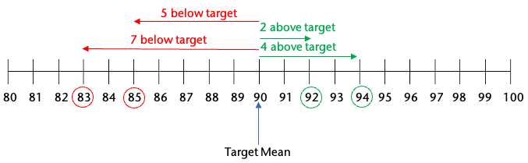

Looking at this diagram, a student can see that the arrows below the target mean have a greater total than those above. What arrow could be added to the number line so that the total less than the target is equal to the total greater than it? What score would that represent?
This reasoning could also be done in a table using signed numbers to denote the distances above and below the target:
Score | Distance from target mean (90)
83 | –7
92 | +2
85 | –5
94 | +4
??? | ???

For 90 to be the mean of the set, the total of all the differences must be 0. What fifth score would make that true?
- Make equal piles. Another useful interpretation of the mean is that it is what each score would be if all the scores were the same. In other words, Dorothy would have a mean score of 90 if all her scores were exactly 90. A student might visualize the scores as stacks of blocks. To keep the visual from being huge, these illustrations only show the tops of them of it. Here’s a model showing all of Dorothy’s scores if you imagine 80 more blocks on the bottom of each stack.
(80 more blocks below this line in each stack)
Target height of 90
Mystery fifth score goes here
83
92
85
94
Here are the scores again, moving some of the blocks around to try to make each of the piles 90 blocks tall.
(80 more blocks below this line in each stack)
Target height of 90
Mystery fifth score goes here
There are still some spaces that need to be filled in. The blocks we use to fill them in will make up the fifth score. Here is a set of scores that are all 90 (so the mean is definitely 90). The new blocks (in solid green) are the fifth score.
(80 more blocks below this line in each stack)
Target height of 90
Here are the scores with all the blocks back in their proper stacks:
(80 more blocks below this line in each stack)
Height of 90
83
92
85
94
This visual may seem very elaborate for something someone might sketch on scratch paper in a test situation. However, students who develop the conceptual understanding of the mean as the value that each number would be if they were all the same will be able to reason through the question like this using much simpler and rougher sketches in the moment.
- Find the total. A student might consider that in the standard procedure for finding the mean, we add up all the numbers and then divide by how many numbers there were. Thinking about this visually, they could imagine that that means putting all the points into one big pile (adding them up) and then dividing that pile into the same number of piles they started with so that all the piles are the same size (dividing by the number of numbers). Because the big pile can be made into 5 smaller piles that are each 90, the student can figure out how big the big pile is. The big pile is also the sum of the 5 individual scores, so the student can figure out the missing score because they know the other 4.
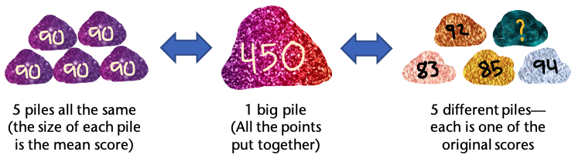
- Guess and check. Even when a situation is not multiple-choice, guess and check can be a good strategy for identifying a missing number. In the case of encountering this kind of question on a test, guess and check gets a little boost because the student already knows the answer must be one of the five answer choices. However, a slightly better strategy is educated guess and check. Before playing plug and chug with the answer choices, students should still make an estimate and use it to inform their first guess – and then use the results of each guess to inform the next. For a detailed example of this, with a similar question to this one, see In Defense of Guess-and-Check.

QUESTION 13
Dorothy has scored 83, 92, 85, and 94 on her first four tests this semester. What does she have to score on the fifth test to have an average (mean) score of 90 for all five tests?
- 88
- 90
- 92
- 94
- 96

My Strategy:

My Favorite Strategy:

I like this strategy because:

QUESTION 14
Alicia works in an appliance store where she earns a base salary of $18.50 per hour plus a 20% commission on any appliances she sells. Last week, she worked 35 hours and sold a dishwasher for $600 and two microwaves for $400 each. Which expression represents her total earnings for the week?
- 0.2 $×$ 2 $×$ (400 + 600) + 18.50
- 35(18.50) + 0.2(600 + 400)
- 35(18.50) + 0.2(600) + 0.2(400)
- 35(18.50) + 0.2(600 + 2 $×$ 400)
- 35(18.50 + 600 + 2 $×$ 400)
Note: This is a variation on Question 22 (Alicia’s Appliances). The scenario is the same, but the question asked is different.

Basic understandings needed
For this question (and questions like it where students have to choose the correct expression), students should understand that expressions are a way of recording thinking and that, just as there are multiple approaches to a question, there are also multiple correct expressions that represent the answer. Students must also understand that different expressions can be equivalent and be able to read and interpret expressions.

Strategies students might use
For this question, the discussion below outlines some ways of teaching and talking about expressions that will prepare students to tackle questions like this. You may want to avoid choosing this question or other “find the correct expression” questions until students have had a chance to build understanding about how expressions record thinking and tell stories and until they are comfortable with Test Talks. The scenario in this question (without the answer choices) can be used as an entry point for learning about expressions.
To build confidence and fluency with writing and interpreting expressions as ways of recording thinking, you might ask all your students to come up with their own expressions for Alicia’s earnings and you can accumulate a large collection of different expressions.

A student might reason about Alicia’s earnings this way:
First, I’ll figure out her earnings from her hourly wage—that’s $18.50 x 35 since she worked 35 hours at $18.50 an hour.
Then I’ll figure out her commission on the dishwasher—that’s $\frac{1}{5}$ of $600 since 20% is the same as $\frac{1}{5}$.
Then I’ll figure out her commission on one of the microwaves. That’s $\frac{1}{5}$ of $400.
Since she sold two microwaves, I’ll add that last number on again for the second microwave.
This reasoning translates into an expression in chunks, just like the student’s reasoning. (Using color to highlight how the parts of the expression correspond to the verbal reasoning can help connect the symbolic notation to the thinking it represents. Students who cannot distinguish colors may choose to use different ways of underlining or circling chunks instead.)
Reasoning | Chunk of Expression
First, I’ll figure out her earnings from her hourly wage—that’s $18.50 x 35 since she worked 35 hours at $18.50 an hour. | 18.50 $× 35$
Then I’ll figure out her commission on the dishwasher—that’s $\frac{1}{5}$ of $600 since 20% is the same as $\frac{1}{5}$. | $$\frac{1}{5} ×600$$
Then I’ll figure out her commission on one of the microwaves. That’s $\frac{1}{5}$ of $400. | $$\frac{1}{5} ×400$$
Since she sold two microwaves, I’ll add that last number on again for the second microwave. | $$\frac{1}{5} ×400$$

All together, the expression looks like this:
$$18.50×35 + \frac{1}{5} ×600 + \frac{1}{5} ×400 + \frac{1}{5} ×400$$
Or like this, if the student chooses to use parentheses to be extra clear about how the thinking is chunked (a practice that is not always necessary, but can be helpful):
$$\left(18.50×35\right)+\left(\frac{1}{5} ×600\right)+\left(\frac{1}{5} ×400\right)+\left(\frac{1}{5} ×400\right)$$
In this way, the student has used mathematical notation to tell a story of their thinking.

Another student might reason differently about Alicia’s earnings:
First, I’ll figure out the total sales she made—that’s $600 for the dishwasher and 2 $×$ $400 for the two microwaves.
Then, I’ll figure out 20% of her total sales by multiplying the total sales by 0.2.
I’ll figure out how much she earned from her hourly wage by multiplying the hours by the wage, so that’s 35 $×$ $18.50.
Translating this reasoning to an expression might look something like this. The student might start by writing their first step as:
$$600+2×400$$
Then continue by multiplying that by 0.2 to get:
$$0.2(600+2×400)$$
And finally add on the result of the third calculation to get:
$$0.2(600+2×400)+35×18.50$$
Asking students to share their thinking and their expressions sets up an important Aha! moment. While there is only one correct answer to the amount Alicia earned, there are many ways to get there, and different mathematical notation can be used to represent the same end value. In other words, different expressions can be equivalent. (This is a key principle underlying what many people think of as “doing algebra.”)
Reading an expression and figuring out the story it tells, can be explored in this same lesson. Have your students trade expressions and try to figure out each other’s thinking. This takes practice, but this cycle of writing expressions to record thinking, recognizing that expressions can be equivalent, and reading expressions with the goal of understanding the story they tell can be repeated many times in different contexts, at different levels, and in different domains. For example, students may come up with many different ways of expressing the perimeter of a rectangle and practice connecting the different formulas that arise to the different ways of thinking about perimeter. (To see a lesson that explores perimeter in this way and connects to using variables in expressions at early levels, see Unit 1, Lesson 4 – Understanding Perimeter with Formulas of the Curriculum For Adults Learning Math (CALM) at https://www.terc.edu/calm.)
Wrapping up a lesson (or several) like this with test-like questions like this one (now presented with the multiple-choice options) can now be a chance for students to practice reading expressions and understanding the stories they tell. The incorrect answers also tell stories, but they are incorrect stories. For example, a student might read answer choice (C) $35\left(18.50\right)+0.2\left(600)+0.2(400\right)$ and realize that it is telling the story of a week where Alicia sold the dishwasher but only sold one microwave. This could be a great extension activity—trying to figure out what story each answer choice tells and whether that story makes sense. For example, answer choice (E) $35\left(18.50 + 600 +2×400\right)$ adds together Alicia’s hourly rate and the value of the items she sold and then multiplies that whole thing by the number of hours she worked. This story says that Alicia makes $18.50 plus the value of all the items she sells every hour that she works. This does not make sense at all!

Two notes on test questions that ask students to choose the correct expression:
- These are not easy problems. Unless a student is lucky enough to think about the situation in exactly the same way the person who wrote the problem did, they will not find their expression among the answer choices. This can cause a lot of anxiety in the moment of taking the test. Students need to be secure in their understanding that there are multiple possible correct expressions so that they do not jump to the conclusion that their thinking is incorrect just because they don’t see their answer in the answer choices. Be careful not to pass on to your students the message that these are easy problems because you only have to find the expression and you don’t have to evaluate it. These problems take time because you have to look closely at each answer choice. Just because it is a multiple-choice question doesn’t mean it is quick and easy.
- There is one test-taking strategy that can make a difference on a question like this. It is valuable for students to have this strategy for the test, but it should not be taught in place of the rigorous learning described above. Students can circumvent the whole issue of figuring out what each expression means by answering the question themselves with a number (Alicia’s actual earnings) and then evaluating each expression to find which one gives the correct answer. This is not necessarily faster, but it is pretty reliable. It is also a strategy that is not useful after test day, as opposed to the ability to write and read expressions which is crucial for moving forward in algebra and beyond.
For an excellent activity and collection of related resources that build the skills and understandings discussed here, check out The Border Problem at CollectEdNY.

My Strategy:
QUESTION 14
Alicia works in an appliance store where she earns a base salary of $18.50 per hour plus a 20% commission on any appliances she sells. Last week, she worked 35 hours and sold a dishwasher for $600 and two microwaves for $400 each. Which expression represents her total earnings for the week?
- 0.2 $×$ 2 $×$ (400 + 600) + 18.50
- 35(18.50) + 0.2(600 + 400)
- 35(18.50) + 0.2(600) + 0.2(400)
- 35(18.50) + 0.2(600 + 2 $×$ 400)
- 35(18.50 + 600 + 2 $×$ 400)

My Favorite Strategy:

I like this strategy because:

Basic understandings needed
QUESTION 15
An icicle grows at a rate of $\frac{2}{5}$ of an inch per minute. How much will the icicle grow in $2\frac{1}{2}$ hours?
- 5 inches
- 12 $\frac{1}{2}$ inches
- 50 inches
- 60 inches
- 150 inches
Students should understand the meaning of a fraction and be able to represent one on a number line or with a diagram. They should also understand the concept of rate.

Strategies students might use
- Estimate! It’s not easy to make sense of a rate like $\frac{2}{5}$ of an inch per minute, but a student who has a strong sense of benchmark fractions may reason that $\frac{2}{5}$ is a little less than $\frac{1}{2}$ (because 2 is a little less than half of 5). Knowing that the icicle is growing at a rate of a little less than half of an inch each minute, a student may reason that it grows a little less than 1 inch every 2 minutes. 2 $\frac{1}{2}$ hours is 150 minutes, so the icicle would grow a little less than 1 inch 75 times (because 150 minutes is 75 groups of 2 minutes).
- Take small steps. Knowing the rate of growth per minute means that we know how much the icicle grows every minute. A student might make a chart to keep track of the growth of the icicle minute by minute:
Wait a minute! $\frac{10}{5}$ inches is the same as 2 inches. Now I know that it grows 2 inches every 5 minutes! I can take bigger jumps in my table!
Minutes | Growth in inches
1 | $$\frac{2}{5}$$
2 | $$\frac{4}{5}$$
3 | $$\frac{6}{5}$$
4 | $$\frac{8}{5}$$
5 | $$\frac{10}{5}=2$$
10 | 4
15 | 6
20 | 8

Maybe I can use this rate to take even bigger jumps!

A few notes about this approach:
- It relies on the understanding that non-unit fractions (fractions with a number other than 1 as a numerator, like $\frac{2}{5}$) are groups of unit fractions (like $\frac{1}{5}$) and that you can count by groups of unit fractions. This is a valuable and demystifying understanding of fractions and is important enough to have its own standard. (Understand a fraction a/b with a > 1 as a sum of fractions 1/b. (4.NF.3)) If you aren’t seeing how this table involves counting by groups of unit fractions, take a close look at the pattern in the numerators in the first part of the table.
- It may seem at first like this approach is too time-consuming, but starting with small steps can reveal patterns that make bigger steps possible and shorten the work.
- Chunk up the time. A student who arrives at the conclusion that the icicle grows 2 inches in 5 minutes may also start to think about how many groups of 5 minutes are in 2 $\frac{1}{2}$ hours:
There are 12 groups of 5 minutes in 1 hour, so there are 24 groups of 5 minutes in 2 hours.
There are 12 groups of 5 minutes in 1 hour, so there are 6 groups of 5 minutes in half an hour.
Therefore, there are 24 + 6 groups of 5 minutes in 2 $\frac{1}{2}$ hours.
In each of those 30 groups of 5 minutes, the icicle grows 2 inches, so it grows 2 inches 30 times.
- Multiply the number of minutes by the amount the icicle grows in each minute. A student can use a memorized procedure to multiply $\frac{2}{5}$ of an inch per minute by 150 minutes but they could also multiply with a visual using bar models. They could use bar models to make 150 groups of $\frac{2}{5}$ (or at least to get an idea of what it might look like if they made 150 groups.)
Here is one group of $\frac{2}{5}$, representing one minute’s growth in inches:

To see two groups of $\frac{2}{5}$ , the student can color in two more blocks. This is 2 minutes of growth—still less than one whole inch.

For a third group, they will need to add in another bar. In three minutes, the icicle will grow 1 $\frac{1}{5}$ inches.

It looks like they can fit two more groups into the model above. Here is a picture of 5 groups of $\frac{2}{5}$. This is 5 minutes’ worth of growth—a total of 2 whole inches.

How would you continue this multiplication model? What connections can you make between this visual and the chunking strategies above? What connections can you make to a procedure you know for multiplying fractions?

My Strategy:
QUESTION 15
An icicle grows at a rate of $\frac{2}{5}$ of an inch per minute. How much will the icicle grow in $2\frac{1}{2}$ hours?
- 5 inches
- 12 $\frac{1}{2}$ inches
- 50 inches
- 60 inches
- 150 inches

My Favorite Strategy:

I like this strategy because:

Basic understandings needed
QUESTION 16
Mark is buying some flower bulbs to plant in his garden in the spring. At the garden store, the large bulbs cost $10 each and the small bulbs cost $4 each. He wants to spend less than $60 on bulbs. The inequality below represents his spending, where $x$ is the number of large bulbs and $y$ is the number of small bulbs he buys.
$$10x+4y<60$$
Which ordered pair (x, y) represents a combination of large and small bulbs Mark can buy?
- (4, 5)
- (4, 6)
- (3, 8)
- (3, 7)
- (2, 10)
Students should understand that letters can stand for unknown numbers or for numbers that can change. To see a lesson that gets students using variables in expressions at early levels, see Unit 1, Lesson 4 – Understanding Perimeter with Formulas in the Curriculum for Adults Learning Math (CALM) at https://terc.edu/calm.
Note: To approach this question, students do not need to be able to write or solve inequalities. The main thing they need to be able to understand is that the first number in each answer choice represents the number of large bulbs and the second number represents the number of small bulbs. It is worth taking the time to struggle through this sense-making.

Strategies students might use
- Remember the context. This question can be answered by checking all the answer choices; however, a student may save some time by considering which answer choices are more likely to work. Mark is trying to spend under $60, so a student might look for an answer choice that has fewer of the more expensive large bulbs without having a lot of the less expensive small bulbs. A quick scan will show that answer choice (B) (4 large bulbs and 6 small bulbs) is not worth checking out because answer choice (A) (4 large bulbs and 5 small bulbs) has the same number of large bulbs but fewer small bulbs, so it must be less money.
- Write out all the possibilities. A question like this can be read a set of yes or no questions instead of multiple choice. For each answer choice, a student can calculate the cost and decide whether Mark can make that purchase.

For example:
Choice (A): 4 large bulbs x $10 each = $40
5 small bulbs x $4 each = $20
Total cost = $60 Too much!

(Remember, the question said Mark wants to spend less than $60, so answer choice a is not correct.)
- Make a chart. A chart is often an appropriate tool to use strategically. Taking a minute to set up a structure for organizing their reasoning can make the reasoning go faster and make mistakes less likely. There are several quantities to attend to in this problem, so laying out the work in an organized way will make a big difference.
Answer choice | # of large bulbs | Cost of large bulbs | # of small bulbs | Cost of small bulbs | Total cost
A | 4 | $40 | 5 | $20 | $60
B
C
D
E

The chart is started for you, but you can finish it. Pay attention to where you see regularity in repeated reasoning. How is filling out this chart similar to plugging in values for x and y in the inequality given in the problem? How is it different?
Bonus: Students and teachers can have a lot more fun and learn a lot more from a scenario like this by exploring it in more open ways than are seen on a multiple-choice test. Asking what combinations of bulbs Mark can buy is much more interesting than asking whether or not he can buy specific combinations. How could you and your students explore that question? What concepts and understandings might come to light through that exploration? What other questions might you ask?

My Strategy:
QUESTION 16
Mark is buying some flower bulbs to plant in his garden in the spring. At the garden store, the large bulbs cost $10 each and the small bulbs cost $4 each. He wants to spend less than $60 on bulbs. The inequality below represents his spending, where $x$ is the number of large bulbs and $y$ is the number of small bulbs he buys.
$$10x+4y<60$$
Which ordered pair (x, y) represents a combination of large and small bulbs Mark can buy?
- (4, 5)
- (4, 6)
- (3, 8)
- (3, 7)
- (2, 10)

My Favorite Strategy:

I like this strategy because:

QUESTION 17
Which ordered pair satisfies the system of equations below?
$$2x -y =11$$
$$x+y =10$$
- (5, 5)
- (10, 9)
- (10, 11)
- (7, 3)
- (2, 8)
Note: This question is lightly adapted from one found in Tools of Algebra: Expressions, Equations, and Inequalities Part 2, a free resource from CUNY designed for adult learners.

Basic understandings needed
Students should be comfortable working with decontextualized expressions and equations. If your students are not working at this level of abstraction, do not use this question. Question 4 in this packet involves similar reasoning but is more concrete. Students should understand what it means for a value to “satisfy” an equation (the equation will be true when the variable is replaced with that value) and they should understand that the ordered pairs in the answer choices give the values of $x$ and $y$ in that order. These are understandings that can be taught when they become relevant. When students are ready to abstract their thinking, they will have an intellectual need for these details.

Strategies students might use
- Turn it into a story. It could be quite a bit of work to come up with a realistic story that the system of equations models, but a student can still take something that looks like alphabet soup and make it more accessible by telling the story in words. For example, a student might re-tell the story of the system of equations this way:
There are two numbers. One thing I know about them is that if you double one of them and subtract the other from it, you’ll get 11. The other thing I know is that together they add up to 10. I want to figure out what the two numbers are.
This is probably not the most compelling story you’ve ever read, but it is a way of making sense of the problem that makes it feel more accessible. Framing this “problem” as a game or a puzzle, even a quest, can free a student from feeling stuck trying to remember the right procedure. What ideas about playing with the numbers come to you from reading this story that you might not think of when just looking at the equations?
- Draw a picture. It can be challenging to draw pictures of subtraction, but visualizing the relationship in the second equation could really help students get a handle on what kinds of numbers might be solutions to the system. A student who has had opportunities to work with concrete manipulatives like counters, might imagine the second relationship as a group of ten counters in two different colors like this:

x could be 2 and y could be 8 because 2 + 8 = 10
Or like this:

x and y could each be 5 because 5 + 5 = 10
Or like this:

x could be 6 and y could be 4 because 6 + 4 is 10
In each set, the total number of counters is the same. A student might even imagine something like a set of 10 pennies, some showing heads and some showing tails. Starting by making sense of the simpler relationship may even allow students to eliminate some incorrect answer choices.
- Reframe subtraction. One thing that makes it challenging to draw pictures of subtraction is that it often feels like an action—the action of taking away. However, a student who has developed operation sense with subtraction may be able to frame the first equation in one or more of the following ways:
- The difference between twice $x$ and $y$ is 11.
- Twice $x$ is 11 more than $y.$
- If I add 11 to $y$, I’ll get the same number as if I double $x$.
How might these understandings make it easier to draw a picture or draw conclusions about the values of $x$ and $y$?
- Make logical inferences. A student might ask what they know about the numbers and their relationships and what conclusions they can draw. Because all the values in the answer choices are positive whole numbers, a student might come up with some inferences like these:
- $x$ and $y$ are both less than 10 because they add up to 10.
- 2$x$ has to be more than $y$ by 11, so $x$ is probably the bigger number.
While it is always possible to approach a problem like this by testing out all the answer choices, taking a minute to think about the relationships and what numbers are likely to work may save time.
- Make a table. Even if this weren’t a multiple-choice question, a quick table could help a student get a handle on what numbers would satisfy the system. Using the fact that the numbers have to add up to 10, a student might set up a table this way:
x | y | 2x – y
0 | 10
1 | 9
2 | 8
3 | 7
4 | 6
5 | 5 | 5
6 | 4
7 | 3
8 | 2
9 | 1
10 | 0
That’s going to be negative. I’d better skip down.

I need a bigger number here… keep going…

You may be wondering if this approach would be helpful if the answers were not positive whole numbers. The answer might not show up in the table, but it would still get a student moving toward it.

My Strategy:
QUESTION 17
Which ordered pair satisfies the system of equations below?
$$2x -y =11$$
$$x+y =10$$
A. (5, 5)
B. (10, 9)
C. (10, 11)
D. (7, 3)
E. (2, 8)

My Favorite Strategy:

I like this strategy because:

Basic understandings needed
QUESTION 18
To improve her English, Isabel watches American television shows at 75% speed. If she watches a show that takes 30 minutes at normal speed, how long will it take to watch it at 75% speed?
- 22.5 minutes
- 37.5 minutes
- 40 minutes
- 45 minutes
- 52.5 minutes
Students should have a basic understanding of what is meant by rate or speed. Students should also have some familiarity with benchmark percents to multiples of 25%.

Strategies students might use
- Make sense of the problem. This is always an important first step in problem-solving – so important that it is the beginning of Standard for Mathematical Practice number one: Make sense of problems and persevere in solving them. For a question like this, it is worth it to take a minute to think about what the question means and what an answer would look like. Specifically, what impact does slowing down a show have on the time it takes to play it? Students who do not pause to make sense of the problem may fall victim to a distracting answer choice if they resort to number grabbing and quickly find 75% of 30 minutes. Students who pause to think about the real context will realize that slowing down a show will make it take longer to watch.
- Try some simpler numbers. Slowing the speed to 75% is tough to reckon with, but what about slowing it to a friendlier 50%? If Isabel watches the show at half speed, how long will the whole show take? If an intuitive answer doesn’t show up, shifting contexts might help. For example, if it normally takes me 20 minutes to get home from work but traffic slows me down to half my usual speed, how long will it take me to get home? (It might also help to ask: If I am driving at half the speed, what fraction of my commute will I have covered in my normal commuting time?) How does trying it with simpler numbers help when those aren’t the numbers in the problem? It might help a student look for and make use of structure…
- Look for and make use of structure. Trying simpler numbers is a way of getting a handle on the structure of the situation. A table using simpler changes to the speed might help. Can you use your understanding of the structure to complete the empty cells in the table on the following page?

Fraction of speed | Effect on time
Half speed | It takes twice as long
Quarter speed
Double speed
 | It takes one-third as long

How can you use your understanding of what happens when you slow down or speed up by simpler numbers to make sense of what happens when you slow the show to 75% or $\frac{3}{4}$ of its normal speed? (Hint: How is $\frac{3}{4}$ speed related to $\frac{1}{4}$ speed?)
- Look for and make use of structure II. Another way of thinking about the effect of slowing down the show is to think about how much of the show Isabel will have watched in a given amount of time. A student might reason that slowing down the show meant Isabel would see less of the show in the same amount of time and reason this way:
How long I’ve watched | How much of the show I’ve seen
1 minute | 45 seconds (75% of 1 minute)
4 minutes | 3 minutes
8 minutes | 6 minutes
12 minutes | 9 minutes
… | …
??? minutes | 30 minutes

- Visualize the progress bar. Along similar lines to the reasoning in the approach above, a student might reason that after 30 minutes, they would only have watched 75% of the show. (At normal speed, you’d watch 100% of the show in 30 minutes, so at 75% speed, you’d watch 75% of the show in the same amount of time.)

After 30 minutes, I’m only 75% of the way through
How might a student mark up the diagram above to help them reason about the total time? (Teacher Hint: Marking the benchmarks 25% and 50% may make the picture clearer if students struggle with this approach.)

My Strategy:
QUESTION 18
To improve her English, Isabel watches American television shows at 75% speed. If she watches a show that takes 30 minutes at normal speed, how long will it take to watch it at 75% speed?
- 22.5 minutes
- 37.5 minutes
- 40 minutes
- 45 minutes
- 52.5 minutes

My Favorite Strategy:

I like this strategy because:

Basic understandings needed
QUESTION 19
There is a 35-year age difference between Paulina and her son. If Paulina’s son is 8, how old is Paulina?
- 27
- 34
- 36
- 43
Students should be able to do operations with one- and two-digit whole numbers.
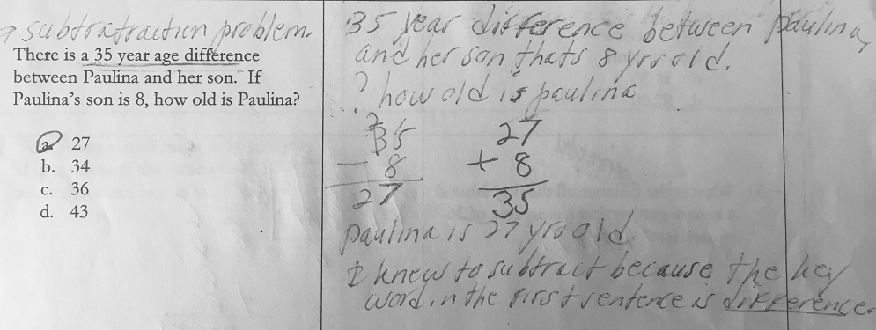
Teacher note: One strategy many students have learned in addressing story problems is to find the key words and perform the operations dictated by them. Here is an example of how this can lead students astray. Consider the student work below before reading about more conceptual approaches.

Strategies students might use
- Make sense of the problem/Think about what is reasonable. A student might take a minute to think about what they know or to retell themself the story in their own words. This can bring the relationships between the numbers in the problem to light in a way that scanning for and applying key words will not. The problem states that there is a 35-year age difference between Paulina and her son. Before choosing an operation to apply, a student might follow a train of thought like the one on the following page to restate the information in a more accessible way, for example, they might reason this way:
There is a 35-year age difference between Paulina and her son.
Paulina is older than her son.
Paulina is 35 years older than her son.

How might this framing affect what math the student chooses to do?
- Use a number line. A number line diagram may make it clear which of the answer choices are reasonable and which mathematical operation or operations will get a student to the right answer:
Paulina’s son is 8 years old.
Paulina’s age = ???
A 35-year age difference

- Use a bar model (also called tape diagrams or Singapore strips). Using one bar to illustrate Paulina’s age and one to illustrate her son’s age will also give a student an idea of what computation will help them find the missing information:
Paulina’s age = unknown
Paulina’s son is 8
A 35-year age difference

- Make an analogy to a situation where all the information is known. A student might think of a similar situation in their own life and use that to figure out the relationships between the numbers in the problem. For example, if the student is 46 years old, and their nephew is 7 years old, the student can figure out the difference in their ages and then can ask, if I knew my nephew’s age and our age difference, how would I figure out my own age? If they are not sure, they can even play with trying different computations and see which gets them to the right answer. Once they understand what works in their own situation, they can apply the same reasoning to the problem.

My Strategy:
QUESTION 19
There is a 35-year age difference between Paulina and her son. If Paulina’s son is 8, how old is Paulina?
- 27
- 34
- 36
- 43

My Favorite Strategy:

I like this strategy because:

Basic understandings needed
QUESTION 20
Ray paid for 2 notepads and 3 pens with a $20 bill and received $6 change. The notepads cost $4 each. How much did each pen cost?
- $1
- $2
- $3
- $5
- $6
Students should be able to do operations with one- and two-digit whole numbers. Students should understand the concept of “change” in transactions with money.
Note: This may look like an algebra story problem, but many approaches can use algebraic reasoning without needing algebraic notation.

Strategies students might use
- Estimate! A student can get a handle on almost any math task that has a real-world context (and many that don’t) with estimation. In this case a student might reason that the cost for each pen is unlikely to be as much as $5 or $6 if the whole purchase was under $20. The numbers in this task are small, so computing with them is not too cumbersome, but it is still worth taking some time to decide what a reasonable answer might look like for two reasons: a) if a student makes a computation or strategy misstep that leads them to an unreasonable answer, having estimated will prompt them to check their work, and b) the process of estimating helps students get a handle on the structure of the situation, setting them up for more precise analysis.
- Work down to the cost of the pens. Starting with the broadest piece of information in the story, a student might bring in the information piece by piece to get to the information they are looking for, making deductions along the way. Receiving $6 change from $20 means that Ray paid $14 for the notepads and pens. The notepads cost $4 each, so they account for $8 of the amount paid and the rest was for the pens. What might the student do next? Don’t forget that there were 3 pens!
Some students might think of this kind of reasoning as “cheating” because it doesn’t look like the steps you would find in a math book. Students who solve things “their own way” may discount the value of their reasoning especially if their past experience in math class or with math books involved being told to do problems a specific way and to show their work to prove they did it that way. Listening to and validating students’ reasoning as real mathematical thinking is an important part of undoing the damage they may have incurred in math class.
- Draw a bar model (also called a tape diagram or Singapore strip diagram). When a story problem tells how quantities are related, drawing a picture that illustrates that relationship can help a student figure out what operations will get them to the missing information. This model shows that the notepads and pens came to $6 less than the $20 bill:
$20
Notepad: $4
Notepad: $4
Pen: $?
Pen: $?
Pen: $?
$6

And this alternative model shows how the $20 bill was broken up.
$6 change
Notepad: $4
Notepad: $4
Pen: $?
Pen: $?
Pen: $?
$20

How might these models help a student figure out the cost of a pen? (Note that drawing and using bar models takes some practice. It can be helpful to start out providing the models for students so they can learn to reason with them, which will motivate them to draw their own models. For an example of what this can look like, check out this Singapore Strips How-To Video.)
- Write and solve an equation. This is a problem that can be solved using an equation. In fact, students who have practiced algebraic reasoning enough to be comfortable shortening their notation, may find it quite natural to represent the relationships in the problem using symbols. Here’s one equation a student might write and solve:
$$2\left(4\right)+3x=20-6$$
Look at the first bar model above. How does this equation compare to that representation? How do the steps you might take to solve this equation compare to what you might do to solve the problem with the bar model?
Here’s another possible equation a student could use:
$$2\left(4\right)+3x+6=20$$
How does this compare to the second bar model?
Are there other ways you could write an equation for this problem? Could those equations also be represented visually with bar models?

My Strategy:
QUESTION 20
Ray paid for 2 notepads and 3 pens with a $20 bill and received $6 change. The notepads cost $4 each. How much did each pen cost?
- $1
- $2
- $3
- $5
- $6

My Favorite Strategy:

I like this strategy because:

Basic understandings needed
QUESTION 21
Amy and Kate are shopping online for kitty litter and have found the following prices at five different online stores. Which store has the lowest price per pound for kitty litter?
Website | Deal
Pet Supplies Unlimited | 8 pounds for $27
Cat Life | 16 pounds for $40
Raining Cats and Dogs | 10 pounds for $35
Love Your Pet | 15 pounds for $37
PetCare.com | 12 pounds for $36

- Pet Supplies Unlimited
- Cat Life
- Raining Cats and Dogs
- Love Your Pet
- PetCare.com

Students should be able to interpret information presented in a chart. Students do not need formal proportional reasoning skills (like setting up and solving proportions). Most adults already have ways of reasoning about comparing deals.

Strategies students might use
- Estimate! This is a real-world situation, and most of the time, in the real world, we try to get away with doing as little calculation as possible. In many cases, estimation is all we need. In this case, a student might check out what whole dollar amounts each rate is between. For example, the rate for Pet Supplies Unlimited must be more than $3 per pound because at $3 per pound, 8 pounds would only cost $24. However, that rate must also be less than $4 per pound because at $4 per pound, 8 pounds would cost $32. (And the actual price is between $24 and $32.)
On the next page, there’s a partially completed table with information on the deals found on the pet store websites in the problem. Try filling in the rest of this chart yourself. How does that move you toward finding the answer? Can you get all the way there with estimation? Why or why not?

Website | Deal | Estimate
Pet Supplies Unlimited | 8 pounds for $27 | Between $3 and $4 per pound
Cat Life | 16 pounds for $40
Raining Cats and Dogs | 10 pounds for $35
Love Your Pet | 15 pounds for $37
PetCare.com | 12 pounds for $36
(Even if you have a calculator handy, it’s a good idea to estimate before you calculate. You’ll see why in approach #4)


- Estimate II. Taking a moment to read through the different deals, a student might notice that the prices for the bottom three brands in the table are very close together, but the number of pounds for the price differs by at least 2 pounds. At PetCare.com, you can get 2 pounds more than at Raining Cats and Dogs for only $1 more. And at Love Your Pet, you can get 3 pounds more than at PetCare.com for only $1 more. How might this help the student think about which of those bottom three brands might be the best deal?
12 Pounds
$36
2 more pounds
1 more dollar

10 Pounds
$35
3 more pounds
1 more dollar
15 Pounds
$37

Once they have an idea of which of the bottom 3 is the best deal, how might they extend their reasoning to compare that to the top two?

- Estimate III. Another good way to use estimation is in making individual comparisons. For example, at Pet Supplies Unlimited, you can get 8 pounds for $27 and at Cat Life, you can get 16 pounds for $40. A student might notice that the number of pounds in the deal from Cat Life is twice the number of pounds in the deal from Pet Supplies Unlimited and that they could compare these deals by doubling the deal from Pet Supplies Unlimited… but do they really need to do that calculation? All they really need to know is whether doubling the deal from Pet Supplies Unlimited will cost more or less than $40.
16 Pounds

8 Pounds
Which is a better deal?
8 Pounds

2 bags at $27 each
1 bag for $40
One individual comparison eliminates one answer choice. What comparison might they make next?
- Calculate unit rates. A student may choose to use a calculator to find the price per pound of each brand. That can be a quick way to get through a question like this on the test or in reality, but it is important that they’ve thought about what they are doing first (maybe by estimating)! We find unit rates by doing division, but what do we divide by what?
Website | Pounds | Dollars | Pounds ÷ Dollars | Dollars ÷ Pounds
Pet Supplies Unlimited | 8 | 27 | 0.296 | 3.375
Cat Life | 16 | 40 | 0.4 | 2.5
Raining Cats and Dogs | 10 | 35 | 0.286 | 3.5
Love Your Pet | 15 | 37 | 0.405 | 2.47
PetCare.com | 12 | 36 | 0.33 | 3
Consider the table below:

Having estimated before calculating will help a student know which of the calculations gives the price per pound of kitty litter. But what do the numbers in that other column mean? How could they help a student identify the website with the best price? (Hint: If dividing dollars by pounds gives you dollars per pound, what does dividing pounds by dollars give you?) It’s easy to divide in the “wrong” direction if you aren’t paying attention, but knowing what kind of answer is reasonable will help you recover quickly from that misstep.

My Strategy:
QUESTION 21
Amy and Kate are shopping online for kitty litter and have found the following prices at five different online stores. Which store has the lowest price per pound for kitty litter?
Website | Deal
Pet Supplies Unlimited | 8 pounds for $27
Cat Life | 16 pounds for $40
Raining Cats and Dogs | 10 pounds for $35
Love Your Pet | 15 pounds for $37
PetCare.com | 12 pounds for $36

A. Pet Supplies Unlimited
B. Cat Life
C. Raining Cats and Dogs
D. Love Your Pet
E. PetCare.com

My Favorite Strategy:

I like this strategy because:

QUESTION 22
Alicia works in an appliance store where she earns a base salary of $18.50 per hour plus a 20% commission on any appliances she sells. Last week, her earnings from commissions were $396. What was the total value of the appliances Alicia sold that week?
- $79.20
- $475.20
- $792.00
- $1,584.00
- $1,980.00
Note: This is a variation on Question 14 (Alicia’s Earnings). The scenario is the same, but the question asked is different.

Basic understandings needed
Students should understand that a percent represents a part-whole relationship and have some familiarity with some benchmark percents like 50% and 25%.

Strategies students might use
- Estimate—Attend to Precision. Estimation is almost always a good starting point. It helps students make sense of the situation and avoid panicked number grabbing. In this case, coming up with an estimate for the total sales will get students thinking about how that number relates to the numbers given in the problem. If Alicia earned $396 from commissions, does that mean the total amount of her sales was more or less than $396? Which would make sense? This will help a student understand what they have and what they are looking for. Do they need to find 20% of $396? That would be less than $396, so that wouldn’t make sense as the total amount of sales. It must be that $396 is 20% and they need to find the number that $396 is 20% of. That number must be bigger than $396. How much bigger? A little or a lot?
Note: Figuring out and paying attention to what each number in a scenario represents (e.g., $396 is 20% of something and I need to figure out the something) is part of attending to precision—Standard for Mathematical Practice #6. Making it a norm to communicate clearly in your classroom about what the numbers you are using mean will help students develop this important mathematical habit of mind and carry it through to the test and even to real world problem solving.

- Estimate with a picture—Use benchmarks. What does 20% look like to you? A common representation of percents is a circle graph (or pie chart). Depending on what benchmarks a student is comfortable with, they might represent 20% as less than half…
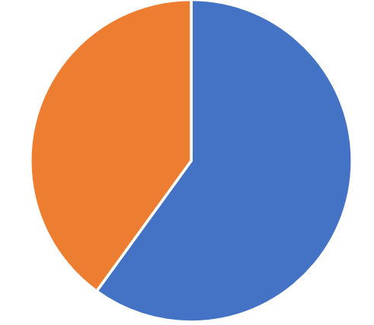
Total Sales
Alicia’s Commission $396
The Rest of the Sales

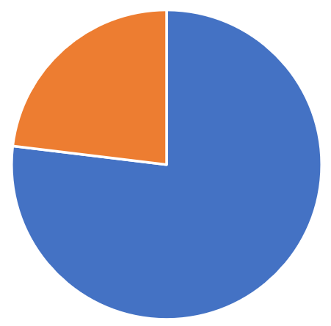
or, as less than one quarter…
Total Sales
Alicia’s Commission $396
The Rest of the Sales

or, even more precisely as exactly one-fifth.
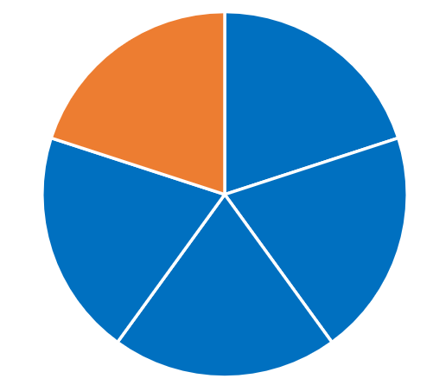
Alicia’s Commission $396
The Rest of the Sales
Total Sales

How might these pictures help a student estimate the total sales? (Note: A student who uses benchmark 50% to estimate what the whole is when 20% is known is not wrong. Having more precise benchmarks will enable students to make better estimates, but students have to work with the benchmarks they know… and continue to grow their repertoire.)
- Reason with a bar model —Use benchmarks. A student who is familiar with the equivalence of 20% and $\frac{1}{5}$, might draw a bar model like this:
$396
Total Sales

Whereas a student who doesn’t have 20% in their set of benchmarks might think in chunks of 10% or $\frac{1}{10}$ instead:
$396
Total Sales

How might these pictures help a student figure out the total sales?
Note: For more on reasoning about percents with bar models, see the Modeling Benchmark Percents and Fractions practice sheet and Answer Key.

My Strategy:
QUESTION 22
Alicia works in an appliance store where she earns a base salary of $18.50 per hour plus a 20% commission on any appliances she sells. Last week, her earnings from commissions were $396. What was the total value of the appliances Alicia sold that week?
- $79.20
- $475.20
- $792.00
- $1,584.00
- $1,980.00

My Favorite Strategy:

I like this strategy because:

Basic understandings needed
QUESTION 23
The area of a rectangle is 24 square inches. The perimeter of the rectangle is 22 inches. What is the length of the shorter side of the rectangle?
- 2 inches
- 3 inches
- 4 inches
- 6 inches
- 8 inches
Students should understand the meanings of area and perimeter. They should understand that the area of a shape is the number of square units inside it and that the perimeter of shape is the distance around it.

Strategies students might use
- Play with area—concretely. Knowing that the area of the rectangle is 24 square inches, a student who is more comfortable reasoning at a concrete level might try using 24 squares to make a rectangle and then finding the perimeter like this:
Attempt 1:
Oops! Not a rectangle! There’s a piece missing in the corner.

This rectangle has a perimeter of
4 in + 6 in + 4 in + 6 in
Close, but not quite there. Keep trying!
6 in

Attempt 2:
4 in

4 in

6 in
- Play with area – representationally or abstractly. A student who is thinking more abstractly about area might make a rough sketch to get a handle on this question or might reason without visuals at all:
A 2” x 12” rectangle would have an area of 24 in², but the perimeter would be 28 in.

or

- Play with perimeter. A student who is reasoning concretely and wants to start with the perimeter of the rectangle could cut a piece of string to 22 inches and then experiment with creating a rectangle with it on one-inch grid paper and counting the squares inside to check the area. A student reasoning more representationally might draw sketches of rectangles with perimeters of 22 inches and find their areas:
Area = 28 in²
7 in
7 in
4 in
4 in
Area = 30 in²
6 in
6 in
5 in
5 in

Getting closer…
Too big…

(It’s not that simple to create a rectangle with a given perimeter! Check out the free sample lesson: Understanding Perimeter with Formulas in the Curriculum for Adults Learning Math (CALM) for ideas on developing this concept.)
- Make use of structure. Explorations with creating rectangles with a target perimeter may lead students to recognize a pattern in the relationship between the length and the width of a rectangle. Since the length and the width are each counted twice in the perimeter, just one of each must make half the perimeter. In other words, if the rectangle has a perimeter of 22 inches, the length and the width must add up to 11 inches. With this information, a student could make an organized table of possible dimensions to find the ones that yield the target area:
Length | Width | Area
1 | 10 | 10
2 | 9 | 18
… | … | …

My Strategy:
QUESTION 23
The area of a rectangle is 24 square inches. The perimeter of the rectangle is 22 inches. What is the length of the shorter side of the rectangle?
- 2 inches
- 3 inches
- 4 inches
- 6 inches
- 8 inches

My Favorite Strategy:

I like this strategy because:

Will This Be on the Test?

APPENDICES

Not every test-like question will be appropriate for a Test Talk. In these appendices, you will find some examples of questions that won’t work well with the Test Talk routine, but which have something to teach us and our students anyway.

Appendix 1: Learning to Let Some Questions Go
Through practicing making sense of test questions and persevering in solving them, students can find entry points into many questions they encounter on high-stakes tests even when they haven’t explicitly studied the topics those questions are testing. However, there will be questions that are out of reach. It is important that teachers and students know and accept this. For example, consider the following test question:
The graph of the function $f\left(x\right)=x^{2}-6x+5$ is a parabola. What are the coordinates of the vertex of the parabola?
A. (-6, 5)
B. (-3, 4)
C. (-3, -4)
D. (3, -4)
E. (5, 6)
There is likely enough unfamiliar vocabulary and notation here that making sense of the problem is not possible given the limited time a student has on the test. Sometimes that happens—and it will happen to your students when they go in to take the test. They will encounter questions on concepts that you did not teach them. They will encounter questions that they cannot make sense of because of unfamiliar vocabulary or notation or because they simply have not learned the concept the question is testing.
There is a simple solution to this issue: make a quick guess and move on. The key for a student is being able to discern which questions are worth their time and which are not. The presence of a variable doesn’t necessarily mean a question is out of reach, but when the question might as well be written in a foreign language, it is not worth a student wasting their precious time trying to wrangle with it. Nobody can answer with certainty a question they do not understand.
Students should learn to read a question and ask themselves if they can make sense of the math in the question. Sometimes unfamiliar vocabulary does not have to be a barrier. For example, a question might state that a gobnabbler machine can produce 16 herbledingles every 5 minutes and ask how many herbledingles two gobnabbler machines can produce in 3 hours. A student can probably reason through that without ever knowing what a herbledingle or a gobnabbler machine is. On the other hand, if a question requires students to evaluate an expression like log₃(81) and they have never seen anything like that before, there isn’t a lot to be gained from trying to figure out or guess what it means in a high-stakes, timed situation. It is up to the student, in the moment they are faced with a question, to decide if it is worth their time, but they should go into the test knowing that not every question will be and that’s okay. You might even work that into any test practice you do—the first step in tackling a problem is deciding whether to tackle the problem.
It is important that we and our students recognize that it is not feasible to prepare students to get a perfect score on their math HSE test. A perfect score should indicate that they have the equivalent of a full high school education, something that takes four years in the life of a teenager whose primary job is to attend school. For adult learners who enter our programs often needing to learn topics found at the middle-school level or below, they just don’t have the time or resources to learn everything that is on the test. We must accept that we will not teach everything that is on the test, and we need to help our students accept that as well.
There are two questions that are important to ask when deciding whether a student is ready to take the test:
- Are they prepared to pass the test by using problem solving, reasoning, estimation skills, and good test-taking techniques?
- Are they prepared for their next step (college, career path, new job, etc.)?
These are the things that matter. They matter a lot more than making sure students are prepared to answer every possible question they might see on the test. If the answer to the second question is no, then passing the test and exiting their program sets students up for failure. For the good of our students, we need to take a broader view than only focusing on test scores. A conceptual approach to teaching math, numeracy, and problem solving prepares students for the test and for life, but we all have to be willing to let go of some questions and topics so students can bring their reasoning power to bear on those questions they can make sense of.
There’s another important point here for teachers. In continuing to grow your own mathematical minds and teaching skills, you will do better by your students if you focus your learning on conceptual understanding and problem solving at the level your students are working than if you struggle through higher level and more abstract concepts until you are sure you could get a perfect score on the test. For many people teaching math to adult learners, those high school level math skills are decades in the past, and maybe they didn’t make sense even then. If you can’t answer the parabola question, that has no bearing on your qualification to teach math to adult learners. It is more important to be able to model critical thinking, curiosity, and a growth mindset for your students than to be able to demonstrate how to reckon with parabolas. It is more important to grow your own conceptual understanding and flexible thinking ability so you can nurture those things in your students than to be able to explain how to do every question on the test.

Appendix 2: On Vocabulary
Some questions students will encounter on standardized tests cannot be solved by reasoning. Instead they require students to know and apply vocabulary and definitions. For example, consider the question below:
C
A
D
B
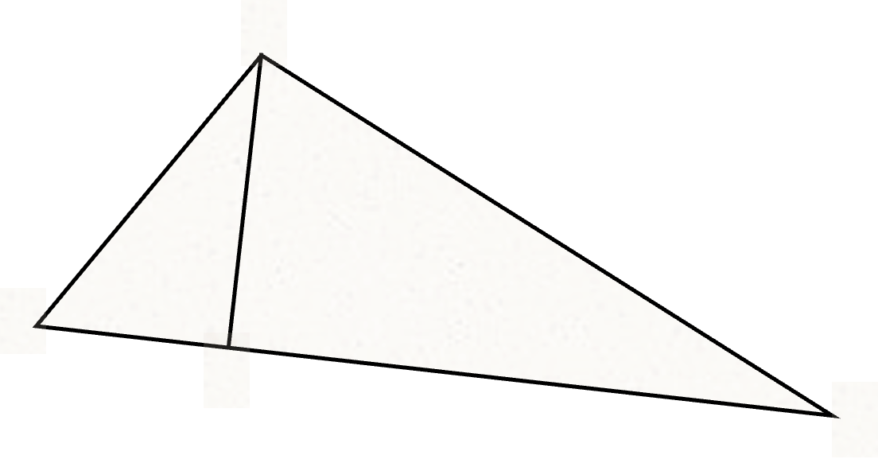
What is the best description of the relationship between line segments $\overline{AD}$ and $\overline{BC}$?
A. $\overline{AD}$ is congruent to $\overline{BC}$
B. $\overline{AD}$ is parallel to $\overline{BC}$
C. $\overline{AD}$ is perpendicular to $\overline{BC}$
D. $\overline{AD}$ is similar to $\overline{BC}$
E. $\overline{AD}$ is equal to $\overline{BC}$

To be able to answer this question, a student needs to recognize the relationship between the two line segments, and they need to know the name for it. It may not be possible to approach this question conceptually, but it is possible to teach mathematical vocabulary conceptually.
There is a lot of math vocabulary to learn and it is important that students learn it, both to be able to answer questions like the one above and also to be able to communicate their thinking and understand other people’s thinking. Some people believe it is best to pre-teach or front-load all the vocabulary students will need for a lesson so that they will not be confused or tripped up when encountering unfamiliar words. However, you will create longer lasting and deeper learning by keeping the focus on the concept and introducing the vocabulary once students have a concept that they need a word for. Understanding a concept before you have the word for it creates an intellectual need for the vocabulary.
Geometry is especially laden with vocabulary and especially rich with beautiful things that that vocabulary can be used to describe. What if, instead of starting off a lesson with a list of long and intimidating words, we gave students some colored pencils and a design like the one on the following page to color on?

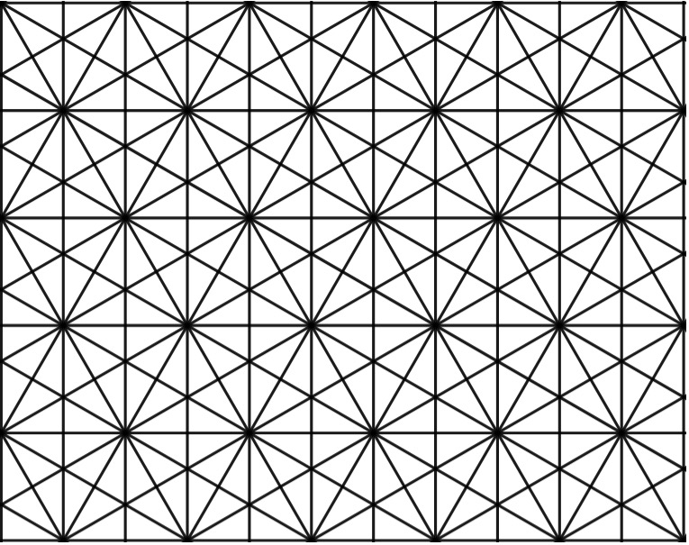

What do you see first in the pattern above? How would you describe it? If you want to explore your own ideas before reading further, you can download a file of the same pattern that you can print out and color yourself. After you color, ask yourself how you would describe your findings to someone who couldn’t see your paper. What vocabulary would you need to use?
What do you see? Maybe you see triangles, rectangles, or parallel lines. Maybe you see trapezoids or rhombuses. Maybe you see different kinds of angles. Maybe you see congruence or similarity. With some freedom to color and explore, students will discover many important geometry concepts that happen to have names. Once your class is deep into a rich discussion of the concepts, it becomes a relatively simple thing to drop the important vocabulary into the conversation and students will have a concept ready and waiting to attach it to.

For example, suppose a student finds the following triangles in the pattern:
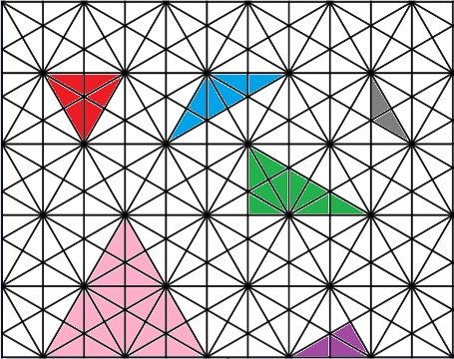
What questions might the student ask about their triangles? What vocabulary might they need to talk about them?
Even asking the question, “How many different triangles did I find?” can motivate important conceptual understandings and vocabulary as the student works to make sense of what it might mean for triangles to be “different”. (Do you think the student has found all the different triangles that are possible to find? How would you argue that they have or that they haven’t?)
What other shapes, concepts, and relationships are present? Starting geometric conversations with “What do you see?” and moving to “How can you describe it?” will have students engaged in conceptual learning and ready and wanting new vocabulary to talk about their ideas. Instead of trying to remember that a rhombus is a quadrilateral with four equal sides but is somehow kind of the same as a square and kind of not, they may remember that “rhombus” is the name for that thing they discovered and why this shape was a rhombus and that one wasn’t.
And once some vocabulary is established, a whole new game is possible. How many different trapezoids can you find? How many parallelograms? Where do you see perpendicular lines? How do you know they are perpendicular?, etc.
Vocabulary doesn’t have to be taught separately from concepts and doesn’t have to be dry and intimidating. After deeply exploring the pattern above or other similarly rich geometric objects, would your students be able to identify the relationship between the line segments in our original problem?
Here are two other good options for explorations that can generate the need for vocabulary:

Kaleidoscope
https://www.adultnumeracynetwork.org/Kaleidoscope
Created in Desmos. Students can manipulate the shapes by moving a slider.

Polypad
https://mathigon.org/polypad
There are a wealth of geometric options to explore at this free resource from Mathigon.org.

Note that Polypad allows users to change the background from blank to a grid or dot array. Look for the button on the right-hand side of the screen that looks like a grid (pictured to the right) to change the background.

(It is important to understand that naming the characteristics of white supremacy culture is very different from believing in white supremacy. This is about cultural norms, not individual beliefs.)

