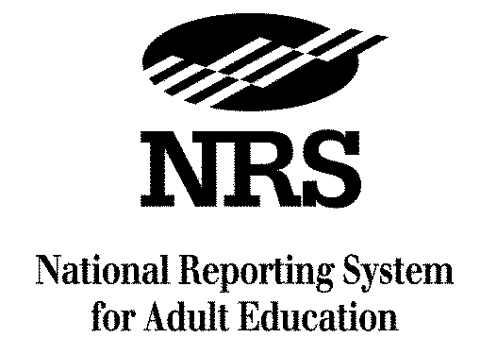
A Project of the U.S. Department of Education

NRS Test Benchmarks for Educational Functioning Levels

Updated February 2015

Adapted by SABES PD Center for Assessment to show only approved Massachusetts Department of Elementary and Secondary Education, Adult and Community Learning Services approved tests.

Adult Basic Education
Please refer to the attached Federal Register notice for a list of NRS approved tests and test forms.
Educational Functioning Level | Test Benchmarks
Beginning ABE Literacy | TABE (9–10) scale scores  (grade level 0–1.9):  Reading: 367 and below  Total Math: 313 and below
Beginning Basic Education | TABE (9–10) scale scores  (grade level 2–3.9):  Reading: 368–460  Total Math: 314–441  MAPT scale scores:  All tests: 200-299

Educational Functioning Level | Test Benchmarks
Low Intermediate Basic Education | TABE (9–10) scale scores  (grade level 4–5.9):  Reading: 461–517  Total Math: 442–505  MAPT scale scores:  All tests: 300-399
High Intermediate Basic Education | TABE (9–10) scale scores  (grade level 6–8.9):  Reading: 518–566  Total Math: 506–565  MAPT scale scores:  All tests: 400-499

Educational Functioning Level | Test Benchmarks
Low Adult Secondary Education | TABE (9–10): scale scores  (grade level 9–10.9):  Reading: 567–595  Total Math: 566–594  MAPT scale scores:  All tests: 500-599
High Adult Secondary Education | TABE (9–10): scale scores  (grade level 11–12):  Reading: 596 and above  Total Math: 595 and above  MAPT scale scores:  All tests: 600-700

English as a Second Language
Please refer to the attached Federal Register notice for a list of NRS approved tests and test forms.
Educational Functioning Level | Test Benchmarks
Beginning ESL Literacy | BEST Plus: 400 and below (SPL 0–1)  TABE CLAS-E scale scores:  Total Reading and Writing: 225-394
Low Beginning ESL | BEST Plus: 401–417 (SPL 2)  TABE CLAS-E scale scores:  Total Reading and Writing: 395-441
High Beginning ESL | BEST Plus: 418–438 (SPL 3)  TABE CLAS-E scale scores:  Total Reading and Writing: 442-482
Educational Functioning Level | Test Benchmarks
Low Intermediate ESL | BEST Plus: 439–472 (SPL 4)  TABE CLAS-E scale scores:  Total Reading and Writing: 483-514
High Intermediate ESL | BEST Plus: 473–506 (SPL 5)  TABE CLAS-E scale scores:  Total Reading and Writing: 515-556
Advanced ESL | BEST Plus: 507–540 (SPL 6)  TABE CLAS-E scale scores:  Total Reading and Writing: 557-600

(page intentionally left blank)

TABE = Tests of Adult Basic Education
MAPT = Massachusetts Adult Proficiency Test
BEST = Basic English Skills Test
TABE CLAS–E = Test of Adult Basic Education Complete Language Assessment System – English
Refer to the TABE CLAS–E Technical Manual for score ranges for individual reading, writing, listening and speaking tests. Table shows only total scores.

